
ECF and ECT Programme Handbook for Induction Tutors
Year 1 and 2
These materials are intended for use by those who oversee the entitlement of early career teachers in schools working with the National Institute of Teaching and their Associate Colleges.

How to get in touch with us:
North West: ECF_NW@niot.org.uk
North East: ECF_NE@niot.org.uk
South East & London: ECF_ESL@niot.org.uk
South West: ECF_SW@niot.org.uk

Online:
Early Career Teachers – The National Institute of Teaching







Introduction
Welcome to this programme overview for the Early Career Teacher (ECT) Programme from the National Institute of Teaching. This document is designed to support the induction of early career teachers and the work of their mentors in your school.
This handbook includes information to support induction tutors to manage and oversee both the ECF programme for year 2 ECTs and the new ECT programme for those in year 1.

Content
ECT Programme - Year 1 | Page 3
Year 1 Mentor Programme | Page 13
ECF Programme– Year 2 | Page 15
Mentors in Year 2 | Page 19
Time commitment 2025/26 – Year 1 and Year 2 | Page 20
On-line learning management system – Prism | Page 21
Wellbeing tool | Page 23
Induction Tutor role and responsibilities | Page 24
Funding | Page 26
Key terminology | Page 27
To do checklist | Page 28
Appendix 1: Year 1 Modules and associated self-studies | Page 29
Appendix 2: NIoT 6-step observation and feedback model | Page 31

ECT Programme – Year 1
From September 2026, all early career teachers starting in year 1 will follow the new ECT programme. In the first year, full time ECTs will study 6 modules, 1 per half term, underpinned by the domains in the new initial teacher training and early career framework (ITTECF). You can read more about the ITTECF here.
ECTs who are working and studying part time will need a bespoke programme to match their working patterns and engagement preferences; in order to arrange this, please contact your Associate College or NIoT campus who will be able to support you. You should also discuss this with your Appropriate body who will help you to decide the best approach in collaboration with your part-time ECT. The quantity of engagement should be manageable for the ECT and ensure they are able to engage in the entire programme over the period of time agreed. E.g. It may be appropriate for an ECT on a 0.5 FTE to complete the programme over 4 years instead of two.
In year 1, ECTs and mentors should meet weekly for an hour (or equivalent) and are entitled to 10% timetable relief. Mentors should observe ECTs each week for around 15 minutes. Mentors will use their weekly meeting to provide feedback using the 6-step feedback model of instructional coaching, recording their feedback and the ECT’s target on Prism. See Appendix 2 for more information on the feedback model.
The new ECT programme from the NIoT offers a flexible sequence of study combined with personalised pathways for participants. Take a moment to watch the video below which outlines how our programme works.

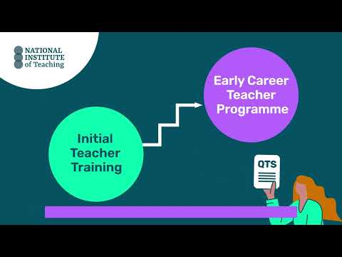
Click to watch video: ECT Programme structure for Y1

Summary of key features of the ECT programme for year 1:
- 6 modules that align with the ITTECF.
- ECTs will complete one module per half-term.
- Each module, is made up of 1 core self-study and 5 elective self-studies.
- The module sequence is flexible apart from the first half-term.
- Content intentionally revisits the evidence that ECTs first explored as an initial teacher trainee providing opportunities for them to build on existing knowledge and skills.
- Having completed their core self-study each term, ECTs will complete a 30-minute diagnostic.
- The diagnostic will help to guide ECTs and their mentors to select 3 elective self-studies (2 in half-term 1)
- Mentor support materials are available to support mentors when working with their ECTs, including planning their weekly meetings.
Modules in year 1
In year 1 of the ECT programme, the modules that ECTs will study are:
- Behaviour and relationships
- Memory and learning
- Planning and delivery
- Subject and curriculum
- Assessment for learning
- Adaptive practice
The first module that all ECTs will complete in year 1 is Behaviour and relationships. This will support ECTs to establish a positive, structured learning environment that fosters pupil engagement, wellbeing, and academic success at the very start of the academic year. You can see a list of the focus areas within each module here.
A flexible approach
In response to feedback from the education sector, our ECT programme offers schools a choice in which ECTs complete the subsequent 5 modules in year 1. This flexibility enables schools to align ECTs’ study and personal development with their own professional development priorities. This can further increase the overall impact of the programme.
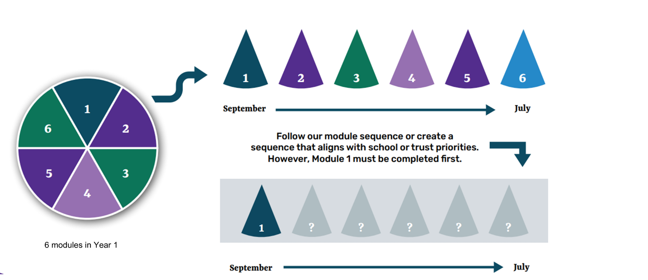

Example of a flexible sequence
Here is an example of an adapted module sequence and the school’s rationale behind their selection.
School A is part of a MAT where adaptive teaching has been prioritised as an area for whole-school professional development for the next academic year. Therefore, they have adapted the sequence of modules so that all ECTs, trust-wide, will complete the ‘Adaptive Practice’ module in Autumn half term 2.
The induction tutor has previously raised concerns that some early career teachers lack confidence in planning and teaching, particularly in using assessment to guide their future planning. Therefore, in the Spring, ECTs will begin by studying ‘Planning and delivery’ before moving on to ‘Assessment for Learning’.
In the final term, all ECTs will explore ‘Memory and Learning’ before finishing the year with ‘Subject and Curriculum’. This will align with a whole-staff professional development package already planned around long-term curriculum planning and subject enhancement.
Following consultation between the MAT’s teaching and learning lead and induction tutor, a decision has been made to adapt the sequence as follows:

Autumn Half term 1 | Autumn Half term 2 | Spring Half term 1 | Spring Half term 2 | Summer Half term 1 | Summer Half term 2
Behaviour and relationships | Adaptive practice | Planning and delivery | Assessment for learning | Memory and learning | Subject and curriculum

Schools with multiple ECTs
In schools where there is more than one ECT, all participants should complete the modules in the same sequence. This will ensure a consistent school approach and provide opportunity for peer-support. This consistency also allows induction tutors and mentors to deepen their expertise in key topics, streamline discussions, and tailor guidance more precisely. If you work in a multi-academy trust, you may need to liaise with colleagues to clarify whether the module sequence is being agreed at a whole-trust or whole-school level.
Due to the flexible approach to the module sequence, some ECTs may complete their study in a different order to colleagues in different schools or outside their trust. Induction tutors should reassure ECTs that this will not impact on their termly progress reports as the programme design ensures that all ITTECF framework statements will be covered across year 1 of the programme and consolidated in year 2.
Selecting a different sequence – what you need to know
- All ECTs must complete the module on ‘Behaviour and relationships’ in Autumn half term 1.
- ECTs will still complete all 6 modules – one module per half term.
- There is no obligation to adapt the sequence of modules; schools can choose to follow our programme as designed. No action is required in this instance.
- All ECTs will attend live seminars in the sequence outlined in the introductory materials and in this document.
- Mentor support materials will align with the ECT’s modules.
- Where there is more than one ECT in a school, all participants must complete the modules in the same order.
- All ITTECF statements will be addressed across year 1 of the programme and consolidated in year 2.
- Confirmation of the revised sequence must be received by the end of half term 1 and no further changes can be made for the remainder of the first year of the programme. This should be done via the LMS, Prism.
- If you do not wish to adapt the sequence, no action is required.
- Should any ECTs join the school later in the year, they should still complete the module on behaviour and relationships first and then join the programme as the same point as their colleagues.
Selecting a different sequence – things to consider
Should you wish to adapt the order in which your ECT(s) complete the modules in year 1, please consider the following:
- If I work in a trust, have I checked with the person responsible for the ECTs whether a module sequence choice is being made at a trust or school level.
- Have I established the professional development priorities for my school or trust this year?
- Have I consulted with any experienced mentors and relevant senior leaders in the school or trust to seek their thoughts on what any change to the suggested sequence should look like?
- Do I have a clear rationale for why studying modules in a different one to the one recommended would be beneficial for my ECT(s) to complete?
How to submit your preferred sequence
If you wish to adapt the sequence of modules 2- 6, please log in to your account on Prism and submit your revised sequence before the end of half-term 1.
Once submitted, no further changes to the sequence can be made during year 1 of the programme.

Return to Content page

Year 1 Programme content - Early Career Teachers
Take a moment to look at the structure of the ECT programme in year 1:
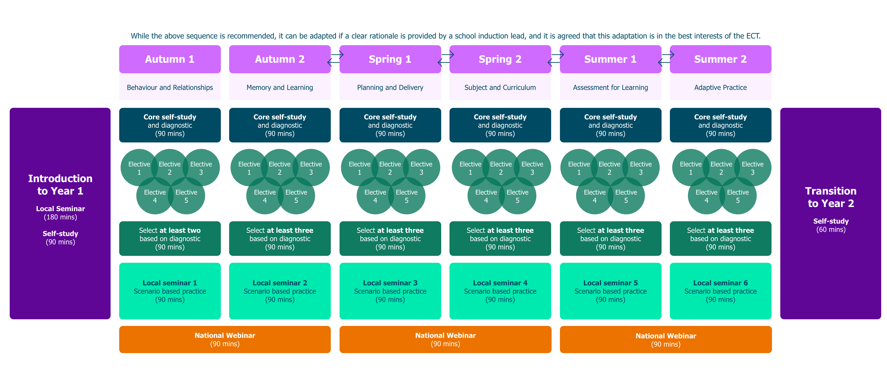

Introductory materials
At the start of the programme, all ECTs will attend a 3-hour in-person local seminar where they will:
- learn more about the structure of the NIoT’s ECT programme
- understand what it means to develop teacher expertise
- explore the observation and feedback model used by the NIoT’s ECT programme
- consider how to manage their well-being
The seminar will also provide the opportunity for ECTs to network with peers. ECTs will also complete a 90-minute on-line self-study as part of their onboarding process.
Core self-study
Early career teachers will complete one core self-study per module followed by a diagnostic reflection. Both of these will be accessed on the learning management system, Prism. The core self-study acts a refresher to the evidence and theory that ECTs will have gained in that specific domain during their ITT.
Diagnostic
ECTs will complete a diagnostic for each module after they’ve read the related core-study. The diagnostic is found on the LMS and it will take them approximately 30 minutes. It’s comprised of 20 multiple-choice questions related to the domain. The results will be accessible to mentors on Prism.
There is no pass or fail - the diagnostic report is designed as a guide or a ‘proxy’ to help mentors and their ECT identify specific areas for further development or enhancement within their current practice. The suggested recommendations are intended to support the start of a conversation between mentors and ECTs as to what electives could have the greatest impact on their personal development.


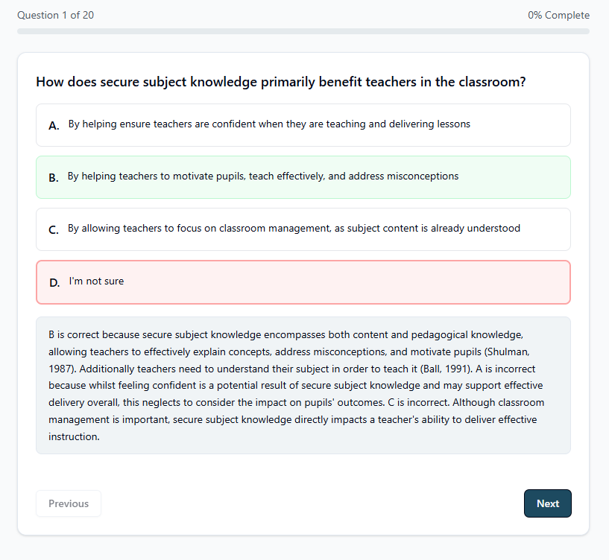

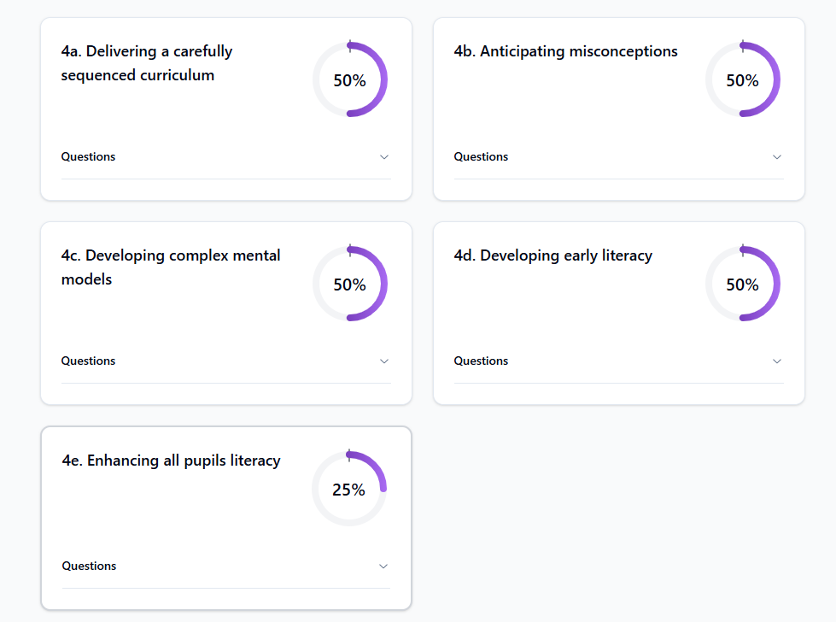

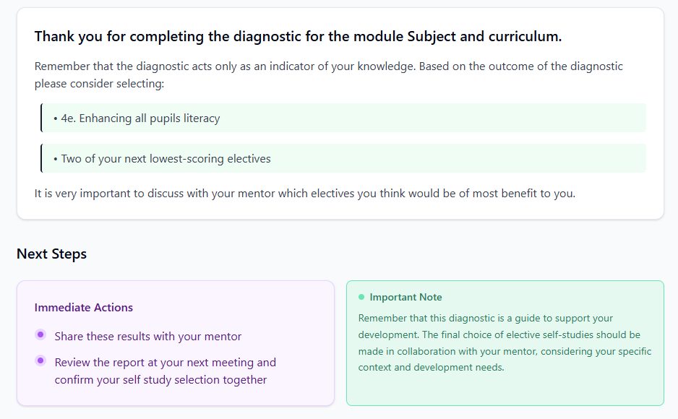

Elective self-studies
The outcome of the diagnostic, along with the ECT’s Career Entry Development Profile (CEDP) or other targets from their ITT, will guide their discussion with their mentor as they identify together a focus for development within a module.
ECTs then select 3 elective self-studies per module – each focused on a more granular aspect of the broader topic. However, for half-term 1 they will only need to complete 2 elective self-studies. This is to give them more time to get settled into the new school year.
Here, you can see how each self-study element is broken down within a typical module. In this example, you can see that the core self-study is completed first and then, following their diagnostic and mentor discussion, this particular ECT has chosen elective self-studies b, c and e to complete.
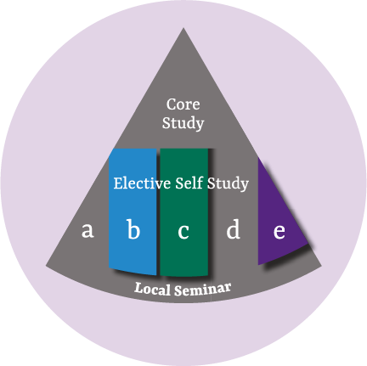

Local seminars
ECTs attend half-termly local seminars which are run by carefully selected, highly experienced teachers and school leaders. The seminars will be either in person or online and the activities undertaken will give them the chance to engage with wider expertise and network with peers.
Our holistic approach to seminar-design means the content of each session will support the development of all ECTs regardless of their sequence of self-study modules or choice of electives.
In seminars, ECTs have the opportunity to connect different aspects of their teaching—such as planning, assessment, and behaviour management—into a more cohesive and effective practice. By integrating multiple elements of teaching as they work through a range of thought-provoking scenarios, ECTs will develop their adaptive expertise supporting them to make better-informed decisions in real time and making their teaching more responsive to individual needs.
For example, while seminar 1 focuses on ‘Ensuring safe and predictable learning environments’, ECTs will also be supported to draw on and deepen their understanding of the role that planning and formative assessment has in achieving this goal.

Local seminars for year 1 - 2025/26
Autumn half term 1 | Autumn half term 2 | Spring half term 1 | Spring half term 2 | Summer half term 1 | Summer half term 2
Ensuring safe and predictable learning environments | Planning effective lessons | Working in partnership with stakeholder | Checking prior knowledge and addressing misconceptions | Assessment literacy and analysis to inform teaching and learning | Integrating technology into classroom practice to support adaptive teaching
National Expert Webinars
ECTs will also attend one National Expert Webinar per term facilitated by leading experts in their fields. These provide an opportunity for them to hear from a range of experts on different areas of pedagogy. The experts leading our National Webinar Series for the 2025/26 Year 1 ECT programme will be confirmed in September 2025. Previous experts include Tom Bennett and Alex Quigley.
Return to Content page

Year 1 Mentor Programme
The mentor programme is designed to develop mentors as mentors of teachers, not just early career teachers. We have spoken to mentors and induction tutors to find out what they feel would be most useful for them. This is an entitlement and (funded) mentors should be enabled and encouraged to engage throughout in order to complete the programme.
Mentors gain access to summaries of the ECT studies each half term so that they can have an overview of what their ECT is learning and the option to look deeper at it as a mentor for their own development – this adjusts in line with any sequence order changes made to their paired ECT's module order. The materials are designed to support mentors to identify the ‘active ingredients’ of effective practice, select appropriate actions for ECTs and plan their weekly meetings. The materials include a framework for them to use to plan these.
Mentors also have a programme of self-study materials, each lasting 30-minutes. They will complete one per term. We have designed the mentor study to be helpful in their role and development as a teacher educator. Self-study content covers topics such as how to effectively lead deliberate practice and how to ‘unlock adaptive teaching’ with other teachers, so that they can support their ECT, and other colleagues to do so. The self-study titles have been carefully planned based on what mentors have told us they find difficult about mentoring, but also to reflect their expertise and the differences in teaching adults, compared to children e.g. How they can help an ECT to use their feedback to best effect in the classroom.
The live sessions intentionally address topics which can be tricky, and which are relevant and current, such as pedagogy vs andragogy, which looks at how teaching adults can be tricky and how to deal with this best in their role as mentor, compared to how you might address this with pupils in their classrooms. Mentors will attend one live event per term and have a choice between the local seminars or the National Expert Webinars that ECTs will be attending.
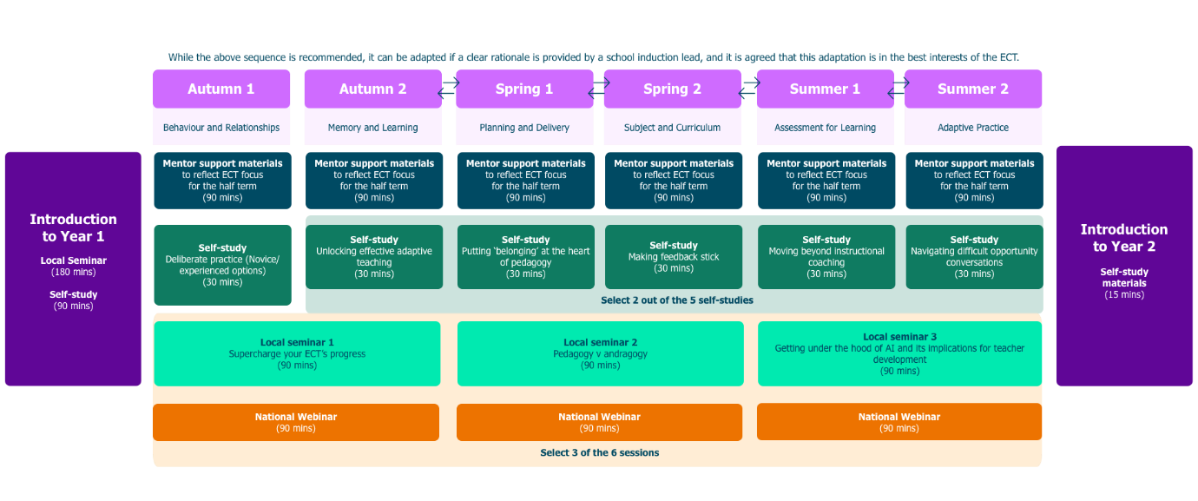
ECTs and mentors should meet each week for 60-minutes and are entitled to 10% timetable relief. Mentors should observe ECTs each week for 15 minutes (approximately) and will provide feedback using the 6-step feedback model focused on instructional coaching. See appendix 2. They will record their feedback and the ECT’s target on Prism.

Return to Content page

ECF Programme – Year 2
For existing ECTs and mentors on the NIoT programme, or those transferring to NIoT in their second year of the programme, they will be continuing on the ECF programme. You should inform your associate college or NIoT campus if an ECT or mentor is transferring to the programme from another lead provider e.g. if they have moved to your school in their second year. The ECF programme continues for two years for mentors, they are required to engage and entitled to this training if they are funded to do so.
In year 2 of the programme, ECTs and mentors should meet once per fortnight for an hour (or equivalent) and are entitled to 5% timetable relief. Mentors should observe ECTs each fortnight for 15 minutes (approximately) and, as with year 1, they will use the 6-step feedback model, instructional coaching and record their feedback and the ECT’s fortnightly target on Prism.
The Year 2 programme is outlined below; please note that the half-termly structure is different to the ECTP Year 1 programme detailed above.
Year 2 Programme content - Early Career Teachers

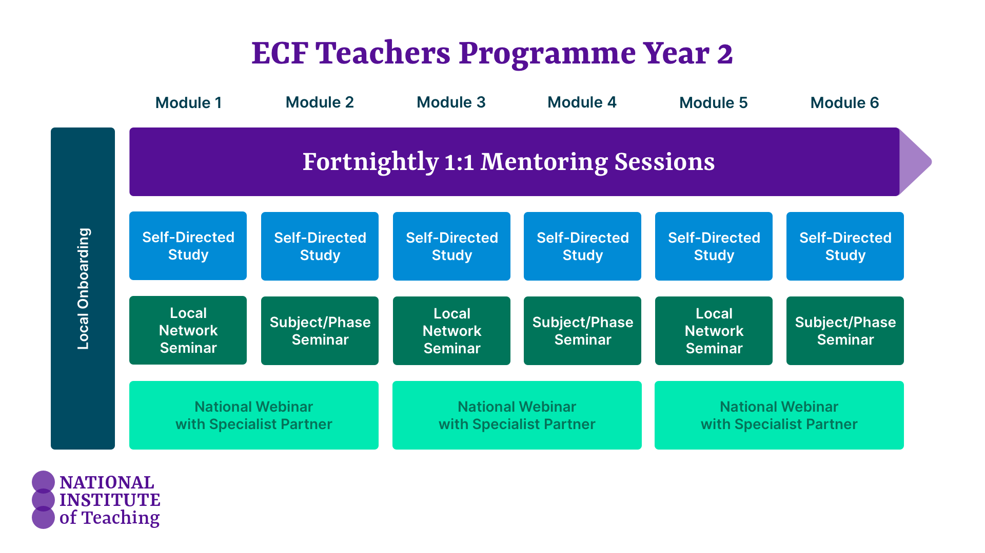
As with the ECTP, everything the ECT does is underpinned by the support and contextualisation provided by their mentor. The ECT still has self-study to complete, however the structure of this is slightly different in year 2 of the ECF.

The programme for year two will build on that of year one, with one area addressed each half term:
- Behaviour
- How pupils learn
- Classroom practice
- Assessment
- Adaptive teaching
- Subject and curriculum
Materials have been designed to ensure that ECTs revisit key concepts and practices from both their initial teacher training and the first year of the ECF programme, using both diagnostic approaches and reflection to ensure that the content you are engaging with is most useful to your developing practice as a teacher.

Year 2 Onboarding
ECTs will attend a three-hour in-person local seminar where they will:
- review the ECT programme structure for year two in depth
- consider the role and responsibilities of a second year early career teacher
- understand what it means to make use of research evidence as they continue to develop teacher expertise
- explore the personal professional development model used by the NIoT’s ECF programme and
- consider how they will manage their own well-being as they continue to develop their career in teaching
- have the opportunity to network with peers
They will also complete an associated self-study on Prism.
Self-study materials
Self-study materials are designed to take 90 minutes over six weeks and are accessed via Prism. These do not need to be completed in one go to support ECTs in managing their time. However, they should complete the study within the first two weeks of the half-term to ensure they have sufficient time to implement the actions.

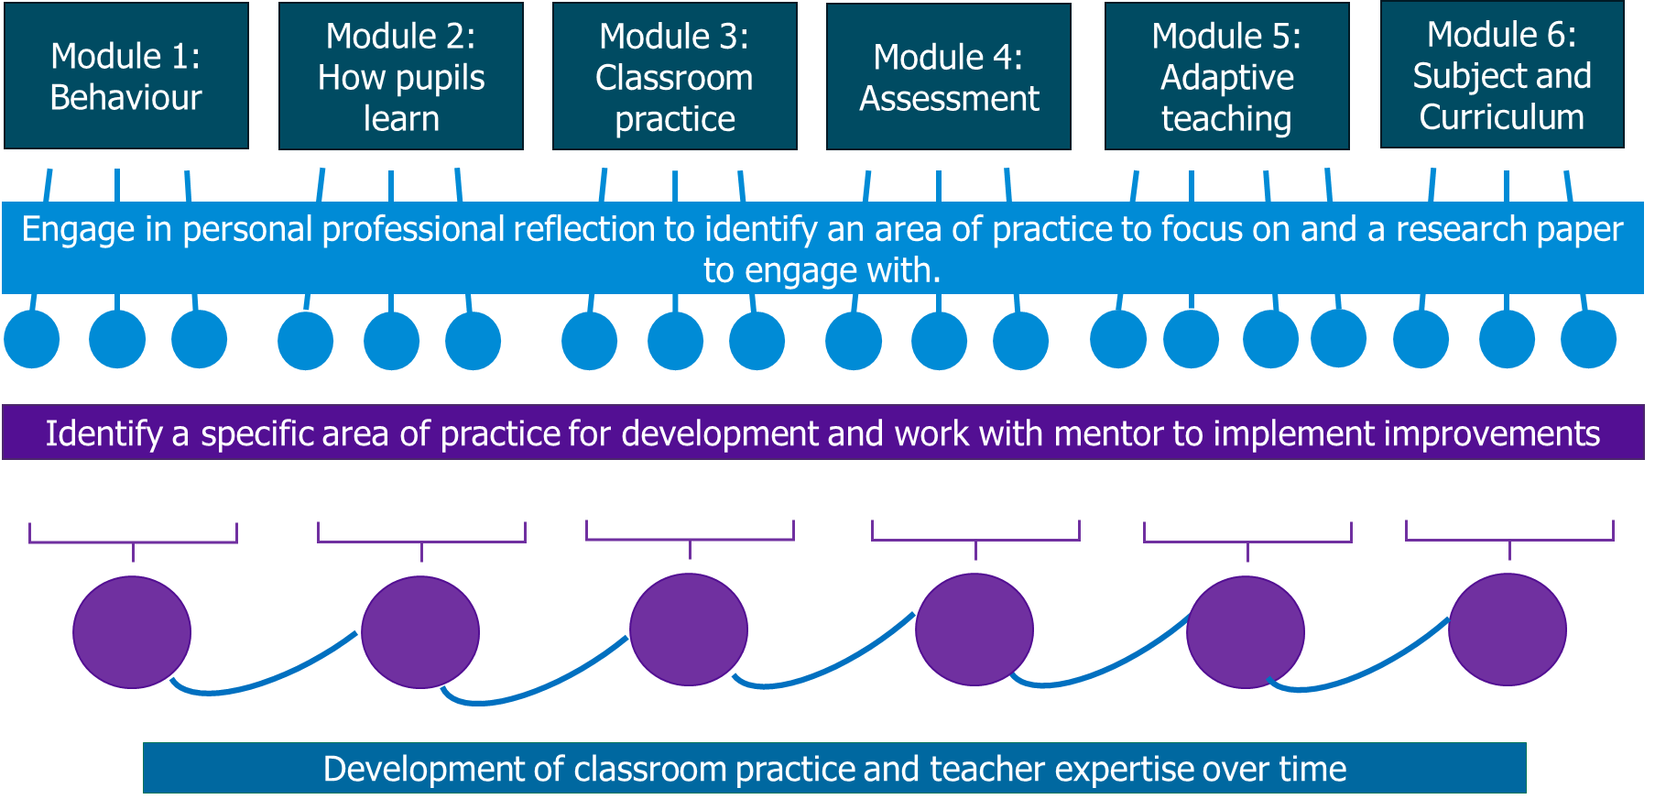

For each module (one per half term, as labelled above), ECTs will study three key ‘readings’. These are summaries of research from the ITTECF evidence base.
Having completed their self-study, ECTs will then complete a diagnostic assessment to identify their current development needs. This can be downloaded from Prism and completed by hand or in Word. ECTs should share their diagnostic assessment with their mentors.
With the support of their mentor, ECTs should explore and choose one of the readings to focus on more closely for the remainder of the half term. They should use their diagnostic assessment to help guide their choice but ultimately they should choose the one which is most relevant, helpful or challenging for them at this point in their journey from novice to expertise.
With support from the mentor to contextualise this chosen evidence piece, the ECT will plan and implement (do) a strategy or approach in their classroom and assess its effectiveness, making tweaks as appropriate across the half term.
Observations should focus on this area and feedback be used to inform those tweaks so that ECTs develop and reflect on and review the impact and success of the implementation throughout the half term and especially in their final meeting of the half term.
This approach is designed to develop evidence-informed, confident practitioners who are able to respond to their pupils and their needs at that time. It helps connect research to practice and will guide their mentor meetings each half.
Meetings with the mentor (fortnightly) should be structured like this across a standard half term to support this implementation cycle:
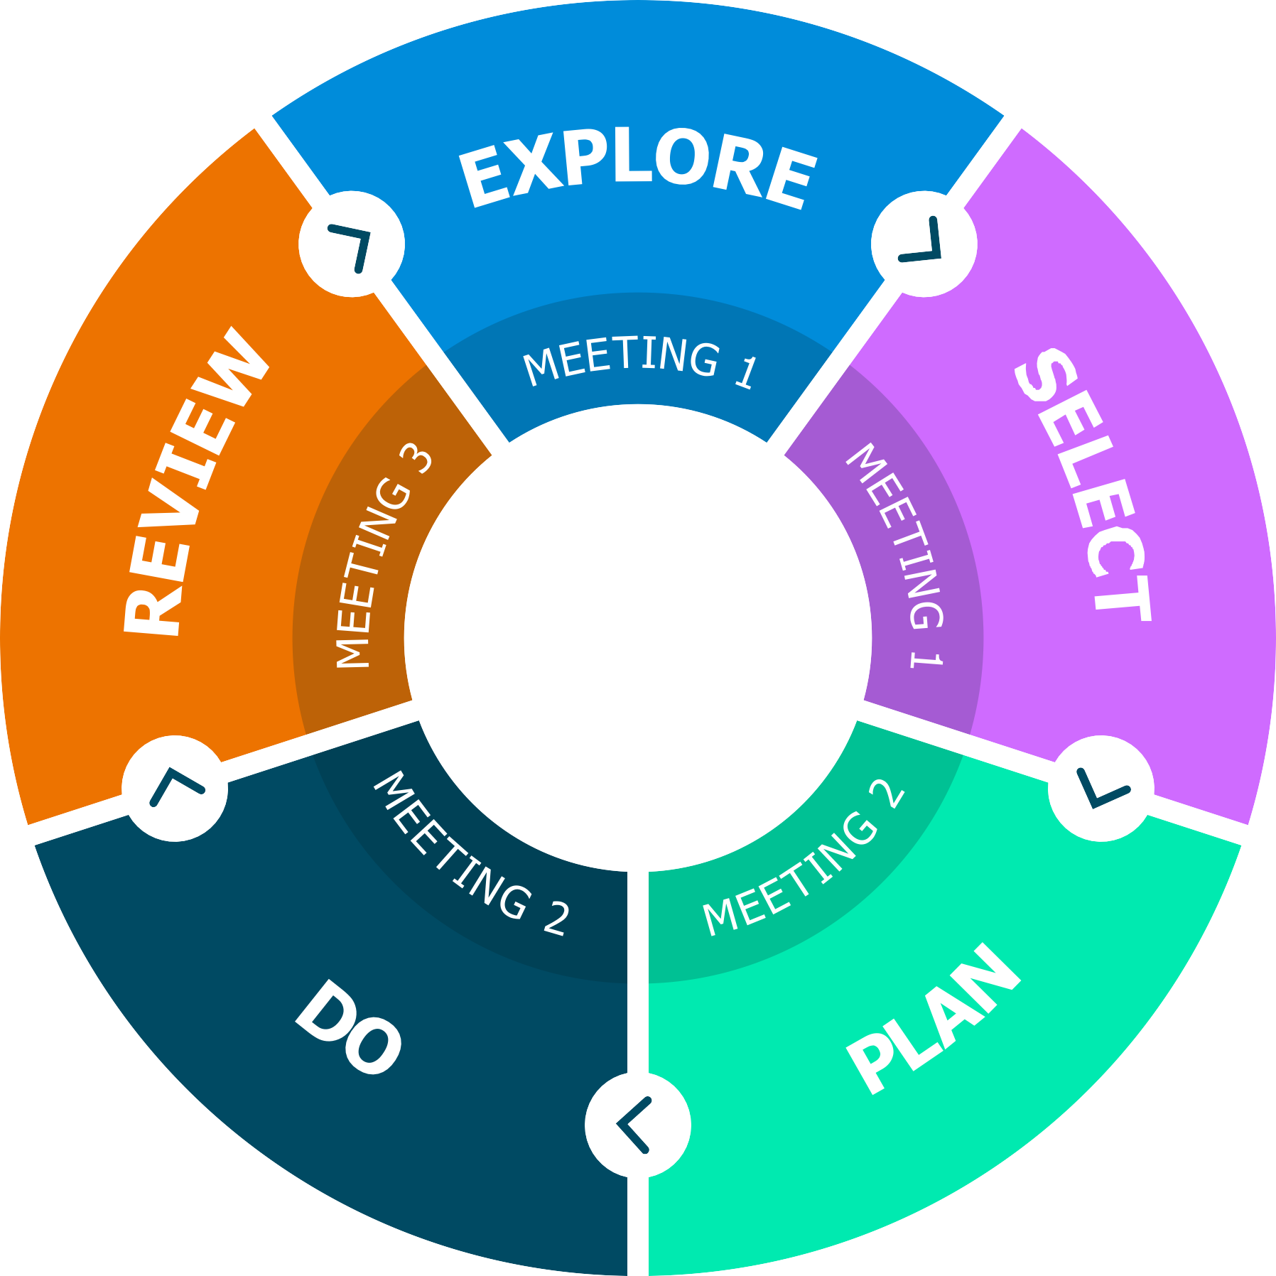

Live seminars
Throughout the second year the ECT will have half termly seminars, lasting 90 minutes, with expert, local facilitators who will reinforce learning, focusing on application in context using deliberate practice to allow ECTs to develop their mental models and gain feedback on their practice.
In year two, there is a greater emphasis on subject and phase specialism. Three of the six sessions will be subject/phase specific, led by experienced subject specialists to deepen ECTs’ expertise.
National Expert Webinars
As with year 1, ECTs will attend one webinar per term, hosted by leading experts in their fields. These last 90 minutes.
Induction tutors must ensure that ECTs attend these seminars and webinars and that for online webinars, they have appropriate technology to be able to actively participate (as per partnership agreements) in conversations and interactive elements of the sessions.
Return to Content page

Mentors in Year 2
Mentors remain a pivotal part of the year 2 programme whether they are funded on the ECF for a second year (and therefore also training on the programme) or a fully trained mentor who is continuing to support an ECT through their induction.
However, for those mentors who are training on the ECF programme already (meaning they commenced training prior to September 2025 and have not completed a full two years of ECF training yet), they have a suite of training of their own. This is aimed at ensuring they are confident in the evidence and its application but also in supporting less-experienced colleagues (ECTs specifically) to apply what they are learning to their school context.
The mentor programme in year 2 combines self-study summaries of ECT content (accessed on Prism) with live termly seminars and optional Nation Expert Webinars to network with other mentors and practice their mentoring skills with both peer and expert facilitator support. Attending these will develop their own skill and expertise as well as learning more about what their ECT is doing on their programme.
Whilst seminars for mentors focus on the ECT readings, they specifically do so from the perspective of a mentor who is supporting an ECT to apply and reflect in context; using the implementation cycles above.
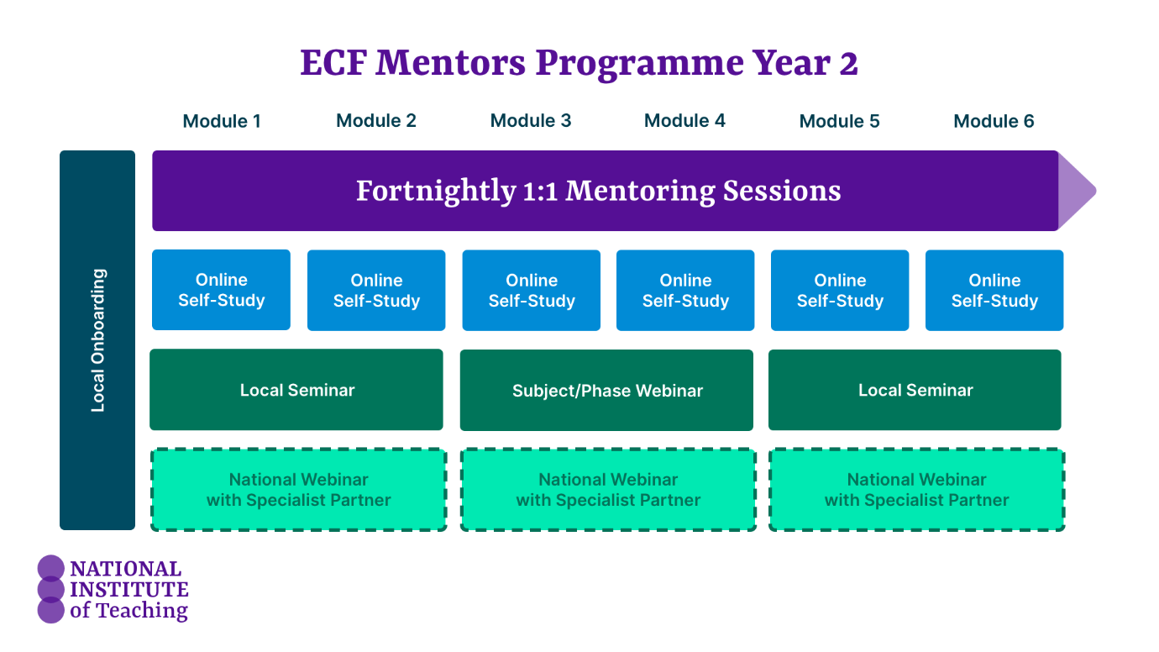

Return to Content page

Time commitment for the 2025-26 programme (Year 1 and 2)
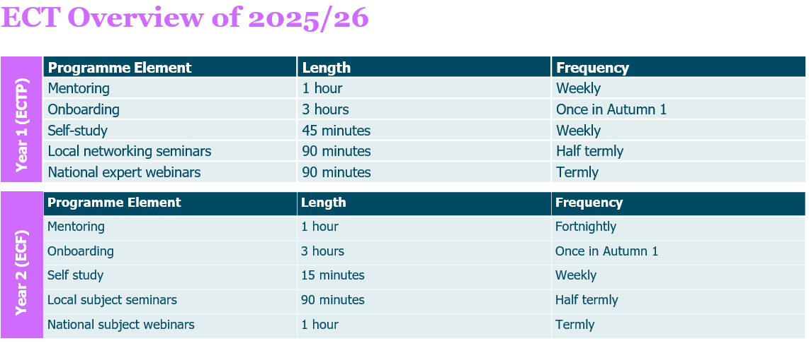
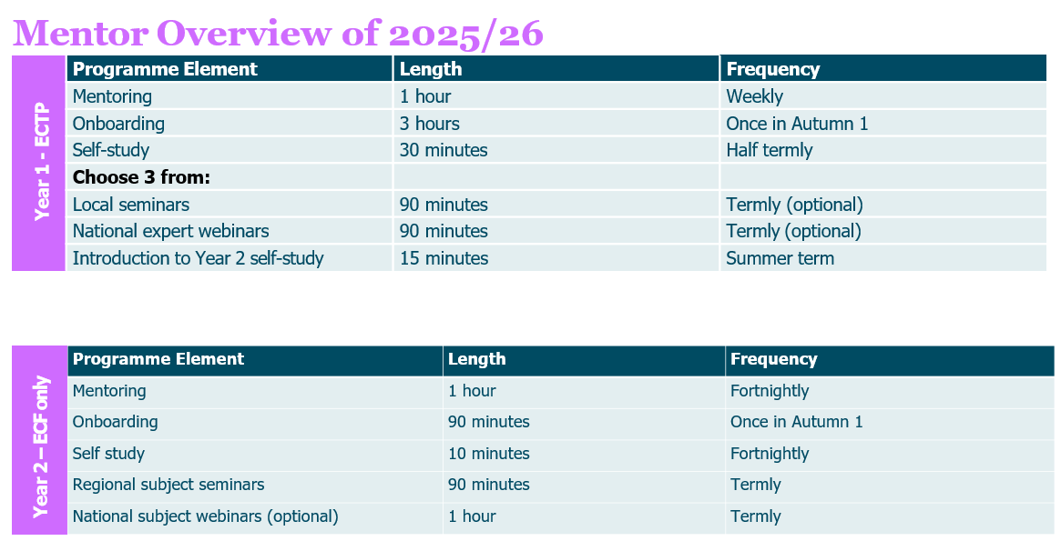

Return to Content page

On-line learning management system – Prism
Our learning management system (LMS) is called Prism.
As an induction tutor it will ensure you have clear insights into how the programme is going for your participants including self-study, live session attendance and mentor meetings. As well as oversight of targets which you can zoom in on and find out more about what your ECTs and mentors are working on and look at the quality of feedback shared.

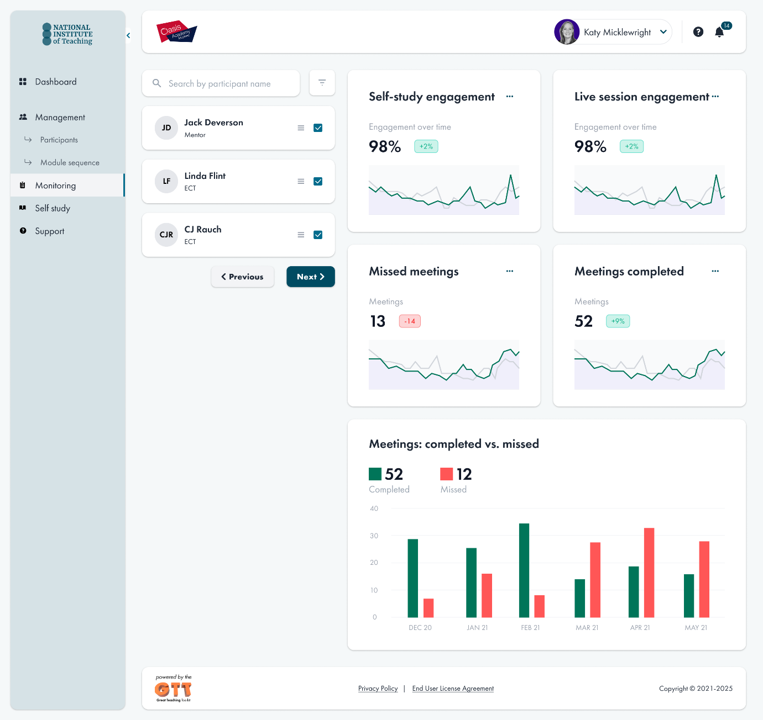
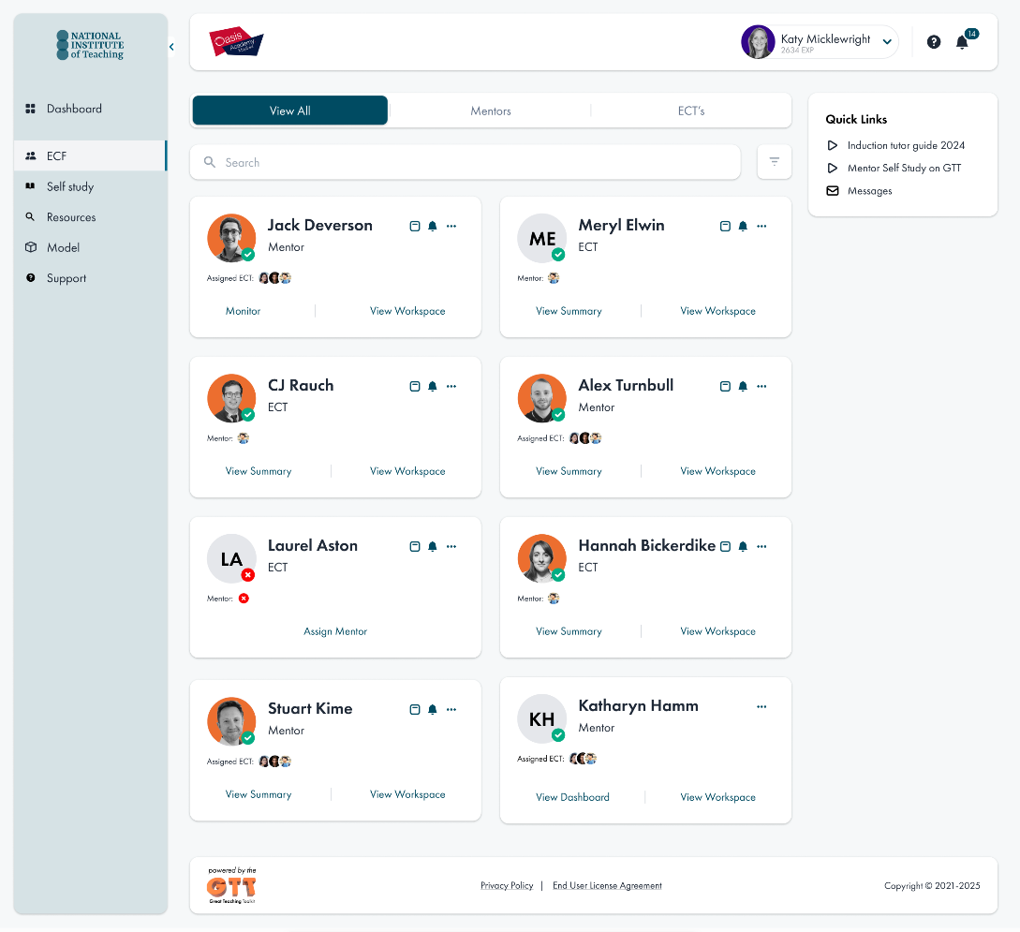
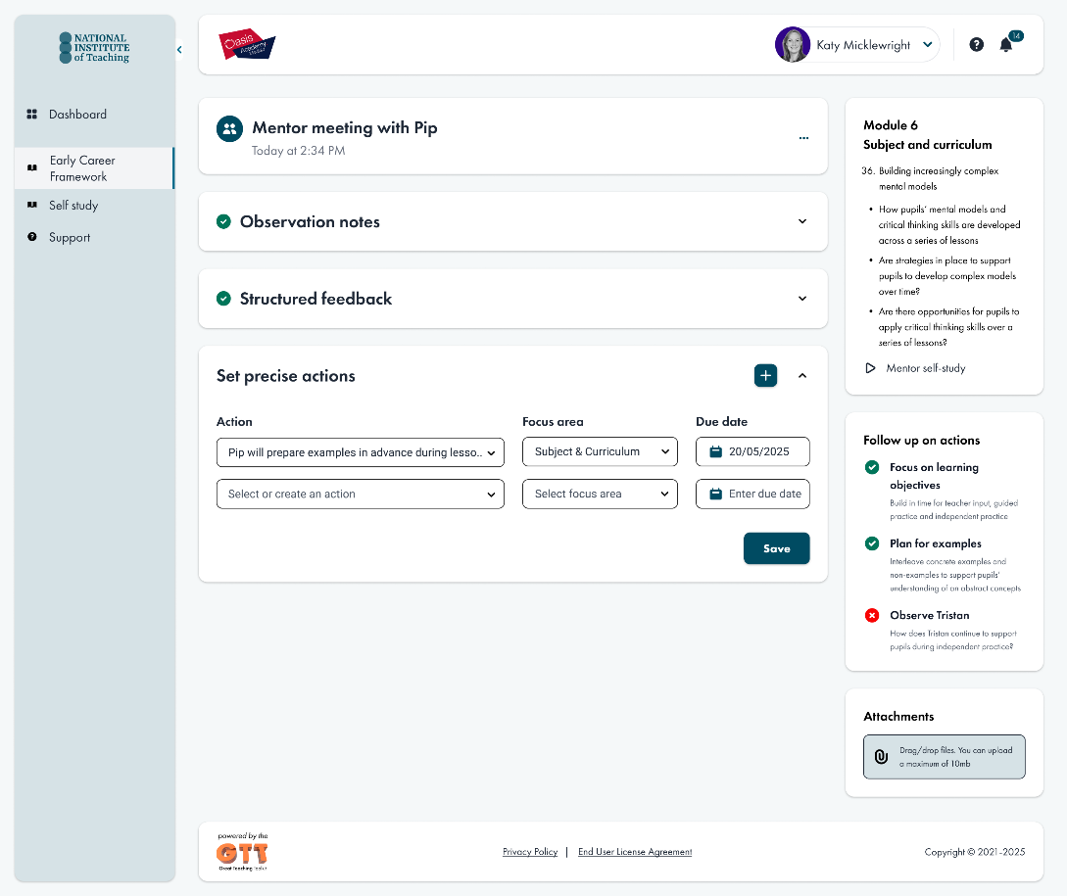

Return to Content page
Well-being tool
We are proud of our well-being tool which is designed to gather diagnostic responses on the well-being of ECTs throughout their two-year ECTE. This tool aims to enhance the overall programme experience for all participants within the National Institute of Teaching.
ECTs will access this via their account on Prism and it will be available for them to access 24/7 as often as they like. It only takes a few minutes for them to complete a diagnostic and the results will be shared with their mentors enabling them to provide additional support where necessary.

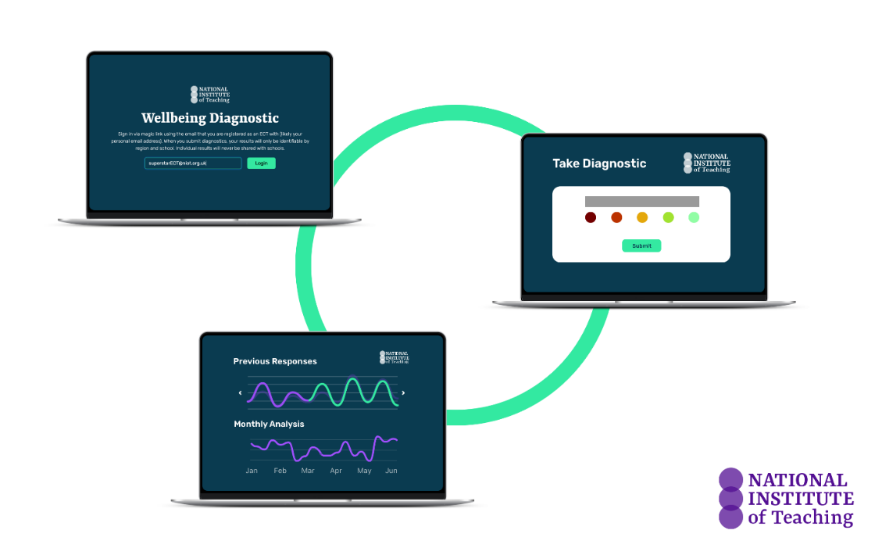

Return to Content page

Induction Tutor role and responsibilities
The role of the induction tutor is crucial to ensuring that ECTs make great progress and feel confident in their teaching as they progress through their induction. Positive management of wellbeing and workload of ECTs and mentors makes a huge difference to their potential retention in your school and as a teacher. The role of the induction tutor is to both enable and monitor this progress throughout the two-year programme. Below is some guidance on doing so which we hope you’ll find helpful. Thank you for the amazing job you do for your ECTs and mentors.
This video below is a general induction tutor briefing for the programme led by Katy Micklewright, the Head of ECF and Rosie Jonas, Lead Writer for NIoT, which may be helpful to watch alongside this handbook.
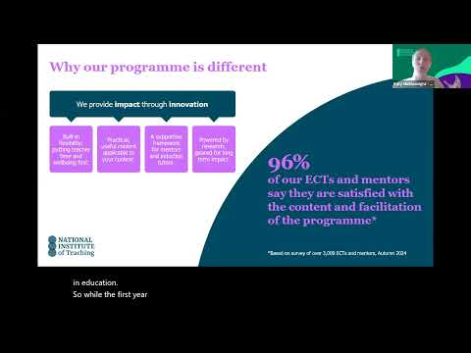
Click to play video: Induction Tutor briefing

Whilst your headteacher or principal has overall responsibility for the early career teacher entitlement (ECTE) in your school. The ECTE should form part of a wider culture of continuing professional development for school staff.
The induction tutor is a pivotal point of contact and person who is able to support both ECTs and mentors throughout the induction period including specific responsibilities detailed below; the induction tutor should not be the same person as the mentor.

Induction tutors should:
- Register ECTs and mentors; this is a three-part process; further detail and guidance from NIOT can be found here for 2025: Induction Tutor Guide to Registration
- Assign appropriate mentors for their ECTs E.g. someone experienced and expert (ideally in closely linked subject or phase), someone who is motivated to do the role and has the time to support the ECT well.
- Organise ECT progress reviews in line with your appropriate body’s requirements and the Teacher Standards
- Ensure ECTs and mentors know about their entitlements and responsibilities
- Ensure that DfE, NIoT and Appropriate Bodies are kept up to date at all times about changes to your school’s ECF or ECTE
- Support ECTs and mentors by ensuring they have the time, tools and support needed to engage fully in all elements of the ECF or ECTP. This may, for instance, include ensuring that their time for the programme is protected or that they are able to complete observation and feedback.
- Monitor and follow-up on engagement in self-study, attendance at seminars and in mentor meetings throughout the programme
- Be able to recognise when action is required if an ECT is having difficulties for any reason and support with this
- Promote the ECF/ECTP within the school to raise awareness of ECTs and mentors' work.
- Periodically attend ECT and Mentor meetings to assess feedback effectiveness in your school.
- Use the ECF to enhance other CPD opportunities in the school.
- Guide discussions on development during and after the program to foster retention.
You can find out more about setting up ECTE here: Set up and manage the early career teacher entitlement - GOV.UK

Return to Content page

Funding
The changes to ECT entitlement mean it is important that induction tutors understand how this affects the school and the training for mentors and ECTs.
There are some key changes to mentor funding for the ECT programme from September 2025:
- Mentors are only funded to train for one year
- Mentors will not be funded if already fully trained on ITT (with NIoT) or ECF (with any provider). Known as ‘fully trained’ or ‘unfunded’ in different cases.
You can read more here: https://www.gov.uk/guidance/funding-and-eligibility-for-ecf-based-training and you can find out whether your mentors are funded via your DfE portal.
Our materials for mentors will still be available for all mentors in both Years 1 and 2 to help them support their ECTs and plan their meetings.

Return to Content page

Key terminology
Early Career Framework (ECF): Replaced Newly Qualified Teacher (NQT) induction in 2021 to enhance career retention. A two-year statutory programme providing core evidence-based training for Early Career Teachers (ECTs) and their Mentors. ECF includes self-study and live sessions, crucial for accessing funding.
Early Career Teacher Programme (ECTP) or Entitlement (ECTE): Replaces ECF from September 2025 onwards. You can read more about the it here.
Lead Provider: National Institute of Teaching (NIOT). Responsible for design and delivery of ECF/ECTP programmes in partnership with local associate colleges and campuses, who contextualise learning for participants to apply effectively in schools.
Delivery Partner/Associate College/Regional Campus: Local organisations collaborating with NIOT to deliver live sessions tailored to ECTs and mentors, utilising their local knowledge for effective support.
Appropriate Body (AB): Organisation to whom termly reviews of ECTs are submitted for progress assessments. An independent body, ABs address concerns about ECT progress, agreeing on extended or reduced inductions and ensuring adequate support for ECTs and mentors.
Funded or fully trained Mentors: Funded mentors are those who are taking part in the programme because they have not yet completed a total of 6 full terms of ECF Mentor induction programme yet. Fully Trained (completed) mentors have completed 6 terms (on any lead provider’s programme) and thus are no longer required to attend live sessions or complete self-study for their own programme; they will no longer be funded to complete the ECTP training. They must still support the ECT in the same way as funded mentors though and are likely to benefit from completing induction training.

Return to Content page

To do checklist
You may find this checklist useful to prepare for the start of the year.
Task | Tick when done
Register ECTs and mentors with the DfE
Register ECTs and mentors with NIoT
Register ECTs with Appropriate Body
Assign ECTs to an appropriate mentor
Check if your mentors are funded
Choose the sequence of modules (Y1) for your school and confirm on Prism
Oversee timetable planning for mentors and ECTs ensuring regular cover is in place for meetings and observations
Ensure you, ECTs and mentors have login details for Prism
Add your own tasks
Appendix 1
Modules and associated self-studies
Module | Elective self-studies in this module
Behaviour and relationships | 1 | Communicating belief in pupils' academic potential
Behaviour and relationships | 2 | Establishing effective routines and expectations
Behaviour and relationships | 3 | Creating a positive, predictable, and safe learning environment
Behaviour and relationships | 4 | Building effective relationships
Behaviour and relationships | 5 | Motivating pupils
Memory and learning | 1 | How the memory works
Memory and learning | 2 | The role of pupils’ prior knowledge
Memory and learning | 3 | Managing cognitive load
Memory and learning | 4 | Understanding and addressing pupil misconceptions
Memory and learning | 5 | Retrieval, revisiting and reviewing information
Planning and delivery | 1 | Explanations, modelling and examples
Planning and delivery | 2 | Scaffolding and increasing challenge
Planning and delivery | 3 | Planning effective practice, including homework
Planning and delivery | 4 | Questioning as an essential tool for teachers
Planning and delivery | 5 | Fostering classroom talk and peer collaboration
Subject and curriculum | 1 | Delivering a carefully sequenced curriculum
Subject and curriculum | 2 | Anticipating misconceptions
Subject and curriculum | 3 | Building increasingly complex mental models
Subject and curriculum | 4 | Developing early literacy
Subject and curriculum | 5 | Enhancing all pupils' literacy
Assessment for learning | 1 | Designing effective assessment
Assessment for learning | 2 | Checking prior knowledge and understanding
Assessment for learning | 3 | Providing high-quality feedback
Assessment for learning | 4 | Making marking and feedback manageable
Assessment for learning | 5 | Developing your practice in relation to assessment and feedback
Adaptive practice | 1 | Understanding different pupil needs
Adaptive practice | 2 | Providing opportunities for all pupils to succeed
Adaptive practice | 3 | Meeting individual needs without creating unnecessary workload
Adaptive practice | 4 | Effective grouping and deployment of teaching assistants (TAs)
Adaptive practice | 5 | Developing your knowledge in special educational needs and disabilities (SEND)

Return to Modules overview

Return to Content page

Appendix 2
The National Institute of Teaching uses the six-step observation and feedback model based on the work of Bambrick-Santoyo (2016).
This six-step observation and feedback model supports mentors to:
- Praise and recognise strengths: Acknowledge where the ECT has effectively planned or implemented actions from prior observations.

- Probe and identify areas for development: Using evidence from the observation, mentors engage in a dialogue with ECTs to identify possible development areas in their practice.

- Set precise actions: Focusing on the highest-leverage granular element of practice linked to the area identified for development.

- Plan together how to apply the action: Mentors work with the ECT to plan when and how the action step will be used in an upcoming lesson.

- Practice how it will be embedded: Using our deliberate practice approach, mentors will model or share an example of effective practice. ECTs will then practice, receiving feedback from their mentor, until they are confident and ready to apply the action in their own classroom or setting.

- Arrange a follow-up observation session: Organise a further opportunity to observe the ECT implementing the agreed action with follow-up feedback.

Return to Content page

