
ECT Programme Handbook for mentors
2026-27
This handbook is for those who mentor early career teachers in schools working with the National Institute of Teaching and their Associate Colleges.







Introduction
Welcome to this mentor handbook for the Early Career Teacher (ECT) Programme from the National Institute of Teaching. It includes information to support mentors working with ECTs in year 1 and year 2 of the programme. Please navigate to the relevant sections using the links in the content table below.

Content
The ECT Programme from the NIoT | Page 3
Roles and responsibilities | Page 6
ECT Programme - Year 1 | Page 8
ECT Programme – Year 2 | Page 15
Mentor Training Programme | Page 23
Time commitment for ECTs and Mentors | Page 25
Observation and feedback model | Page 27
Deliberate Practice | Page 29
On-line learning management system – Prism | Page 31
Wellbeing tool | Page 32
Key terminology | Page 33
Suggested actions | Page 34
References and further reading | Page 35
Appendix 1: Year 1 Modules and associated self-studies | Page 36
Appendix 2: Year 2 reading summaries and focus areas | Page 38
Appendix 3: Guidance on weekly meetings for ECTs in year 1 | Page 39
Appendix 4: Guidance for mentor meetings with ECTs in year 2 | Page 41
Appendix 5: Mentor Training Programme - self-study overview | Page 45
Appendix 6: The ITTECF and Teachers’ Standards | Page 46
Appendix 7: Flowchart to show mentor types and training required | Page 48
The Early Career Teacher Programme from the NIoT
Our Early Career Teacher programme is designed to be flexible, contextualised and respectful of teachers’ time, recognising that there is no one-size-fits-all approach to professional development.
It enables ECTs, mentors and school leaders to tailor learning through diagnostic-informed pathways, flexible module sequencing and locally delivered sessions that reflect regional contexts and challenges.
Our programme provides the opportunity for ECTs to:
- engage in a fully funded two-year programme designed to intentionally revisit learning from initial teacher training with the opportunity to apply practice​ in context;
- have ongoing support from a mentor who will help them adapt what they learn to their specific context;
- attend live seminars to engage in deliberate practice to develop their expertise;
- attend free webinars led by world-class experts in specific fields;
- develop relationships with a network of peers with the opportunity to share experiences or collaborate;
- access specialised support as required.
Through engaging with the ECT Mentor programme offered by the NIoT, you will have the opportunity to:
- access evidence-informed materials that are grounded in the most current research to support your ECT’s development;
- engage with self-study materials to enhance your own professional development as a mentor and coach;
- attend live seminars to and develop your expertise as a mentor and leader of teacher development;
- attend webinars to engage with world-class experts in specific fields;
- network with peers and develop opportunities for collaboration.
Programme modules
The programme has six modules. In both years of the programme, the modules are:
- Behaviour and Relationships
- Memory and Learning
- Planning and Delivery
- Subject and Curriculum
- Assessment for Learning
- Adaptive Practice
For full time early career teachers each module lasts a half term.
A flexible approach
The first module that all ECTs complete is ‘Behaviour and Relationships’. This will support them to establish a positive, structured learning environment that fosters pupil engagement, wellbeing, and academic success at the very start of the academic year.
Your school or trust have the option to follow a different order for the remaining 5 modules. This flexibility means that your ECT’s professional development can be closely aligned with the priorities of your school or trust, potentially increasing the impact of their training. Your support materials will align with your early career teacher’s sequence of learning.
Your Induction Tutor will confirm the sequence of study, and it will automatically appear in the correct order when you and your ECT log-in into our learning management system (LMS), Prism.
Developing inclusive practice
Inclusive practice promotes the high standards and fulfilment of potential for all pupils by removing barriers to learning and ensuring that pupils receive an education appropriate to their needs (EEF, n.d). For this reason, each module on the NIoT’s ECT programme will be also explored through the lens of inclusive practice, ensuring that ECTs consider strategies to meet the diverse needs of all pupils in every element of their training.
Scenario-based learning
The content of the ECT programme provides an opportunity for ECTs to reflect on their previous learning throughout their induction period. Throughout the programme, they will engage with different scenarios, allowing them to draw on their previous experience and apply their knowledge and skills in real-school contexts.
Flexibility in how you drop-in on your ECT
From September 2026, early career teachers will have the option to record their lessons via a new recording tool in Prism, our learning management system (LMS). ECTs will be able to share their recording with you, and this can be used in place of an in-person lesson drop in. You’ll also be able to record your own lessons to share models of effective practice with your ECT.
Listen to Katy Micklewright, Head of the ECT Programme at the NIoT, explain a bit more.
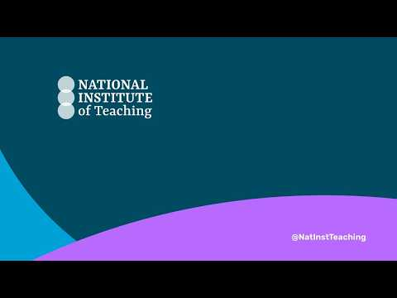

Click here to watch: Introduction to the recording tool for mentors

You can find out more about how use the recording tool in the lesson recording knowledge base.
Access to the recording tool is enabled by your induction tutor through a short onboarding process in PRISM. Once this is complete, you and your ECT will be able to use the tool.

Return to Content page

Roles and responsibilities
Mentor
Mentors are absolutely crucial to the development, confidence and future of the teachers they support through their training and early careers. The role you play should not be underestimated; thank you for all that you do for your ECTs now and as they progress through the programme.
This section will help outline how to have the best impact as an ECT mentor.
You will support your ECT throughout the final two years of the ITTECF entitlement, helping them apply and embed their learning.
You will meet and drop-in on your ECT weekly in year 1 and fortnightly in year 2, either in-person or by reviewing a Prism recording, and will also help them engage with programme materials and reflect on their practice and identify next steps for professional development. To do this well, ensure that you review the ECT support materials before feedback meetings.
A key part of your role is helping your ECT turn theory into practice in your setting through regular developmental discussions, using the NIoT observation and feedback model to support their growth.
You may also arrange opportunities for your ECT to observe experienced colleagues so they can see effective practice in context.
Your role also includes pastoral support, so you should monitor your ECT’s wellbeing by:
- including a wellbeing check-in in meetings and reflecting on insights from the NIoT wellbeing tool;
- signposting school wellbeing support where needed;
- ensuring your ECT receives their full non-contact time;
- sharing strategies for using time efficiently;
- using AOB in meetings to discuss upcoming school events or other support needs.
If you have concerns about your ECT, raise them with your Induction Tutor.

What training am I entitled to as a mentor?
Dependent on your experience and prior training as a mentor, you may be entitled to a programme of training and support to help you develop your skills and confidence as a teacher-educator and to best support your ECT. If you are a ‘training mentor’ your ECTP programme will be compulsory and inform funding that your school receives.
Use the flow chart in Appendix 7 to check which type of mentor you are and which programme is relevant for you. If you aren’t sure, check with your induction tutor in school.
Other key roles and responsibilities
The early career teacher entitlement also includes a number of other key support roles. As a mentor, you will work more closely with some than others, however they will all play a role to support your ECT’s induction process.
Induction tutor – This role has different responsibilities to a mentor. These include providing or coordinating the ECT induction programme and carrying out assessments and regular progress reviews. In some cases, for example in smaller schools or settings, the induction tutor may also be the mentor. Induction tutors will monitor the engagement of ECTs and mentors in the programme.
Headteacher or Principals – Headteachers and principals have various roles, many of which focus on ensuring compliance. They will oversee the overall induction, ensuring both the induction tutor and mentor have time and ability to support ECTs effectively. They are also responsible for appointing an appropriate body and making the recommendations to them regarding the ECT’s performance against the Teachers’ Standards.
Appropriate Body – The appropriate body is responsible for quality assurance within the induction process, ensuring that all aspects are correctly enacted. Your headteacher will report to them on your ECT’s progress and performance against the Teachers’ Standards to them throughout the two-year induction.
You can find out more about each role in Section 5 here: Induction for early career teachers (England) statutory guidance
ECT Entitlement
ECTs have specific entitlements to support their induction into the profession. One of these is a reduced timetable. In the first year, they must not teach more than 90% of the timetable of experienced teachers on the main pay range. In their second year on the programme this should be no more than 95% (or the equivalent for part-time ECTs).
This reduction is in addition to the standard planning, preparation and assessment (PPA) time all teachers receive. The allocated time off-timetable is specifically for them to engage in induction activities such as mentor meetings, self-study or observing colleagues.
Return to Content page

Early Career Teacher Programme - Year 1
Programme overview
Year 1 of the National Institute of Teaching’s Early Career Teacher Programme is designed to support teachers as they move from initial teacher training into their first year as qualified professionals. The programme explicitly builds on the knowledge and experiences ECTs bring from ITT, recognising that newly qualified teachers are no longer trainees, but still require structured, expert support as they take on full classroom responsibility.
Year 1 is designed to reduce unnecessary repetition while helping ECTs deepen and apply what they already know in their own classroom context. The curriculum draws on the ITTECF, supporting ECTs to revisit core principles—such as behaviour, learning, assessment and adaptive teaching—through a more applied and classroom-focused lens. This helps bridge the gap between theory encountered in training and the day-to-day realities of teaching practice.
Take a look at this short video overview:
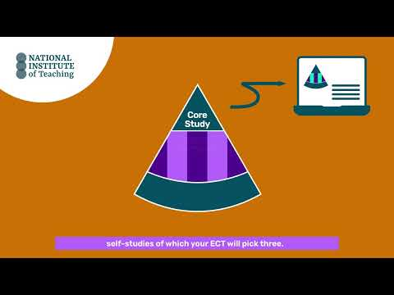
Click to watch: Introduction to year 1 ECT programme

Programme structure for ECTs in year 1
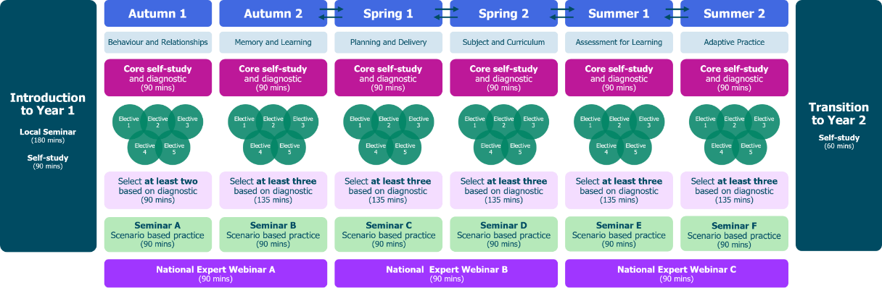

Let’s look at each of those components a bit more closely.
Each module is made up of one core self-study and 5 elective self-studies. The core self-study revisits the evidence and theory that the ECTs explored as an initial teacher trainee. A diagnostic activity will then guide them to select three further elective self-studies to complete.
The elective self-studies offer a personalised pathway of study that will support ECTs’ understanding of how to put the theory into action in their own classroom practice.
Core self-study
Early career teachers will complete one core self-study per module followed by a diagnostic reflection. Both of these will be accessed on Prism.
The core self-study acts a refresher to the knowledge ECTs will have gained in that specific element of teaching during their ITT. It will take ECTs around 60 minutes to complete and can be done in smaller chunks to help them manage their time.
Diagnostic
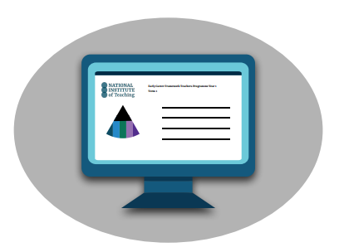
ECTs will complete one diagnostic for each module after they’ve read the related core-study. The diagnostic will take them approximately 30 minutes and they should complete it independently. Your ECT can share the feedback from the diagnostic with you during your first meeting.
There is no pass or fail - the diagnostic is designed as a guide or a ‘proxy’ to help you and your ECT identify specific areas for further development or enhancement within their current practice. The suggested recommendations the diagnostic produces simply support the start of a conversation between yourself and your ECT as to what electives could have the greatest impact on their personal development.
Elective self-studies
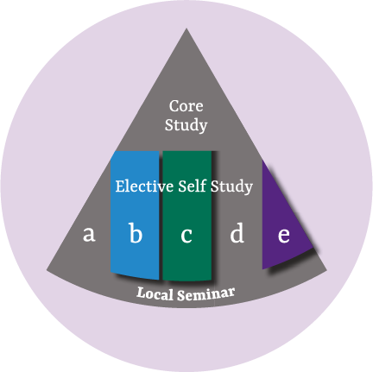
The feedback from the diagnostic, along with your ECT’s Career Entry Development Profile (CEDP) or other targets from their ITT, will guide your discussions as you identify together a focus for development within each module.
ECTs then complete three elective self-studies per module, each focused on a smaller part of the wider topic. In half-term 1, they complete two so they have more time to settle into the school year.
Each elective self-study takes about 45 minutes and can be spread across the half-term to help manage time and workload.
You can find the focus areas for each module in Appendix 1.
ECT seminars
Alongside self-study, ECTs attend half-termly local seminars led by experienced teachers and school leaders. These may be in person or online and give ECTs the chance to learn from others and network with peers.
Like the elective self-studies, seminars use scenario-based learning to help ECTs connect areas such as planning, assessment and behaviour into stronger classroom practice.
Here are the focus areas for seminars for year 1:
Autumn half-term 1 | Ensuring safe and predictable learning environments  ECTs consider the impact of the environment on pupils' learning and collaborate with their peers and expert facilitators to explore ways to ensure safe and predictable settings for all pupils.
Autumn half-term 2 | Planning effective lessons  Working with peers and expert facilitators, ECTs explore key strategies for structuring well-organised lessons, managing cognitive load, checking understanding, and using scaffolding effectively to meet the needs of all pupils.
Spring half-term 1 | Working in partnership with stakeholders  ECTs collaborate with peers and expert facilitators to explore strategies for establishing and maintaining effective relationships with colleagues, parents, and carers to ensure the needs of all pupils are met.
Spring half-term 2 | Checking prior knowledge and addressing misconceptions  ECTs consider the importance of prior knowledge in pupils' learning. Through collaboration with peers and expert facilitators, they explore formative assessment strategies to assess prior knowledge and approaches to address misconceptions.
Summer half-term 1 | Using assessment to inform teaching  Working with peers and expert facilitators, ECTs explore assessment strategies and approaches to bridge the gap between teaching and learning, adapting practices to effectively meet the needs of all pupils.
Summer half-term 2 | Integrating technology into teaching and learning  In an ever-changing technological landscape, ECTs collaborate with peers and mentors to explore how technology, informed by evidence, can be used judiciously to help pupils progress and enhance working practices.
All seminars are delivered in mixed cohorts in the first year of the programme.
National Expert Webinars
Our ECT programme also offers free termly National Expert Webinar Series with leading experts in their fields. These provide a great opportunity for ECTs to hear from a range of experts in pedagogy to support your own professional development.
New mentors have the option to join the National Expert Webinars as part of their training programme with the NIoT, however all mentors are welcome to join these too.
The webinars are 60 minutes long with a further 30 minutes for Q&A at the end and take place after the school day, typically between 3.45pm and 5.15pm.

Year 1 National Expert Webinars for 2026-27
Autumn Term | Mohammad Abdallah – Belonging and Mattering  ECTs will gain a sharper, research‑informed understanding of belonging and mattering using a new lens for interpreting pupil behaviour and engagement. They will come away with practical ideas they can begin applying immediately in their setting.
Spring Term  Option A | Alex Quigley – Embedding Literacy Across The Curriculum  A highly practical, research-informed webinar, focused on helping teachers support pupils to read, write, speak and think more effectively in every subject.
Option B – for mentors only | Rob Nash – Feedback Literacy  This webinar is designed intentionally to support mentors in their role. It will cover the following topics:  - Psychology behind giving and receiving feedback  - How to maximise feedback impact and efficacy from the perspective of the mentor and anyone they may be providing feedback too.  - Addressing why we sometimes don’t act on feedback or why feedback may not be received in the way in which it is intended.
Summer Term | Kate Jones – Retrieval and Memory  This National Expert webinar explores how memory works and what this means for effective classroom practice. Drawing on research ECTs will explore working memory, long-term memory and the learning process.  The seminar connects research evidence to practical classroom decisions, helping teachers think carefully about what pupils are thinking about during lessons and how this shapes long-term learning.

Here is an example of a typical half-term’s study for ECTs taken from Module C, Planning and Delivery.
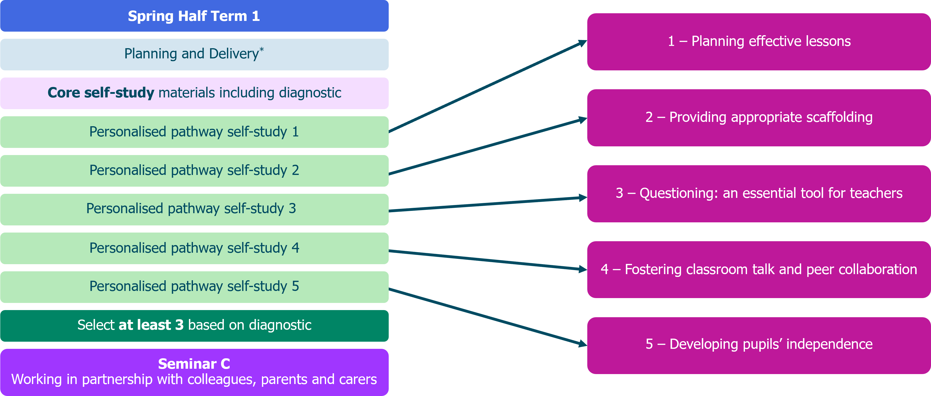
Mentor support for ECTs in year 1
Year 1 ECTs receive ongoing, structured support from mentors. Mentors play a crucial role in helping ECTs make sense of programme content, link it to their pupils and setting, and prioritise what will have the greatest impact. Regular mentor meetings provide protected time for focused professional dialogue, reflection on practice and actionable next steps. The programme is designed so that mentor support continues as ECTs begin their career as qualified teachers, rather than dropping away after ITT.
The ECT and ECT mentor programmes are aligned to ensure there is seamless and consistent support for both mentor and mentee. For example, the online study for ECTs in the first module, Behaviour and Relationships, includes theory-based content on how to maintain high expectations in the classroom. This is mirrored in the support material for mentors in which a summary of the learning is provided. This will help you to facilitate discussions and bridge theory into practice for your ECT.
Lesson drop-ins
Weekly interactions with your ECT in Year 1 should include a lesson drop-in of no more than 15 minutes where you will observe your ECT’s practice. This can be done, either in person or by watching a recording of the lesson shared by your ECT on Prism. The focus of each drop-in should be a current weekly action for your ECT.
Mentor meetings
Each drop-in is followed by a 45-60-minute follow up meeting using the National Institute of Teaching’s Observation and Feedback model, along with the ECT Support Materials, to support your ECT in developing their practice. This meeting should be recorded on Prism so that both you and your ECT can view the feedback during your meeting.
Click this link to watch a video of how to create a meeting in Prism. How do I complete a mentor meeting?
ECT support materials
Each module includes materials designed to help mentors support their ECT’s development.
These short-read summaries of the ECT materials will take up to 90 minutes per half term (or 15 minutes per week) to complete and will be found on Prism. You don’t need to read them all once and can come back to them at any time.
The summaries correspond to the ECTs’ half termly core and elective self-studies. This will include the ‘active ingredients’ (the components) that make particular elements of practice effective. This will help to create a clear set of criteria for your ECT to work towards and guide your feedback.
The mentor self-studies also include suggested actions that your ECT could take to implement the theory into their own practice in the following week. Each of these self-studies also includes a framework with prompts to help you plan your weekly ECT meeting. We recommend that you review the content of the relevant section in advance of your weekly lesson drop-in and meeting.
Here is what a typical half-term might look like for you, but this may vary depending on your own context.
Week 1 | Week 2 | Week 3 | Week 4 | Week 5 | Week 6
Read the Core self-study ECT support materials (15 mins)  Lesson drop-in or review recording on Prism (up to 15 mins)  Mentor meeting (45 mins-1hr) | Read Elective ECT support materials (15 mins)  Lesson drop-in or review recording on Prism (up to 15 mins)  Mentor meeting (45 mins-1hr) | Lesson drop-in or review recording on Prism (up to 15 mins)  Mentor meeting (45 mins-1hr) | Read ECT Support materials (15 mins)  Lesson drop-in or review recording on Prism (up to 15 mins)  Mentor meeting (45 mins-1hr) | Lesson drop-in or review recording on Prism (up to 15 mins)  Mentor meeting (45 mins-1hr) | Read ECT support materials (15 mins)  Lesson drop-in or review recording on Prism (up to 15 mins)  Mentor meeting (45 mins-1hr)

You can see more about how your time will be spent here.
Return to Content page
Early Career Teacher Programme Year 2
Programme overview
Year 2 of the National Institute of Teaching’s ECT Programme is designed to consolidate and extend the foundations established during ITT and Year 1, as ECTs continue to develop confidence, consistency and professional judgement in their classroom practice. While Year 1 focuses on supporting ECTs through the transition into full teaching responsibility, Year 2 places greater emphasis on deepening critical engagement with research and understand how to contextualise the theory.
ECTs revisit core areas, such as behaviour and relationships and classroom practice, but with a stronger focus on strategic application and impact over time. Content is pitched to recognise that ECTs are now more secure in day-to-day routines and ready to think more deliberately about how their practice affects pupil outcomes across sequences of learning and different contexts.
Programme structure for ECTs in year 2
Watch this video to hear more about the programme structure:
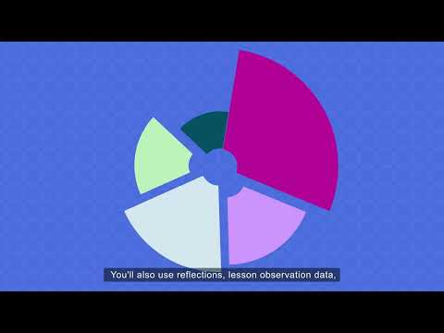
Click here to watch: Introduction to Year 2

Programme structure for ECTs in year 2

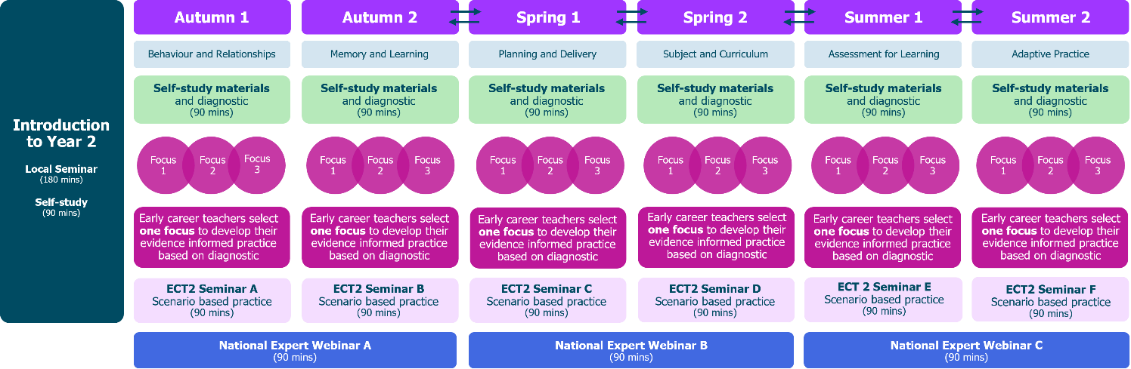

Let’s look at the different components of the programme more closely.
Diagnostic
At the start of every module in year 2, ECTs will complete a diagnostic on Prism. The diagnostic will take them approximately 30 minutes and they should complete it independently. Your ECT can share the feedback from the diagnostic with you.
As with year 1, there is no pass or fail - the diagnostic is designed as a guide or a ‘proxy’ to help you and your ECT identify specific areas for further development or enhancement within their current practice.

ECT self-study
In year 2, ECTs will complete one 60-minute self-study per half-term. ECTs will work through this on Prism.
The self-study is in two sections:
Section 1
ECTs read three short summaries of research papers relating to the module, for example, assessment. They then complete a short reflection task related to each of the summaries and their current teaching practice. This takes around 20 minutes.
In their first mentor meeting of the half-term, they will then identify their area for development with you. This will guide their personalised pathway for the rest of the self-study. You’ll read more about the focus of each meeting a little later.
Section 2
ECTs will critically engage with the research paper related to their focus for the half-term. The materials provide an opportunity for them to:
- consider what the research tells us about teaching and improving practice;
- reflect on the limitations of the evidence;
- see phase-specific examples of how the theory might look in practice;
- explore how the research supports their own development as a teacher; and
- plan how it will guide their personal cycle of improvement this half-term.
This section will take around 35-40 minutes to complete.
Here is an overview of the modules and how the self-study process works in year 2.

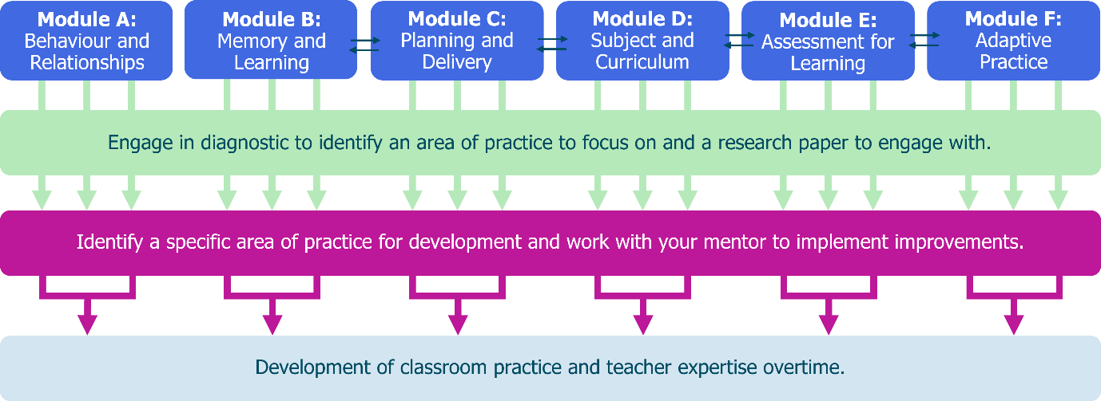
For an overview of the readings in year 2, see Appendix 2
ECT Seminars
ECTs have six seminars in year 2 – one per half term. These last 90 minutes and may be delivered in person or online. Three of the seminars are designed to be delivered in subject or phase specific groups.
Here are the focus areas for seminars for year 2:
Autumn half-term 1 | Embedding high expectations, expectancies and routines in the classroom
Autumn half-term 2  Subject/phase | Enhancing instructional design through understanding how the memory works
Spring half-term 1 | Understanding how to support pupils to plan and deliver effective lessons
Spring half-term 2 Subject/phase | The importance of subject knowledge to support all pupils' learning
Summer half-term 1  Subject/phase | Using assessment to move learning forward
Summer half-term 2 | Adaptive teaching strategies to support all pupils to make progress

National Expert Webinars
In year 2 of the ECT programme, ECTs will attend webinars, as they did in Year 1 with different experts in their field.
Year 2 National Expert Webinars for 2026-27
Autumn Term | Bradley Busch – Evidence Informed Wisdom  ECTs will look at the important role that research plays in informing our judgement, along with why research by itself is not sufficient. They will also look at different types of research, how to analyse it critically, the role that context plays in applying research and the importance of developing experience and expertise.
Spring Term | Sonia Thomson – Effective Curriculum Design  The primary aim of this webinar is to provoke thought and stimulate conversation around effective curriculum design. ECTs will reflect on their own practices and consider new strategies for enhancing their educational environments. This includes consideration of the importance of work with other adults.  ECTs will consider proactive approaches they could take to create an inclusive environment and positive culture, both inside and outside of their classrooms, including for pupils and families living with disadvantage; pupils and families who have SEND and pupils and families who have English as an additional language.
Summer Term | National Expert Webinar Optional Menu  In the final term of their programme, ECT2s will be offered a choice of different webinars to attend based on their current interests and needs. The sessions offered will be informed by current issues facing the education sector. Likely to include AI and digital misinformation, teacher and pupil wellbeing, SEND, but this will be informed by the feedback and needs of ECTs in the current academic year.

The Personal Professional Development Cycle
In year 2, the weekly actions are replaced by the Personal Professional Development Cycle. Once the focus area for the half-term has been identified, you and your ECT will devise a plan of how to implement this improvement(s) into their teaching practice, within your context using the cycle as a framework.
Each mentor meeting of the half-term has a specific focus that will help put the plan into action, ensuring ECTs are supported every step of the way. You’ll read more about that in the next section.
This approach enables ECTs to take more of a lead in their personal development journey. The model enables mentors to provide support or stretch their ECTs depending on their individual needs.
Watch this video to find out more about how you will use it to support your early career teacher.
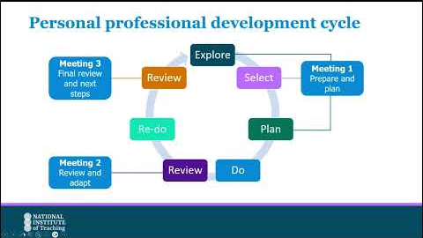
Click here to watch: Personal professional development cycle for mentors
Mentor support for ECTs in year 2
Year 2 ECTs continue to receive ongoing, structured support from mentors as they embed their learning into their everyday practice.
Lesson drop-ins
You’ll conduct fortnightly lesson drop-ins of no more than 15 minutes where you will observe your ECT’s practice. Again, this can be done either in person or by watching a recording of the lesson shared by your ECT on Prism.
We recommend that the first drop-in of the half-term should take place in week 1. This will help you identify any possible gaps in practice and feed into your first meeting with your ECT where you will plan their actions for the half-term using the Personal Professional Development Cycle.
Lesson drop-ins should be followed by a follow up discussion lasting up to one hour. In year 2, you will continue to use NIoT’s Observation and Feedback model.
Mentor meetings
In year 2, meetings are held fortnightly and each meeting has a specific focus linked closely to the Personal Professional Development Cycle. The fortnightly templates for this cycle can be found in Prism within the mentor meetings area.
This meeting should be recorded on Prism so that both you and your ECT can view the feedback during your meeting.
In year 2 of the programme, each meeting has a different focus as outlined below:

Meeting 1 Prepare and Plan (Week 1)
- Conducted in the first week of the half-term, ideally, ECTs meet with their mentor to engage in the explore, select and plan aspect of the professional development model
- Explore the specific element within that domain that they wish to improve based on their reflections, diagnostic feedback and review any lesson drop-in data or current targets.
- Mentors will support ECTs to select the specific element from three self-studies on Prism, they will focus on improving in this area for the rest of the half term, using the theory in their self-study to guide this process.
- Together you will devise a plan of how to implement this improvement(s) into their teaching practice, within their unique context using the Personal Professional Development Cycle as a framework.
- ECTs then put this into practice during the ‘do’ phase of the cycle. They will make minor adaptations and adjustments as they go, making notes to bring to their 2nd mentor meeting.

Meeting 2 Review and Adapt (Week 3)
- Here ECTs and mentors will review and reflect on the experience so far and consider any adaptions that have been made or need to be made to support all learners.
- They will consider how the experience so far aligns with what the evidence says and probe why things may look different.
- They will use the conversations in this meeting to then refine the ECT’s practice in the ‘re-do’ phase, continuing to gather data and reflections.

Meeting 3 Final review and next steps (Week 6)
- In the final meeting of the half term, mentors and ECTs review the experience as a whole to inform future adjustments and refinements in their teaching practice.
- Again, they will consider how far it aligned with the evidence and why they may have needed to make adjustments.

Click this link to watch a video of how to create a meeting in Prism. How do I complete a mentor meeting?
You can see a further guidance in Appendix 4.
ECT support materials
ECT support materials are a compulsory part of the programme for training mentors and are available to all mentors (training or not) to outline the ECT study, provide suggested action steps that can be implemented as part of the Personal Professional Development Cycle.
They also provide helpful guidance to help you prepare for each of your fortnightly meetings.
Here is what a typical half-term might look like:
Week 1 | Week 2 | Week 3 | Week 4 | Week 5 | Week 6
Lesson drop-in or review recording on Prism (up to 15 mins)  Mentor meeting 1: Prepare and Plan (45 mins-1hr) | Read ECT support materials (15 mins) | Lesson drop-in or review recording on Prism (up to 15 mins) | Mentor meeting 2: Review and adapt (45 mins-1hr) | Lesson drop-in or review recording on Prism (up to 15 mins) | Mentor meeting 3: Final Review (45 mins-1hr)
You can see more about how your time will be spent here.

Return to Content page

Mentor Training Programme
If you are a new mentor, then you will complete the National Institute of Teaching’s Mentor Training Programme. Find out whether you are a training or non-training mentor here
The mentor programme lasts one year and is aimed to develop mentors as teacher-educators, working not only with ECTs but with other colleagues to develop their practice. You must complete a minimum of 75% of the programme in order for your school to receive their funding if you are a training mentor.
Areas covered include the implications of AI in education, deepening understanding of adaptive teaching, exploring how to put belonging at the heart of teaching and considering the differences between pedagogy and andragogy.
The programme is made up of online study and local seminars. Take a look at the overview below:
Mentor Training Programme Overview

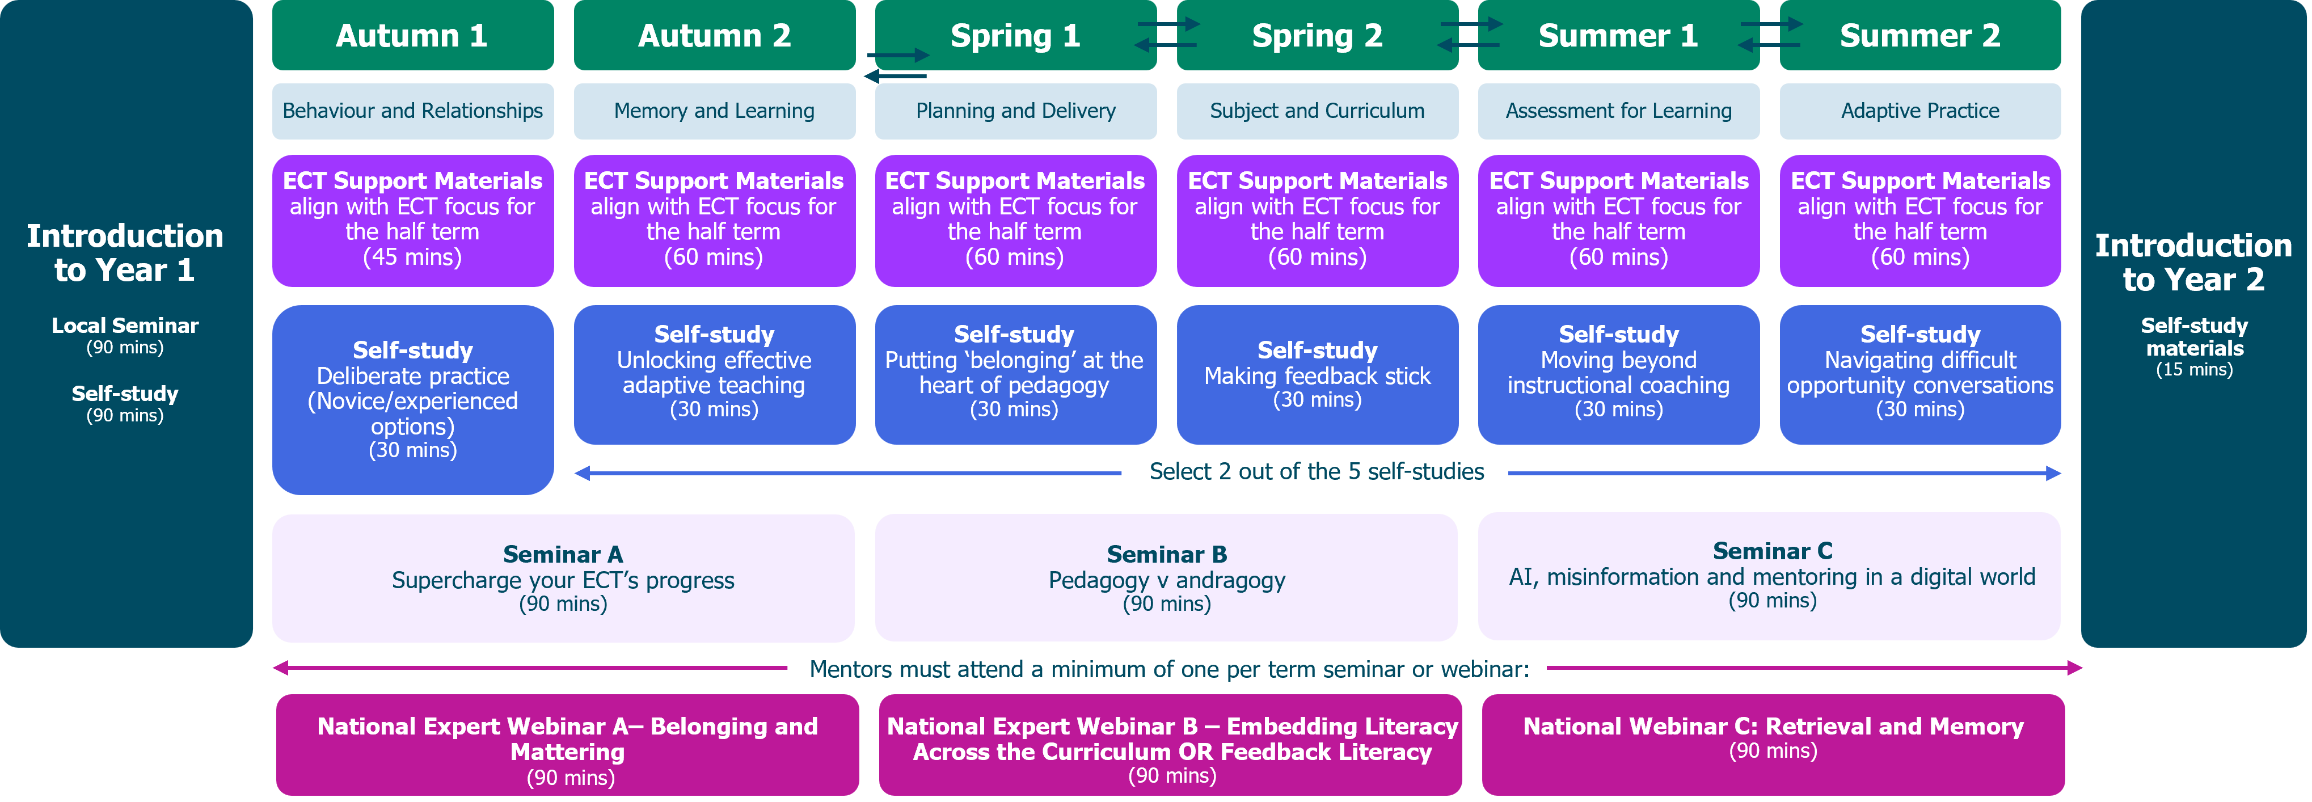
Introduction to the programme
The programme begins with a 90-minute online self-study on Prism. This can be completed in smaller sections to help manage your time. You’ll also have a 90-minute seminar, where you will learn more about your role and responsibilities as an ECT mentor; explore the observation and feedback model used in NIoT's ECT programme in more detail; practice applying your knowledge of this model; and learn more about how to support your ECT in managing their wellbeing.
Mentor self-study
You will complete one self-study per term, and these take around 30-minutes to complete. There is a choice of six different topics to choose from which allows you freedom to select the focus that most closely meets your current developmental needs. You can complete more if you wish.
You will start with the self-study on Deliberate Practice which is a cornerstone of all our programmes. Two options are available for you to choose from depending on your prior experience of Deliberate Practice: novice and expert.
For a summary of the Mentor Training Programme self-study topics click here.
Mentor synchronous study
You training includes synchronous seminars. These may be in-person or online and includes seminars and National Expert Webinars. You must attend one event per term, with the seminars being the priority.
Seminars
The programme includes three 90-minute seminars, all designed to develop your understanding, expertise and confidence in key areas of pedagogy in the sector. These are compulsory for training mentors. There is one seminar per term and the topics covered are:
- Seminar A - Supercharge your ECT’s progress
- You’ll collaborate with peers as you enhance your instructional coaching practices by effectively using the Observation and Feedback model to support ECT development.
- Seminar B – Pedagogy v Andragogy?
- You will work with peers to consider which principles are common to both teaching children and adults and how to navigate the challenges that andragogy may present.
- Seminar C – AI, misinformation and mentoring in a digital world
- Explore how AI and the wider online environment are shaping teacher development alongside the risks and challenges it brings.

National Expert Webinars
You will be invited to attend the same series of National Expert Webinars as your ECT. We also offer an expert webinar specifically for mentors in Term 2 on feedback literacy which you should attend. These webinars provide an opportunity for you to hear from a range of experts in pedagogy to support your own professional development and to share in your ECT’s learning.

Return to Content page
Time commitment for the 2026-27 programme
Your time will be spent differently, depending on your previous mentor training. If you have not previously undertaken any mentor training, for example, you will complete the NIoT Mentor Training Programme.
It’s important that you know which programme elements you need to complete as this will affect the funding your school receives. To help you to establish this, please refer to the flowchart in Appendix 7.
If you are still unsure on mentor types or engagement requirements, you should speak to your Induction Tutor.
Training mentor – full programme
For mentors who have not previously received any training as either an ITT or ECT mentor.
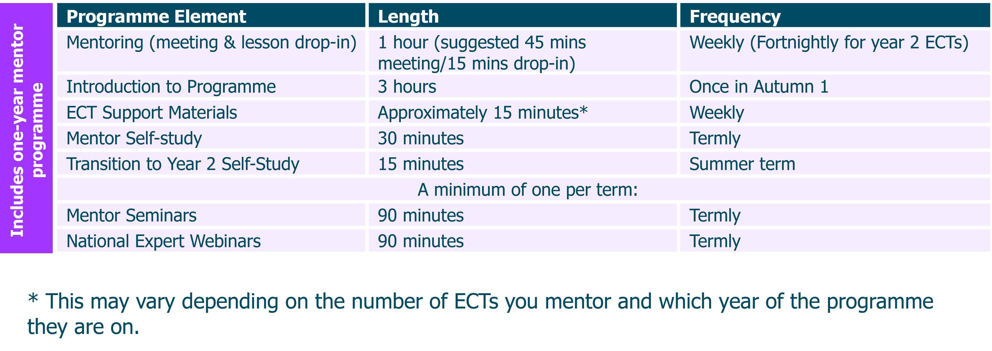
Training mentor – reduced programme
If you have previously received training as either an ITT or ECT mentor with either the NIoT or another provider, but you have not completed it, this is how your time will be spent.
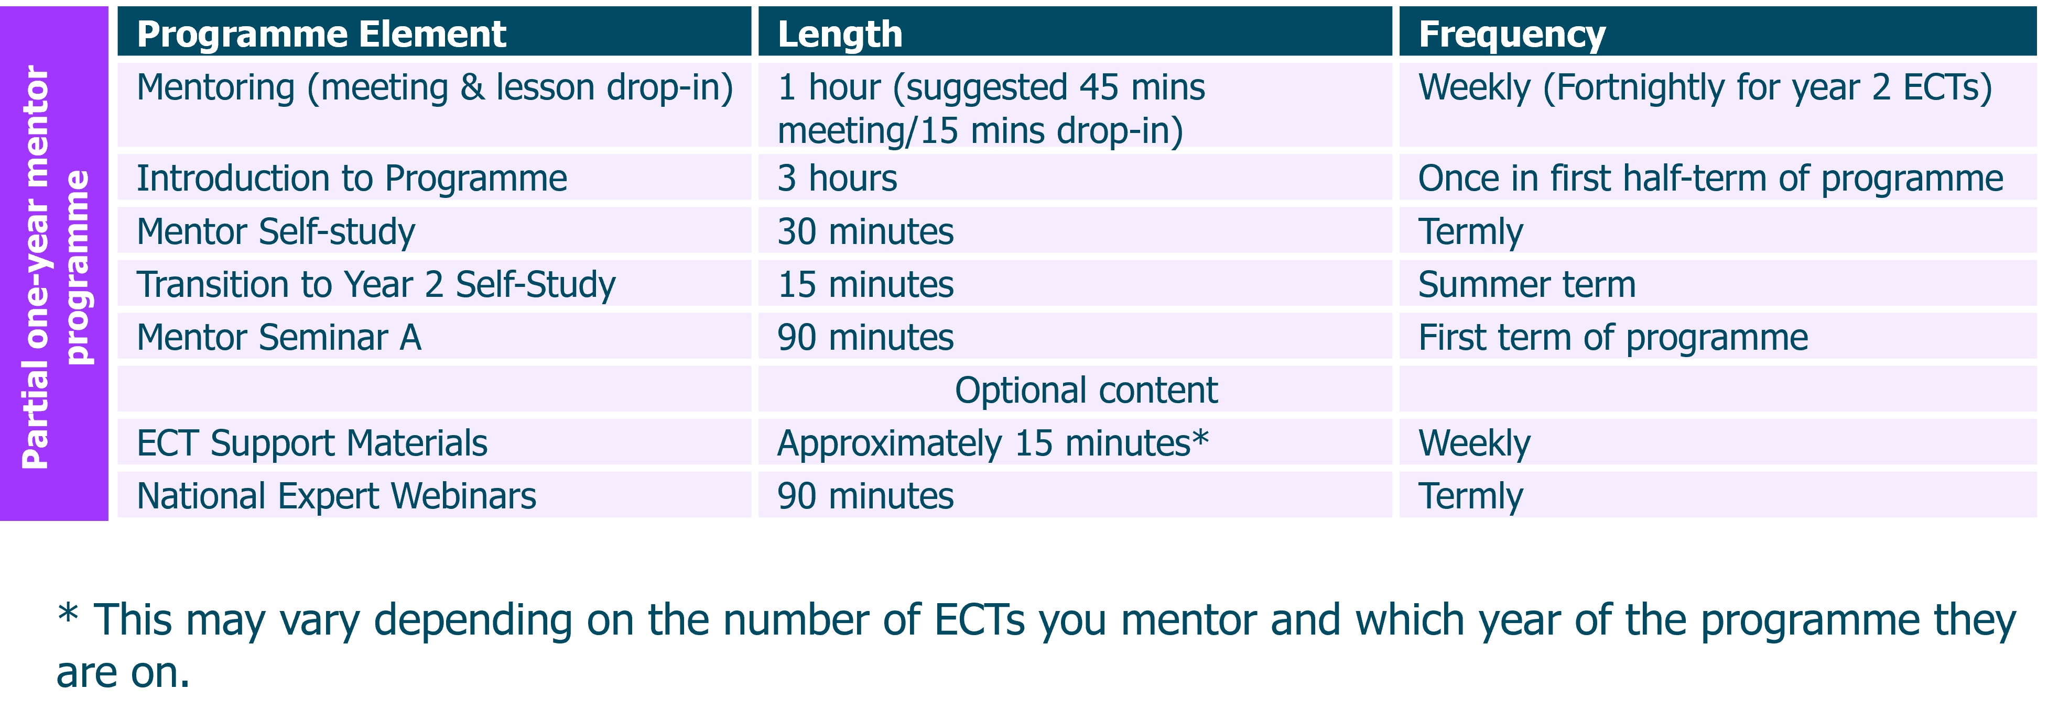

Non-training mentor
If you have previously received training as either an ITT or ECT mentor with either the NIoT or another provider, you do not need to complete any study. However, we do still recommend that you read the ECT Support Materials which are designed specifically to help you plan and prepare for your meetings.

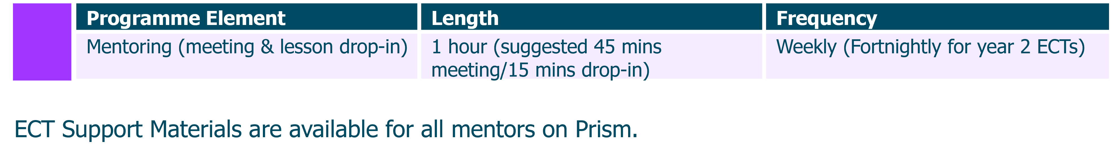
Early Career Teachers
To help you support your early career teacher(s), here is an overview of how their time will be spent in each year of the programme.

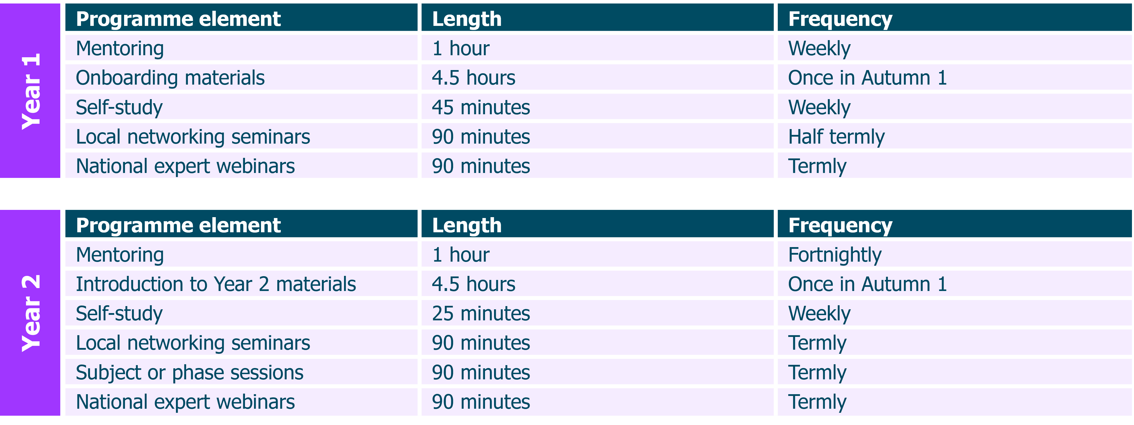
This time commitment is for full-time ECTs. For part-time ECTs, or ECTs on an extended programme, please contact your local NIoT regional campus or associate college, who will be able to provide more information.

Return to Content page

The Six-Step Observation and Feedback Model
The National Institute of Teaching uses the six-step observation and feedback model based on the work of Bambrick-Santoyo (2016). This is a guided process in Prism using the mentor meeting templates with your ECT.
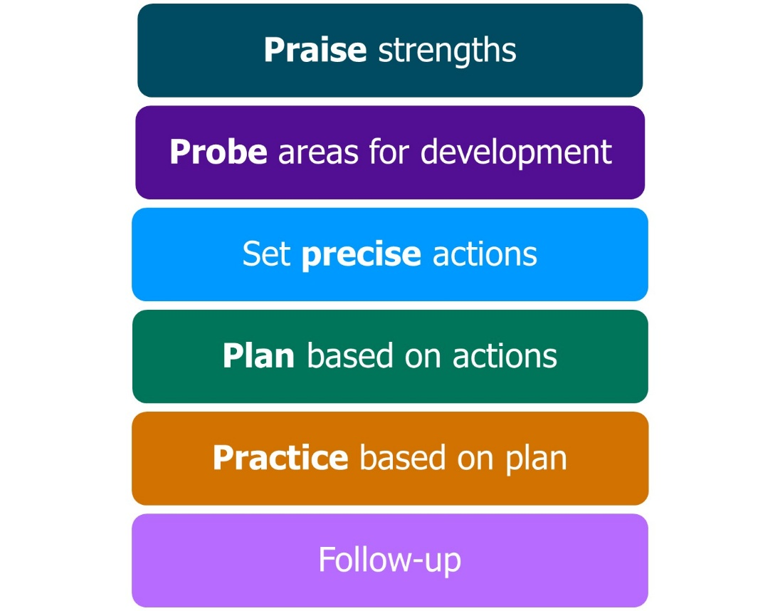
Adapted from Bambrick-Santoyo, 2016
Following your regular lesson drop-ins, the framework should be used to provide feedback to early career teacher. Here’s a quick overview of each step:
- Praise and recognise strengths: Acknowledge where the ECT has effectively planned or implemented actions from prior drop-ins.

- Probe and identify areas for development: Using evidence from the drop-in, mentors engage in a dialogue with ECTs to identify possible development areas in their practice.

- Set precise actions: Focusing on the highest-leverage granular element of practice linked to the area identified for development.

- Plan together how to apply the action: Mentors work with the ECT to plan when and how the action step will be used in an upcoming lesson.

- Practice how it will be embedded: Using our deliberate practice approach, mentors model or share an example of effective practice. ECTs will then practice, receiving feedback from their mentor, until they are confident and ready to apply the action in their own classroom or setting.

- Arrange a follow-up observation session: Organise a further opportunity to observe the ECT implementing the agreed action with follow-up feedback.

Watch this video introduction to the model for more details about each part and guidance on how to use it in your meetings. This video and a PDF version of the slides is available in the Knowledge Base on Prism.
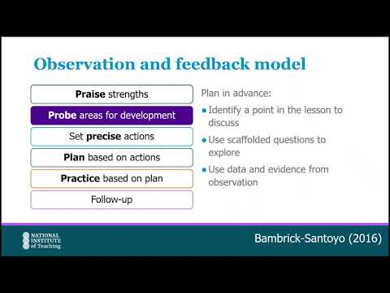
Click here to watch: Introduction to the Six-Step Observation and Feedback model

Return to Content page

Deliberate Practice
Deliberate Practice is a key component in all programmes at the National Institute of Teaching. It focuses on developing expertise by tailoring practice with guidance from peers, an experienced teacher, a coach or a mentor.
The NIoT approach draws on Bambrick-Santoyo’s ‘See it, name it, do it’ model (2018) and Deans for Impact’s ‘Practice with Purpose’ (2016).
As a mentor, you will use this in the regular meetings with your ECT. It lies within the Observation and Feedback model - during the fifth step, ’Practice based on plan’.
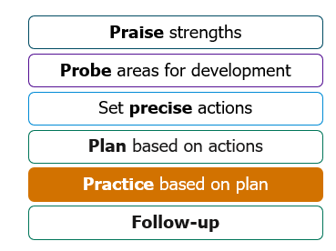
Adapted from Bambrick-Santoyo, 2016
Watch this short introduction to the Deliberate Practice model:
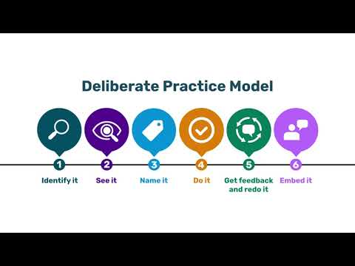

Click to watch: NIoT Deliberate Practice model

Within this model, your role as a mentor is to:
- Support your early career teacher to identify the highest-leverage developmental area in their current practice.
- Share a model of effective practice – a video, an observation of a colleague, a script or you might model within the meeting.
- Name the active ingredients of the model that made it effective.
- Provide a safe and supportive climate in which your ECT feels comfortable and confident to practice (as many times as needed).
- Provide targeted, granular feedback linked to the active ingredients.
- Plan a time when you will watch your ECT put the practice into action.

ECTs also use Deliberate Practice during their seminars and this will be a framework that is familiar to them.

Return to Content page
Prism
Our learning management system (LMS) is called Prism.
As a mentor, it will help you to support your ECT by giving you clear insights into how the programme is going for them, including their self-study, live session attendance and meetings. It’s where you will record your feedback and set and monitor their actions. It is also where you will engage with your Mentor Training Programme self-study (if you are a training mentor).
Prism is a one-stop shop where you will be able to:
- Access ECT Support Materials
- Engage with the Mentor Training Programme self-study content
- Monitor progress and engagement of your ECT with their self-study and seminars (minimum 75% required)
- Review lesson recordings shared by your ECT
- Record your own lessons to share with your ECT
- Add lesson drop-in feedback for your ECT
- Set and monitor actions for your ECT
- Engage with the NIoT’s wellbeing tool

The Prism Knowledge Base contains helpful guidance on all you need to know.

Wellbeing tool
This tool, brought to you by the NIoT, is designed to gather diagnostic responses on the well-being of ECTs and mentors throughout their programme. It aims to enhance the overall programme experience for all participants by gathering anonymous insights that can be used to refine and enhance the programme materials and to identify any patterns or changes in well-being that may need to be addressed.
You’ll find it on Prism, and it will be available for you to access 7 days a week, as often as you like. It only takes a few minutes to complete the diagnostic questions, and a reminder that submissions are completely anonymous.
Please note that the wellbeing tool is currently being enhanced following feedback and the implementation of a wellbeing research study during the previous academic year. It is anticipated that developments will be complete during the 2026 autumn term, and following its launch, further information and guidance will be available on the Prism Knowledge Base.

Return to Content page
Key terminology
Early Career Teacher Programme (ECTP): The Early Career Teacher (ECT) Programme is the part of the statutory two-year period of training and support for all newly qualified teachers in England. Mentors are entitled to one year of training from September 2025 onwards.
Early Career Teacher Entitlement (ECTE): the statutory two-year period of training and support to help ECTs develop their professional knowledge, skills, and confidence as classroom practitioners. It builds on initial teacher training and is based on the Initial Teacher Training and Early Career Framework (ITTECF).
You can read more about it here.
Initial Teacher Training and Early Career Framework (ITTECF): The Initial Teacher Training and Early Career Framework (ITTECF) supports new teachers through their training and early years in teaching. It underpins one year of Initial Teacher Training (ITT) and two years of Early Career Teacher (ECT) training (or part-time equivalent).
Lead Provider: National Institute of Teaching (NIOT). Responsible for design and delivery of ECTP programmes in partnership with local associate colleges and campuses, who contextualise learning for participants to apply effectively in schools.
Delivery Partner/Associate College/Regional Campus: Local organisations collaborating with NIOT to deliver live sessions tailored to ECTs and mentors, utilising their local knowledge for effective support.
Appropriate Body (AB): Organisation to whom termly reviews of ECTs are submitted for progress assessments. An independent body, ABs address concerns about ECT progress, agreeing on extended or reduced inductions and ensuring adequate support for ECTs and mentors.
Training and non-training mentors: Training mentors are those who are taking part in the programme because they have not yet completed either a total of 6 full terms of an ECF Mentor programme or 3 full terms of an ECTP Mentor programme. Non-training mentors have completed either of the above and thus are no longer required to attend live sessions or complete self-study for their own programme; they will no longer be funded to complete the ECTP training. They must still support the ECT in the same way as training mentors though and will have access to resources to support with this.

Return to Content page
Actions
To help you prepare for your role, you should consider the following actions:
- Speak to your Induction Tutor to confirm the module sequence for your school.
- Login into Prism and check that you can you see your ECT’s details and any relevant programmes of study for yourself. If you cannot, please let your Induction Tutor know.
- Plan time to complete any self-study or reading to support you in your role.
- Schedule time within your timetable to meet with your ECT either weekly (Year 1) or fortnightly (Year 2).
- Support your ECT with allocating time in their timetable to engage with the content of the self-study each week.
- Check the dates for seminar delivery for yourself and your ECT and ensure that it is possible to attend.
- If they are new to your school, you may wish to spend some time in your first meeting helping your ECT find the answers to some of the following questions:
- What are the different platforms that the school uses to take the register or record behaviour incidents and rewards? How do they use them?
- What should they do if they encounter an IT issue during a lesson?
- How many duties will they have? What is expected of them during duty? What should they do if there's an issue while on duty?
- Where can they find the resources they need to plan and adapt their lessons?
- What are the working hours? When do staff need to arrive at the building?
- What time can staff leave at the end of the day?
- How can they make a call out to SLT or their Head of Department if they need assistance in their classroom?

You may need to schedule some time with your Induction Tutor or other colleagues to find the appropriate responses to some of these questions.
Return to Content page

Further reading
- Education Endowment Foundation (EEF) (2021) Effective professional development. London: Education Endowment Foundation. Available at: https://educationendowmentfoundation.org.uk/education-evidence/guidance-reports/effective-professional-development (Accessed: 7 May 2026).
- Deans for Impact (2016) Practice with purpose: The emerging science of teacher expertise. Austin, TX: Deans for Impact. Available at: https://www.deansforimpact.org/files/assets/practice-with-purpose.pdf (Accessed: 7 May 2026).
- Deans for Impact (2015) The science of learning. Austin, TX: Deans for Impact. Available at: https://www.deansforimpact.org/tools-and-resources/the-science-of-learning (Accessed: 7 May 2026).
References
- Bambrick-Santoyo, P. (2016) Get better faster: A 90-day plan for coaching new teachers. San Francisco: Jossey-Bass.
- Bambrick-Santoyo, P. (2018) Leverage leadership 2.0: A practical guide to building exceptional schools. San Francisco: Jossey-Bass.
- Deans for Impact (2016) Practice with purpose: The emerging science of teacher expertise. Austin, TX: Deans for Impact.
- Department for Education (DfE) (2019) Early career teacher entitlement. Available at: https://www.gov.uk/government/publications/early-career-teacher-entitlement/early-career-teacher-entitlement (Accessed: 7 May 2026).
- Department for Education (DfE) (2021) Teachers’ standards. Available at: https://www.gov.uk/government/publications/teachers-standards (Accessed: 7 May 2026).
- Department for Education (DfE) (2024) Induction for early career teachers (England): Statutory guidance. Available at: https://www.gov.uk/government/publications/induction-for-early-career-teachers-england (Accessed: 7 May 2026).
- Education Endowment Foundation (EEF) (n.d.) Special educational needs in mainstream schools. Available at: https://educationendowmentfoundation.org.uk/education-evidence/guidance-reports/send (Accessed: 7 May 2026).
- Initial Teacher Training and Early Career Framework (ITTECF) (2024) Initial teacher training and early career framework. London: Department for Education. Available at: https://www.gov.uk/government/publications/initial-teacher-training-and-early-career-framework (Accessed: 7 May 2026)

Return to Content page
Appendix 1
Year 1 ECT Programme - Modules and associated self-studies
Module | Elective self-studies in this module
Behaviour and relationships | 1 | Communicating belief in pupils' academic potential
Behaviour and relationships | 2 | Establishing effective routines and expectations
Behaviour and relationships | 3 | Creating a positive, predictable, and safe learning environment
Behaviour and relationships | 4 | Building effective relationships
Behaviour and relationships | 5 | Motivating pupils
Memory and learning | 1 | How the memory works
Memory and learning | 2 | The role of pupils’ prior knowledge
Memory and learning | 3 | Managing cognitive load
Memory and learning | 4 | Understanding and addressing pupil misconceptions
Memory and learning | 5 | Retrieval, revisiting and reviewing information
Planning and delivery | 1 | Explanations, modelling and examples
Planning and delivery | 2 | Scaffolding and increasing challenge
Planning and delivery | 3 | Planning effective practice, including homework
Planning and delivery | 4 | Questioning as an essential tool for teachers
Planning and delivery | 5 | Fostering classroom talk and peer collaboration
Subject and curriculum | 1 | Delivering a carefully sequenced curriculum
Subject and curriculum | 2 | Anticipating misconceptions
Subject and curriculum | 3 | Building increasingly complex mental models
Subject and curriculum | 4 | Developing early literacy
Subject and curriculum | 5 | Enhancing all pupils' literacy
Assessment for learning | 1 | Designing effective assessment
Assessment for learning | 2 | Checking prior knowledge and understanding
Assessment for learning | 3 | Providing high-quality feedback
Assessment for learning | 4 | Making marking and feedback manageable
Assessment for learning | 5 | Developing your practice in relation to assessment and feedback
Adaptive practice | 1 | Understanding different pupil needs
Adaptive practice | 2 | Providing opportunities for all pupils to succeed
Adaptive practice | 3 | Meeting individual needs without creating unnecessary workload
Adaptive practice | 4 | Effective grouping and deployment of teaching assistants (TAs)
Adaptive practice | 5 | Developing your knowledge in special educational needs and disabilities (SEND)

Return to Content page

Appendix 2
Year 2 ECT Programme – Overview of focus areas
Each focus area links to a piece of research from the ITTECF. ECTs will select one and read a summary of the paper before they critically reflect on the evidence.
Module | Focus area 1 | Focus area 2 | Focus area 3 | Focus area 4
Module A Behaviour and Relationships | ‘The Pygmalion Effect’ and teacher expectancies | Using ante-cedent strategies to manage behaviour proactively | Strategies and approaches to motivate pupils
Module B Memory and Learning | Deepening understanding of working memory | Instructional designs and Cognitive Load Theory | ‘The Testing Effect’ – how to use feedback as part of retrieval practice
Module C Planning and Delivery | Exploring the role of scaffolding | Using worked examples as part of instructional design | How to develop pupils as self-regulated learners
Module D  Subject and Curriculum | Understanding ‘inflexible knowledge’ | Using corrective feedback to address misconceptions | Developing pupils’ critical thinking
Module E Assessment of Learning | Deepening understanding of using formative assessment to move learning forwards | Understanding how and when to use different focus areas of feedback | Planning to use formative assessment effectively
Module F Adaptive Practice | Strategies and approaches for pupils with communication SEN | Strategies and approaches for pupils with cognition and learning SEN | Strategies and approaches for pupils with BESD | Strategies and approaches for pupils with sensory or physical SEND

Return to Content page

Appendix 3
Guidance for weekly meetings with year 1 early career teachers
This guidance combines the NIoT Observation and Feedback model with the Six Principles of Deliberate Practice.
When you create a meeting in Prism, use the prompts provided and make sure you select the correct template.
It may also help to read the ECT support materials before your meeting.
Check-in
Start by asking how your ECT’s week has been, in and out of school, and check in on wellbeing, workload and energy levels.
Ask whether they have used the NIoT Wellbeing tool and discuss any patterns, concerns or successes it highlights.
Invite them to share any challenges or areas where they would like support.
Diagnostic review and discussion (First meeting of the half-term only)
In the first meeting of the half-term, use the diagnostic, your lesson drop-in evidence and your ECT’s reflections to identify development priorities and choose three elective self-studies (two in the first half-term). You may also take account of whole-school priorities.
Use the prompts in Prism to support this discussion.
Then, using the NIoT Observation and Feedback model:
Praise strengths
Praise a specific strength from this week’s observation, including progress against a previous action where relevant.
Probe areas for development
Using your observation notes, identify one development area linked to the current focus. You may also use your ECT’s self-study reflections to deepen the discussion.
Set precise actions
Agree one precise action linked to the focus area. Make sure it is:
- Observable – something you can see in the next lesson observation.
- Practice-able – achievable, not aspirational.
- Bite-sized – small and specific enough to achieve by the next observation.
- Include the ‘how’ not just ‘what’ – use success criteria to show how it will be done.
You may wish to use the suggested action steps in the ECT Support Materials to guide this.
Agree precise action
Agree what the action for your ECT will be using the criteria above to guide your decision. This will be the focus of the next drop-in.
Plan based on actions: Work with your ECT to review and refine their chosen action. This could include a script or product to be used live with pupils. Identify success criteria together focusing on the ‘active ingredients’ of the approach. Through questioning and dialogue, support your ECT to identify ways to successfully implement their action.
You might consider organising for your ECT to observe colleague in your school or within your trust actively puts the approach into practice.
Practice based on plan: Practice could involve creating a product, such as a resource or it may include planning a scripted performance that would ultimately be delivered live to pupils.
You may wish to review the ‘active ingredients’ highlighted in the ECT Support Materials. If you wish to review the NIoT model for Deliberate Practice, click here.
In summary, the practice should include:
- Recap the focus of the practice and what the current challenge is (Identify it)
- Review what effective delivery would look like and the active ingredients (Name it).
- Provide your ECT with a model or exemplar of how to implement the chosen strategy or approach before supporting them with practice (See it).
- Having shared the model or exemplar with your ECTs, they should then undertake practice using the success criteria you have written together (Do it).
- Provide feedback based on the success criteria and support your ECT as required. ​ This may involve repeating the practice until all the success criteria are successfully achieved (Get Feedback and redo it).

Follow up: Plan a follow-up observation of your ECT to see them put their plan into action (Embed it).

AOB (any other business)
Is there anything else you need to discuss with your ECT today? This could include upcoming dates in the school diary or any other areas of support they might need.
Return to Content page

Appendix 4
Guidance for fortnightly meetings with year 2 early career teachers
Meeting 1: Prepare and plan
Wellbeing check-in
Check that your ECT has the NIoT Wellbeing Tool and for any relevant areas for concern or further discussion.
Check in on how they are feeling and any points they would like support with.
If you have any concerns about your ECT’s well-being, you should raise this with your Induction Tutor.
Starting the meeting
Check your ECT has completed their diagnostic and that they have the outcomes.
Check that that they have completed Section 1 of their self-study and that they have their notes with them.
Explore
Review the diagnostic outcomes and its recommendations with your ECT.
Share you feedback from lesson observation 1.You may have used the recording tool for this or conducted an in-person drop-in. Feedback should be given using the NIoT Six step observation and feedback model. Probe how far your feedback aligns with the diagnostic outcomes. Discuss any other targets or goals that your ECT currently has.
Prompt your ECT to share their reflections from Section 1 of their self-study. You may want to ask them:
- Which area of your self-study do you feel you would like to explore further?
- What does the research say about this?
- How does this relate to what you are seeing in your classroom?
How far do these reflections align with the diagnostic outcomes, your observation and pupils data?
Is a pattern emerging that identifies a likely area for development this half-term?

Select
Having explored the possible areas for development, you should jointly agree on the research reading and focus for development for the half-term. For some ECTs, this may be an opportunity to be stretched and challenged.
Plan
Refer to the action steps related to the chosen reading (see ECT Support Materials in Prism). Choose one which best supports your area of focus. For some ECTs, you may wish to stretch them by agreeing on an additional action.
You may also wish to select your own alternative focus area that more specifically meets the needs of your context but is related to adaptive practice.
Prompt your ECT to think specifically about their class/classes. How can they apply the research to implement the chosen strategy or approach and meet the unique needs of your pupils and classroom context?
Ask them to consider any barriers or challenges that could hinder the development of the identified approach or strategy. Support your ECT to plan how they could address these challenges.
Plan together the specific steps needed to implement the chosen teaching strategy in their classroom. What resources or materials will they need? Could they observe another colleague part of the plan?
Discuss how to measure progress. Your observations will focus on this.
Together, identify realistic and measurable goals for the changes they intend to make in their teaching practice. Agree what it would look like if it was effective.
Meeting 2: Review and adapt
Wellbeing check-in
Time to ask how your ECT is feeling and if there is anything they would like support with.
Check if they have been using the NIoT Wellbeing Tool and any insights this has revealed.
You may wish to check how they are managing their workload and review any upcoming possible pinch points in the school’s calendar.
If you have any concerns about your ECT’s well-being, you should raise this with your Induction Tutor.
Review and adapt
Ask your ECT to share their reflections on the do phase of the Personal Professional Development Cycle. What went well? What changes have they made and why? What challenges did they encounter? Encourage them to use pupil data to support their reflections.
Share your feedback from lesson observation 2 using the NIoT observation and feedback model. The focus should be on the actions included in the agreed plan. You should refer to the criteria agreed in Meeting 1 to measure impact. Does your observation align with your ECT’s reflections?
Agree on any adaptations that need to be made to the plan for the next phase – re-do. Does your ECT need any further support? Are they ready to be challenged? Refer to appendix 2 in the ECT Support Materials on Prism for suggested extensions to the action steps.
Revisit the criteria for measuring what success will look like for your ECT and their pupils.
Meeting 3: Final review and next steps
Wellbeing check-in
Ask how your ECT is feeling and if there is anything they would like support with.
Check if they have been using the NIoT Wellbeing Tool and any insights this has revealed.
If you have any concerns about your ECT’s well-being, you should raise this with your Induction Tutor.
Final review
Prompt your ECT to share their reflections and notes from the re-do phase of the cycle. Ask them to use pupil data to support their findings.
You may wish to discuss the following:
- What aspects of the implementation were successful, and why?
- Does this mirror the suggestions within your chosen research? Was there anything that didn’t align with the evidence and why not?
- What challenges did you face and were they any barriers that you couldn’t overcome? Why?
Share your feedback from lesson observation 3 using the NIoT observation and feedback model. The focus should again be on the actions included in the agreed plan and any changes made during your last meeting. You should refer to the criteria measure impact. Does your observation align with your ECT’s final reflections?
Next steps
Discuss how this cycle will inform your ECT’s future practice. What would they do differently next time? How has it developed their understanding of how to apply the theory and evidence to their own practice?
AOB (any other business)
Is there anything else you need to discuss with your ECT today? This could include upcoming dates in the school diary or any other areas of support they might need.

Return to Content page

Appendix 5 Mentor programme self-study overview
Autumn Term
 | Self-study | Title | Summary
Choose 1 | 1a | Delving into deliberate practice | Exploring the key components of effective deliberate practice for those who have not used it before.
Choose 1 | 1b | Beyond the basics: embedding deliberate practice | Revisiting and developing your understanding of the key components of effective deliberate practice.
Spring and Summer terms
Choose 2 from the following | 2 | Unlocking effective adapting teaching | Considering how to support their ECTs to adapt their classroom practice in order to make their teaching inclusive. Responding to the growing numbers of pupils with SEND in mainstream settings, this self-study will draw on the latest research.
Choose 2 from the following | 3 | Putting 'belonging' at the heart of pedagogy | Explore the value of pupils' sense of 'belonging' and its impact on positive outcomes both in school and longer term. They will work with peers and experts to explore how to support ECTs in considering where 'belonging' fits within their teaching and how to develop this.
Choose 2 from the following | 4 | Making feedback stick | Consider why feedback isn't always acted on by the recipient. Using up-to-the-minute research and insights gained from NIoT research on feedback literacy, participants will explores strategies and approaches to ensure their feedback sticks.
Choose 2 from the following | 5 | Moving beyond instructional coaching | Lifting the lid on coaching approaches, providing insights into the mechanisms for effective coaching including instructional coaching and also exploring other strategies that can be leveraged as part of the professional development of others.
Choose 2 from the following | 6 | Navigating difficult opportunity conversations | Tools for mentors to feel better-equipped to conduct potentially challenging conversations and re-framing them as opportunities for reflection, growth and development.

Return to Content page

Appendix 6
The Initial Teacher Training and Early Career Framework and Teachers’ Standards
What is the ITTECF?
The Initial Teacher Training and Early Career Framework (ITTECF) supports new teachers through their training and early years in teaching. It underpins one year of Initial Teacher Training (ITT) and two years of Early Career Teacher (ECT) training (or part-time equivalent). It sets out the evidence-informed knowledge, skills, and behaviours that lead to effective teaching.
Whichever provider new teachers train with, the ITTECF will guide their development across a three-year programme. ECTs will cover the ITTECF in full during their initial teacher training and also during the two-year ECT programme. This is an intentional decision by the Department for Education to ensure that the knowledge, skills, and behaviours gained during Initial Teacher Training can be revisited and consolidated. The ITTECF supports a cohesive and continuous professional development journey for new teachers as they progress through their early teaching careers.
How does the ITTECF link to the Teachers’ Standards?
The eight strands of the ITTECF are closely aligned with the Teachers’ Standards. However, it is important to understand that the ITTECF is neither an assessment tool nor a curriculum but an entitlement for all Initial Teacher Trainees and Early Career Teachers. Its purpose is to support their development against the Teachers’ Standards, and for this reason, they are intentionally interwoven.
Along with the Induction Tutor, you will support new teachers in monitoring and reviewing their progress against the Teachers’ Standards. This progress will be reported to the Appropriate Body (see Roles and Responsibilities).
You can see how the ITTECF and the Teachers’ Standards align here:
The ITTECF Framework | Teacher Standards
- High expectations | - Set high expectations
- How pupils learn | - Promote good progress
- Subject and curriculum | - Demonstrate good subject and curriculum knowledge
- Classroom practice | - Plan and teach well-structured lessons
- Adaptive teaching | - Adapt teaching
- Assessment | - Make accurate and productive use of assessment
- Managing behaviour | - Manage behaviour effectively
- Professional behaviours | - Fulfil wider professional responsibilities

Each strand of the ITTECF contains a series of ‘Learn that…’ and ‘Learn how to…’ statements that underpin the weekly activities and action steps that ECTs undertake as part of the two-year ECT programme.
The mentor’s role is to guide ECTs to contextualise the ‘learn that’ elements from their self-study to ‘learn how to’ in your context. Here is an example of some of these statements, taken from the Adaptive Teaching strand:
Adaptive Teaching (Standard 5 – Adapt Teaching)
Learn that… | Learn how to…
- Adapting teaching in a responsive way, including by providing targeted support to pupils who are struggling, is likely to increase pupil success. | Meet individual needs without creating unnecessary workload, by:  k) Making use of well-designed resources (e.g. textbooks, manipulatives).  l) Planning to connect new content with pupils' existing knowledge or providing additional pre-teaching if pupils lack critical knowledge.
Further information regarding the frameworks can be found at:
Initial Teacher Training and Early Career Framework
Teachers’ Standards guidance (publishing.service.gov.uk)

Return to Content page

Appendix 7
Flowchart to show mentor types and training required
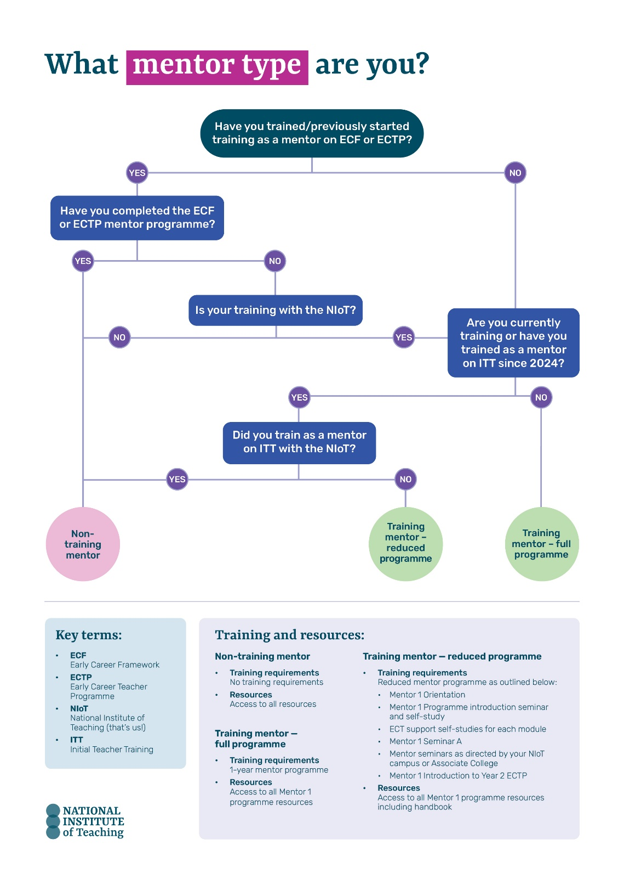
Return to page 25
Return to Content page

