
ECT Programme Handbook for Induction Tutors
2026-27
This handbook is for those who oversee the entitlement of early career teachers in schools working with the National Institute of Teaching and their Associate Colleges.







Introduction
Welcome to the Early Career Teacher (ECT) Programme from the National Institute of Teaching. This handbook is designed to support the induction of early career teachers and the work of their mentors in your school. Please navigate to the relevant sections using the links in the content table below.
Content
Induction Tutor role and responsibilities | Page 2
The Early Career Teacher Programme from the NIoT | Page 6
How to select a flexible sequence of self-study | Page 10
ECT Programme - Year 1 | Page 13
ECT Programme– Year 2 | Page 20
Mentor Training Programme | Page 27
Time commitment for ECTs and Mentors | Page 29
Online System - Prism | Page 31
Wellbeing tool | Page 32
Funding | Page 33
Entitlement | Page 34
Key terminology | Page 35
To do checklist | Page 36
Appendix 1: Year 1 ECT Modules and associated self-studies | Page 37
Appendix 2: Year 2 ECT Focus areas | Page 39
Appendix 3: Six-step observation and feedback model | Page 40
Appendix 4: Deliberate Practice | Page 42
Appendix 5: Flexible module sequence FAQs | Page 43
Appendix 6: Mentor Training Programme – self-study overview | Page 46
Appendix 7: Guide to different mentor types and training | Page 47
Induction Tutor role and responsibilities
The role of the induction tutor is crucial to ensuring that ECTs make great progress and feel confident in their teaching as they progress through their induction. Positive management of wellbeing and workload of ECTs and mentors makes a huge difference to their potential retention in your school and as a teacher. The role of the induction tutor is to both enable and monitor this progress throughout the two-year programme.
Below is some guidance on doing so which we hope you’ll find helpful. Thank you for the amazing job you do for your ECTs and mentors.
This video below is a general induction tutor briefing for the programme led by Katy Micklewright, the Head of ECF and Rosie Jonas, Lead Writer for NIoT, which may be helpful to watch alongside this handbook.
Click to play video: Discover the NIoT's Early Career Teachers programme webinar

Whilst your headteacher or principal has overall responsibility for the early career teacher entitlement (ECTE) in your school. The ECTE should form part of a wider culture of continuing professional development for school staff.
The induction tutor is a pivotal person for support of both ECTs and mentors throughout the induction period. Induction tutors have specific responsibilities detailed below. Please note, the induction tutor should not be the same person as the mentor.
Induction tutors should:
- Register ECTs and mentors; this is a three-part process; further detail and guidance from NIoT can be found here for 2026:NIOT Induction tutor guide to registration 2026-27
- Ensure that mentors and ECTs have adequate time to complete the programme (Time Commitment) and to complete their regular mentor meetings. That should be protected in timetables, during the school day and should take priority for both parties. Note ECT programme time should not be used for cover.
- Assign appropriate mentors for your ECTs e.g. someone experienced and expert (ideally in closely linked subject or phase), someone who is motivated to do the role and has the time to support the ECT well.
- Organise ECT progress reviews in line with your appropriate body’s requirements and the Teacher Standards
- Ensure ECTs and mentors know about their entitlements and responsibilities
- Ensure that DfE, NIoT and Appropriate Bodies are kept up to date at all times about changes to your school’s ECF or ECTP programmes and participants
- Support ECTs and mentors by ensuring they have the time, tools and support needed to engage fully in all elements of the ECF or ECTP. This may, for instance, include ensuring that their time for the programme is protected, that they are able to attend seminars and that they are able to complete drop-ins and feedback.
- Monitor and follow-up on engagement in self-study, attendance at seminars and in mentor meetings throughout the programme
- Be able to recognise when action is required if an ECT is having difficulties for any reason and support with this
- Promote the ECF/ECTP within the school to raise awareness of ECTs and mentors' brilliant work. Consider how they can contribute to wider CPD of others using the up to date evidence from the programme.
- Periodically attend ECT and Mentor meetings to assess feedback effectiveness in your school.
- Use the ECTP to enhance other CPD opportunities in the school.
- Guide discussions on development and career progression during and after the programme to foster retention.
You can find out more about setting up ECTE here: Set up and manage the early career teacher entitlement - GOV.UK
Other key roles
Mentors – Responsible for supporting ECT’s development throughout the two-year programme. This includes meeting regularly to provide support and feedback including subject and phase specific guidance.
Headteacher or Principals – Headteachers and principals have various roles, many of which focus on ensuring compliance. They will oversee the overall induction, ensuring both the induction tutor and mentor have time and ability to support ECTs effectively. They are also responsible for appointing an appropriate body and making the recommendations to them regarding the ECT’s performance against the Teachers’ Standards.
Appropriate Body – The appropriate body is responsible for quality assurance within the induction process, ensuring that all aspects are correctly enacted. Your headteacher or principal will report to them on your ECT’s progress and performance against the Teachers’ Standards to them throughout the two-year induction. Depending on where you work, the appropriate body could be:
- Teaching School Hubs (TSHs)
- Multi-Academy Trusts (MATs) (if authorised)
- Appropriate Body Services from the Independent Schools Teacher Induction Panel (ISTIP) (for independent schools)
You can find out more about each role in Section 5 here: Induction for early career teachers (England) statutory guidance

Return to Content page

The Early Career Teacher Programme from the NIoT
Our Early Career Teacher programme is designed to be flexible, contextualised and respectful of teachers’ time, recognising that there is no one-size-fits-all approach to professional development.
It enables ECTs, mentors and school leaders to tailor learning through diagnostic-informed pathways, flexible module sequencing and locally delivered sessions that reflect regional contexts and challenges.
Our programme provides the opportunity for ECTs to:
- engage in a fully funded two-year programme designed to intentionally revisit learning from initial teacher training with the opportunity to apply practice​ in context;
- have ongoing support from a mentor who will help them adapt what they learn to their specific context;
- engage with self-studies that provide phase and setting specific content;
- attend live seminars to engage in deliberate practice to develop their expertise;
- attend free webinars led by world-class experts in specific fields;
- develop relationships with a network of peers with the opportunity to share experiences or collaborate; and
- access specialised support as required.
Through engaging with the ECT Mentor programme offered by the NIoT, mentors will have the opportunity to:
- access evidence-informed materials that are grounded in the most current research to support their ECT’s development;
- engage with a self-study materials to enhance their own professional development as a mentor and coach;
- attend live seminars to and develop their expertise as a mentor and leader of teacher development;
- attend optional webinars to engage with world-class experts in specific fields; and
- network with peers and develop opportunities for collaboration.
Programme modules
The programme has six modules which build upon previous learning. In both years of the programme, the modules are:
- Behaviour and Relationships
- Memory and Learning
- Planning and Delivery
- Subject and Curriculum
- Assessment for Learning
- Adaptive Practice
For full time early career teachers each module lasts a half term.
Part-time ECTs or those on extended programmes
ECTs who are working and studying part time will need a bespoke programme to match their working patterns and engagement preferences; in order to arrange this, please contact your Associate College or NIoT campus who will be able to support you. You should also discuss this with your Appropriate body who will help you to decide the best approach in collaboration with your part-time ECT. The quantity of engagement should be manageable for the ECT and ensure they are able to engage in the entire programme over the period of time agreed. E.g. It may be appropriate for an ECT on a 0.5 FTE to complete the programme over 4 years instead of two, but this is not required if it is not deemed necessary by the appropriate body, ECT and school.
A flexible approach
The first module that all ECTs complete is ‘Behaviour and Relationships’. This will support them to establish a positive, structured learning environment that fosters pupil engagement, wellbeing, and academic success at the very start of the academic year.
Your school or trust have the option to follow a different order for the remaining five modules. This flexibility means that your ECT’s professional development can be closely aligned with the priorities of your school or trust, potentially increasing the impact of their training. ECT Support Materials for mentors will align with their early career teacher’s sequence of learning.
Developing inclusive practice
Inclusive practice promotes the high standards and fulfilment of potential for all pupils by removing barriers to learning and ensuring that pupils receive an education appropriate to their needs (EEF, n.d). For this reason, each module on the NIoT’s ECT programme will be also explored through the lens of universal, inclusive practice, ensuring that ECTs consider strategies to meet the diverse needs of all pupils in every element of their training including for those with SEND, EAL and required additional challenge.
Scenario-based learning
The content of the ECT programme provides an opportunity for ECTs to reflect on their previous learning throughout their induction period. Throughout the programme, they will engage with different scenarios, allowing them to draw on their previous experience and apply their knowledge and skills in real-school contexts.
Flexibility in how mentors observe (drop-in) ECTs
From September 2026, early career teachers will have the option to record their lessons via a new recording tool in Prism, our learning management system (LMS). ECTs will be able to share their recording with mentors and this can be used in place of an in-person lesson drop in. Mentors can also record their own lessons to share models of effective practice with their ECT.
Watch the following two videos to learn more about why the tool is being used and how to use it.
First, Katy Micklewright, Head of the ECT Programme at the NIoT, explains what the recording tool is for and how it will support early career teacher development.

Click here to watch: Introducing the recording tool

The following video is an introduction to the recording tool.
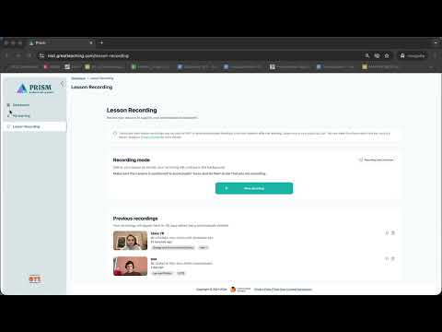

Click here to watch: Introduction to using the recording tool

You can find out more about how use the recording tool in the Knowledge Base on Prism here.

Return to Content page

How to select a flexible module sequence of self-study
In response to feedback from the education sector, our ECT programme offers schools a choice in which ECTs complete modules B-F. This flexibility enables schools to align ECTs’ study and personal development with their own professional development priorities. This can further increase the overall impact of the programme.
Example of a flexible sequence
Here is an example of an adapted module sequence and the school’s rationale behind their selection.
School A is part of a MAT where adaptive teaching has been prioritised as an area for whole-school professional development for the next academic year. Therefore, they have adapted the sequence of modules so that all ECTs, trust-wide, will complete the ‘Adaptive Practice’ module in Autumn half term 2.
The induction tutor has previously raised concerns that some early career teachers lack confidence in planning and teaching, particularly in using assessment to guide their future planning. Therefore, in the Spring, ECTs will begin by studying ‘Planning and delivery’ before moving on to ‘Assessment for Learning’.
In the final term, all ECTs will explore ‘Memory and Learning’ before finishing the year with ‘Subject and Curriculum’. This will align with a whole-staff professional development package already planned around long-term curriculum planning and subject enhancement.
Following consultation between the MAT’s teaching and learning lead and induction tutor, a decision has been made to adapt the sequence as follows:

Autumn Half term 1 | Autumn Half term 2 | Spring Half term 1 | Spring Half term 2 | Summer Half term 1 | Summer Half term 2
Behaviour and Relationships | Adaptive Practice | Planning and Delivery | Assessment for Learning | Memory and Learning | Subject and Curriculum
Schools with multiple ECTs
In schools where there is more than one ECT, all participants should complete the modules in the same sequence. This will ensure a consistent school approach and provide opportunity for peer-support. This consistency also allows induction tutors and mentors to deepen their expertise in key topics, streamline discussions, and tailor guidance more precisely. If you work in a multi-academy trust, you may need to liaise with colleagues to clarify whether the module sequence is being agreed at a whole-trust or whole-school level.
Due to the flexible approach to the module sequence, some ECTs may complete their study in a different order to colleagues in different schools or outside their trust. Induction Tutors should reassure ECTs that this will not impact on their termly progress reports as the programme design ensures that all ITTECF framework statements will be covered across year 1 of the programme and consolidated in year 2.
Selecting a different sequence – what you need to know
- All ECTs must complete the module on ‘Behaviour and Relationships’ in Autumn half term 1.
- ECTs will still complete all six modules per year – one module per half term.
- All ITTECF statements will be addressed across year 1 of the programme and consolidated in year 2.
- Where there is more than one ECT in a school, all participants must complete the modules in the same order.
- ECTs in year 1 and 2 within the same school or trust must complete the modules in the same sequence.
- There is no obligation to adapt the sequence of modules; schools can choose follow our programme as designed. No action is required in this instance.
- All ECTs will attend live seminars in the sequence outlined in the introductory materials and in this document.
- ECT Support Materials for mentors will align with the ECT’s modules.
- Confirmation of the revised sequence must be received by the end of half term 1 and no further changes can be made for the remainder of the first year of the programme. This should be done via the LMS, Prism.
- Should any ECTs join the school later in the year, they should still complete the module on Behaviour and Relationships first and then join the programme as the same point as their colleagues.
Selecting a different sequence – things to consider
Should you wish to adapt the order in which your ECT(s) complete the modules, please consider the following:
- If I work in a trust, have I checked with the person responsible for the ECTs whether a module sequence choice is being made at a trust or school level.
- Have I established the professional development priorities for my school or trust this year?
- Have I consulted with any experienced mentors and relevant senior leaders in the school or trust to seek their thoughts on what any change to the suggested sequence should look like?
- Do I have a clear rationale for why studying modules in a different one to the one recommended would be beneficial for my ECT(s) to complete?
How to submit your preferred sequence
Once you have made the necessary checks, if you wish to adapt the sequence of modules B-F, please log in to your account on Prism and submit your revised sequence before the end of half-term 1.
Once submitted, no further changes to the sequence can be made during year 1 of the programme.
You can see the FAQs regarding a flexible sequence here and can read more about how to select the sequence here.

Return to Content page

Early Career Teacher Programme – Year 1
Programme overview
Year 1 of the National Institute of Teaching’s Early Career Teacher Programme is designed to support teachers as they move from initial teacher training into their first year as qualified professionals. The programme explicitly builds on the knowledge and experiences ECTs bring from ITT, recognising that newly qualified teachers are no longer trainees, but still require structured, expert support as they take on full classroom responsibility.
Year 1 is designed to reduce unnecessary repetition while helping ECTs deepen and apply what they already know in their own classroom context. The curriculum draws on the ITTECF, supporting ECTs to revisit core principles—such as behaviour, learning, assessment and adaptive teaching—through a more applied and classroom-focused lens. This helps bridge the gap between the theory encountered in training and the day-to-day realities of teaching practice.
Take a look at this short video overview:
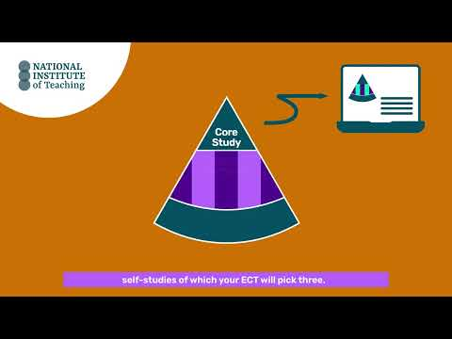
Click to watch: Introduction to year 1 ECT programme

Programme structure for ECTs in year 1

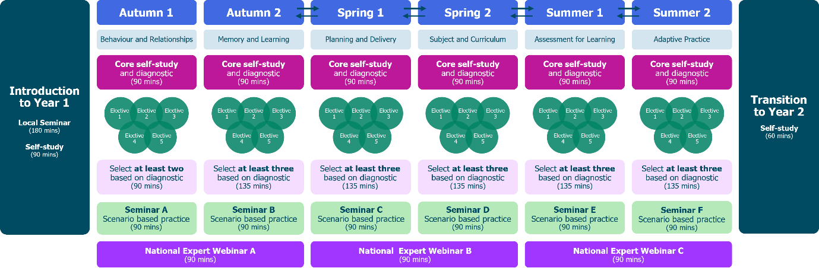

Let’s look at each of those components a bit more closely.
Each module is made up of one core self-study and five elective self-studies. The core self-study revisits the evidence and theory that they ECTs explored as an initial teacher trainee. A diagnostic activity will then guide them to select three further elective self-studies to complete.
The elective self-studies offer a personalised pathway of study that will support ECTs’ understanding of how to put the theory into action in their own classroom practice. They also provide an opportunity for ECTs to study areas that may be relevant to their own context, phase or subject.
Core self-study
Early career teachers will complete one core self-study per module followed by a diagnostic reflection. Both of these will be accessed on our learning management system, Prism.
The core self-study acts a refresher to the knowledge ECTs will have gained in that specific element of teaching during their ITT. It will take ECTs around 60 minutes to complete and can be done in smaller chunks to help them manage their time.
Diagnostic

ECTs will complete one diagnostic for each module after they’ve read the related core-study. The diagnostic provides different phase and setting options and will take them approximately 30 minutes and they should complete it independently. Your ECT can share the feedback from the diagnostic with their mentor during their first meeting.
There is no pass or fail - the diagnostic is designed as a guide or a ‘proxy’ to help ECTs and their mentor identify specific areas for further development or enhancement within their current practice. The suggested recommendations the diagnostic produces simply support the start of a conversation between mentors and ECTs as to what electives could have the greatest impact on their personal development.
Elective self-studies
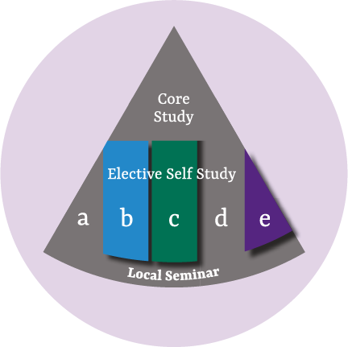
The feedback from the diagnostic, along with the ECT’s Career Entry Development Profile (CEDP) or other targets from their ITT, will guide discussions as mentors and ECTs identify together a focus for development within each module.
ECTs then select three elective self-studies per module – each focused on a more granular aspect of the broader topic. Note that for half-term 1, they will only need to complete two elective self-studies. This is to give them more time to get settled into the new school year.
Each elective self-study takes around 45 minutes to complete and ECTs can space this study out across the half-term to help them manage their time and workload.
You can see a list of the focus areas within each module in Appendix 1.
ECT seminars
In addition to self-directed study, ECTs also attend half-termly seminars which are run by carefully selected, highly experienced teachers and school leaders. The seminars will be either in person or online and the activities undertaken will give them the chance to engage with wider expertise and network with peers.
Like the elective self-studies, the seminars adopt a scenario-based approach in which enable early career teachers to connect different aspects of their teaching - such as planning, assessment, and behaviour management - into a more cohesive and effective practice.
Here are the focus areas for seminars for year 1:
Autumn half-term 1 | Ensuring safe and predictable learning environments
Autumn half-term 2 | Planning effective lessons
Spring half-term 1 | Working in partnership with stakeholders
Spring half-term 2 | Checking prior knowledge and addressing misconceptions
Summer half-term 1 | Using assessment to inform teaching
Summer half-term 2 | Integrating technology into teaching and learning
All seminars are delivered in mixed cohorts in the first year of the programme.

National Expert Webinars
Our ECT programme also offers free termly National Expert Webinar Series with leading experts in their fields. These provide a great opportunity for ECTs to hear from a range of experts in pedagogy to support your own professional development.
New mentors have the option to join the National Expert Webinars as part of their training programme with the NIoT; however, all mentors are welcome to join these too.
The webinars are 60 minutes long with a further 30 minutes for Q&A at the end and take place after the school day, typically between 3.45pm and 5.15pm.

Year 1 National Expert Webinars for 2026-27
Autumn Term | Mohammad Abdallah – Belonging and Mattering  ECTs will gain a sharper, research‑informed understanding of belonging and mattering using a new lens for interpreting pupil behaviour and engagement. They will come away with practical ideas they can begin applying immediately in their setting.
Spring Term  Option A | Alex Quigley – Embedding Literacy Across The Curriculum  A highly practical, research-informed webinar, focused on helping teachers support pupils to read, write, speak and think more effectively in every subject.
Spring Term  Option B – for mentors only | Rob Nash – Feedback Literacy  This webinar is designed intentionally to support mentors in their role. It will cover the following topics:  - Psychology behind giving and receiving feedback  - How to maximise feedback impact and efficacy from the perspective of the mentor and anyone they may be providing feedback too.  - Addressing why we sometimes don’t act on feedback or why feedback may not be received in the way in which it is intended.
Summer Term | Kate Jones – Retrieval and Memory  This National Expert webinar explores how memory works and what this means for effective classroom practice. Drawing on research ECTs will explore working memory, long-term memory and the learning process.  The seminar connects research evidence to practical classroom decisions, helping teachers think carefully about what pupils are thinking about during lessons and how this shapes long-term learning.

Here is an example of a typical half-term’s study for ECTs taken from Module C, Planning and Delivery.
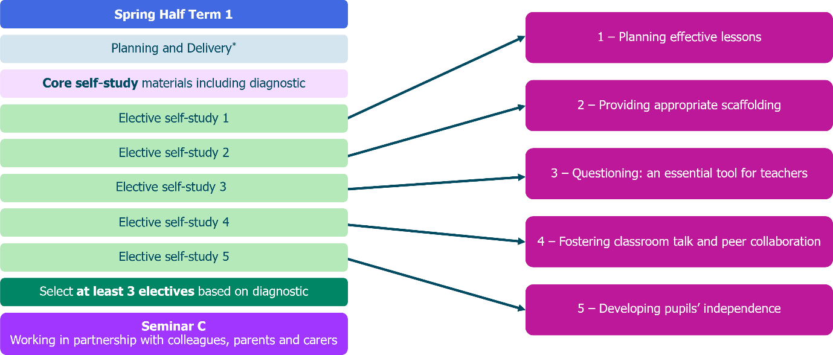
Mentor support for ECTs in year 1
Year 1 ECTs receive ongoing, structured support from mentors. Mentors play a crucial role in helping ECTs make sense of programme content, link it to their pupils and setting, and prioritise what will have the greatest impact. Regular mentor meetings provide protected time for focused professional dialogue, reflection on practice and actionable next steps. The programme is designed so that mentor support continues as ECTs begin their career as qualified teachers, rather than dropping away after ITT.
The ECT and ECT mentor programmes are aligned to ensure there is seamless and consistent support for both mentor and mentee. For example, the online study for ECTs in the first module, Behaviour and Relationships, includes theory-based content on how to maintain high expectations in the classroom. This is mirrored in the support material for mentors in which a summary of the learning is provided. This will help to facilitate discussions and bridge theory into practice for ECTs.
Lesson drop-ins
Weekly interactions with ECTs in Year 1 should include a lesson drop-in of no more than 15 minutes where mentors will observe their ECT’s practice. This can be done, either in person or by watching a recording of the lesson shared by the ECT on Prism. The focus of each drop-in should be a current weekly action for the ECT.
Mentor meetings
Each drop-in is followed by a 45-60-minute follow up meeting using the National Institute of Teaching’s Observation and Feedback model, along with the ECT Support Materials, to support the ECT in developing their practice.
Mentors should Prism to create their meetings using the templates to support their discussion and record their notes.
ECT support materials
Each module includes materials designed to help mentors support their ECT’s development.
These short-read summaries of the ECT materials will take up to 90 minutes per half term (or 15 minutes per week) to complete and can be completed in stages to help mentors manage their time.
The summaries correspond to the ECTs’ half termly core and elective self-studies. This will include the ‘active ingredients’ (the components) that make particular elements of practice effective. This will help to create a clear set of criteria for your ECT to work towards and guide your feedback.
Return to Content page

Early Career Teacher Programme - Year 2
Programme overview
Year 2 of the National Institute of Teaching’s ECT Programme is designed to consolidate and extend the foundations established during ITT and Year 1, as ECTs continue to develop confidence, consistency and professional judgement in their classroom practice. While Year 1 focuses on supporting ECTs through the transition into full teaching responsibility, Year 2 places greater emphasis on deepening critical engagement with research and understand how to contextualise the theory.
ECTs revisit core areas, such as behaviour and relationships and classroom practice, but with a stronger focus on strategic application and impact over time. Content is pitched to recognise that ECTs are now more secure in day-to-day routines and ready to think more deliberately about how their practice affects pupil outcomes across sequences of learning and different contexts.
Programme structure for ECTs in year 2
Watch this video to hear more about the programme structure:
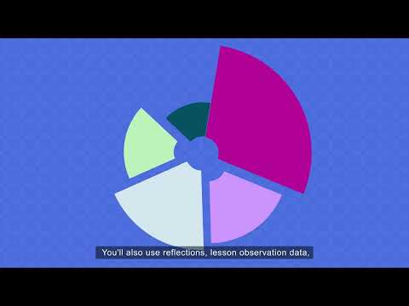
Click here to watch: Introduction to Year 2

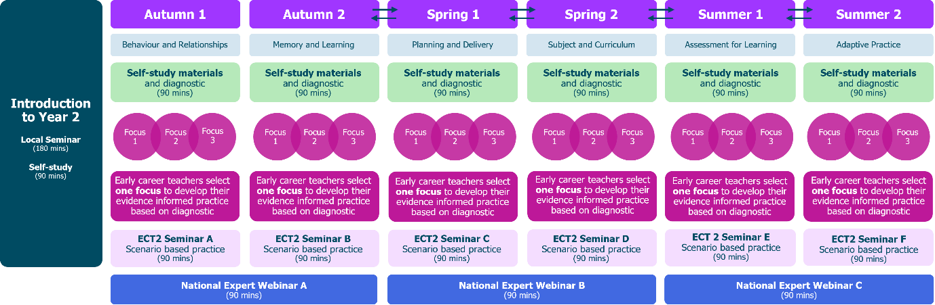

Let’s look at the different components of the programme more closely.
Diagnostic
At the start of every module in year 2, ECTs will complete a diagnostic on Prism. The diagnostic provides different phase and setting options diagnostic will take them approximately 30 minutes and they should complete it independently. ECTs then share the feedback from the diagnostic with their mentor.
As with year 1, there is no pass or fail - the diagnostic is designed as a guide or a ‘proxy’ to help the mentor and ECT identify specific areas for further development or enhancement within their current practice.
ECT self-study
In year 2, ECTs will complete one 60-minute self-study per half-term. ECTs will work through this on Prism.
The self-study is in two sections:
Section 1
ECTs read three short summaries of research papers relating to the module, for example, assessment. They then complete a short reflection task related to each of the summaries and their current teaching practice. This takes around 20 minutes.
In their first mentor meeting of the half-term, they will then identify their area for development using the reflection, any lesson drop-in data and their diagnostic feedback. This will guide their personalised pathway for the rest of the self-study.
Section 2
ECTs will critically engage with the research paper related to their focus for the half-term. The materials provide an opportunity for them to:
- consider what the research tells us about teaching and improving practice;
- reflect on the limitations of the evidence;
- see phase-specific examples of how the theory might look in practice;
- explore how the research supports their own development as a teacher; and
- refine their plan for how it will guide their personal cycle of improvement this half-term.
This section will take around 35-40 minutes to complete.
Here is an overview of the modules and how the self-study process works in year 2.

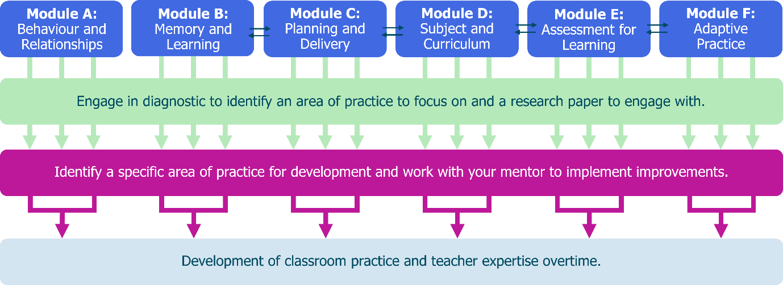
For an overview of the readings in year 2, see Appendix 2
ECT Seminars
ECTs have six seminars in year 2 – one per half term. These last 90 minutes and may be delivered in person or online. Your local delivery partner will confirm the mode of delivery with you. Three of the seminars are designed to be delivered in subject or phase specific groups.
Here are the focus areas for seminars for year 2:
Autumn half-term 1 | Embedding high expectations, expectancies and routines in the classroom
Autumn half-term 2  Subject/phase | Enhancing instructional design through understanding how the memory works
Spring half-term 1 | Understanding how to support pupils to plan and deliver effective lessons
Spring half-term 2  Subject/phase | The importance of subject knowledge to support all pupils' learning
Summer half-term 1  Subject/phase | Using assessment to move learning forward
Summer half-term 2 | Adaptive teaching strategies to support all pupils to make progress

National Expert Webinars
In year 2 of the ECT programme, ECTs will attend free webinars as they did in Year 1. The webinars will be hosted by different experts in their field with a choice of webinars in the final term.
Year 2 National Expert Webinars for 2026-27
Autumn Term | Bradley Busch – Evidence Informed Wisdom  ECTs will look at the important role that research plays in informing our judgement, along with why research by itself is not sufficient. They will also look at different types of research, how to analyse it critically, the role that context plays in applying research and the importance of developing experience and expertise.
Spring Term | Sonia Thomson – Effective Curriculum Design  The primary aim of this webinar is to provoke thought and stimulate conversation around effective curriculum design. ECTs will reflect on their own practices and consider new strategies for enhancing their educational environments. This includes consideration of the importance of work with other adults.  ECTs will consider proactive approaches they could take to create an inclusive environment and positive culture, both inside and outside of their classrooms, including for pupils and families living with disadvantage; pupils and families who have SEND and pupils and families who have English as an additional language.
Summer Term | National Expert Webinar Optional Menu  In the final term of their programme, ECT2s will be offered a choice of different webinars to attend based on their current interests and needs. The sessions offered will be informed by current issues facing the education sector. Likely to include AI and digital misinformation, teacher and pupil wellbeing, SEND, but this will be informed by the feedback and needs of ECTs in the current academic year.
All mentors are welcome to join the webinars.
The sessions last 60 minutes long 30 minutes for Q&A at the end and, as with Year 1, they take place after the school day, typically between 3.45pm and 5.15pm.
The Personal Professional Development Cycle
In year 2, ECT’s weekly actions are replaced by the Personal Professional Development Cycle. Once the focus area for the half-term has been identified, mentors and ECTs will devise a plan of how to implement this improvement(s) into their teaching practice, within your context, using the cycle as a framework.
Each mentor meeting of the half-term has a specific focus that will help put the plan into action, ensuring ECTs are supported every step of the way.
This approach enables ECTs to take more of a lead in their personal development journey and scope to align with key school, phase or context priorities. The model enables mentors to provide support or stretch their ECTs depending on their individual needs.
Watch this video to find out more about the model supports your early career teacher’s development.
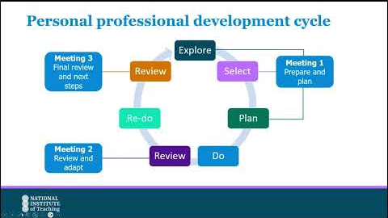
Click here to watch: Personal professional development cycle for mentors

Mentor support for ECTs in year 2
Year 2 ECTs continue to receive ongoing, structured support from mentors as they embed their learning into their everyday practice.
Lesson drop-ins
Mentors should conduct fortnightly lesson drop-ins of no more than 15 minutes. Again, mentors can do this either in person or by watching a recording of the lesson shared by the ECT on Prism.
We recommend that the first drop-in of the half-term should take place in week 1. This will help you identify any possible gaps in practice and feed into the first meeting where the mentor and ECT will plan the actions for the half-term using the Personal Professional Development Cycle.
Lesson drop-ins should be followed by a follow up discussion lasting up to one hour. In year 2, mentors continue to use NIoT’s Observation and Feedback model.
Mentor meetings
Meetings are held fortnightly and each meeting has a specific focus linked closely to the Personal Professional Development Cycle. The fortnightly templates for this cycle can be found in Prism within the mentor meetings area.
Mentors should continue to use Prism with year 2 ECTs to create their meetings using the templates for each meeting to support their discussion and record their notes.
In year 2 of the programme, each meeting has a different focus as outlined below:

Meeting 1 Prepare and Plan (Week 1)
- Conducted in the first week of the half-term, ideally, ECTs meet with the mentor to engage in the explore, select and plan aspect of the professional development model
- They explore the specific element within that domain that they wish to improve based on their reflections, diagnostic feedback and review any lesson drop-in data or current targets.
- Mentors will support ECTs to select the specific element from three self-studies on Prism, they will focus on improving in this area for the rest of the half term, using the theory in their self-study to guide this process.
- Together they will devise a plan of how to implement this improvement(s) into their teaching practice, within their unique context using the Personal Professional Development Cycle as a framework.
- ECTs then put this into practice during the ‘do’ phase of the cycle. They will make minor adaptations and adjustments as they go, making notes to bring to their 2nd mentor meeting.
Meeting 2 Review and Adapt (Week 3)
- Here ECTs and mentors will review and reflect on the experience so far and consider any adaptions that have been made or need to be made to support all learners.
- They will consider how the experience so far aligns with what the evidence says and probe why things may look different.
- They will use the conversations in this meeting to then refine the ECT’s practice in the ‘re-do’ phase, continuing to gather data and reflections.

Meeting 3 Final review and next steps (Week 6)
- In the final meeting of the half term, mentors and ECTs review the experience as a whole to inform future adjustments and refinements in their teaching practice.
- Again, they will consider how far it aligned with the evidence and why they may have needed to make adjustments.
ECT support materials
ECT support materials are available for mentors on Prism. These provide an overview of the ECT study and suggested action steps that can be implemented as part of the Personal Professional Development Cycle.

Return to Content page

Mentor Training Programme
All new mentors must complete the National Institute of Teaching’s Mentor Training Programme. A new mentor is a mentor who has not previously completed six half-terms of mentor training with any provider, either on an Initial Teacher Training or Early Career Teacher programme.
The programme lasts one year and is aimed to develop mentors as teacher-educators, working not only with ECTs but with other colleagues to develop their practice. Mentors must complete a minimum of 75% of the programme in order for your school to receive their funding if they are a training mentor.
Areas covered include the implications of AI in education, deepening understanding of adaptive teaching, exploring how to put belonging at the heart of teaching and considering the differences between pedagogy and andragogy.
The programme is made up of both online study and seminars. Take a look at the overview below:
Mentor Training Programme Overview
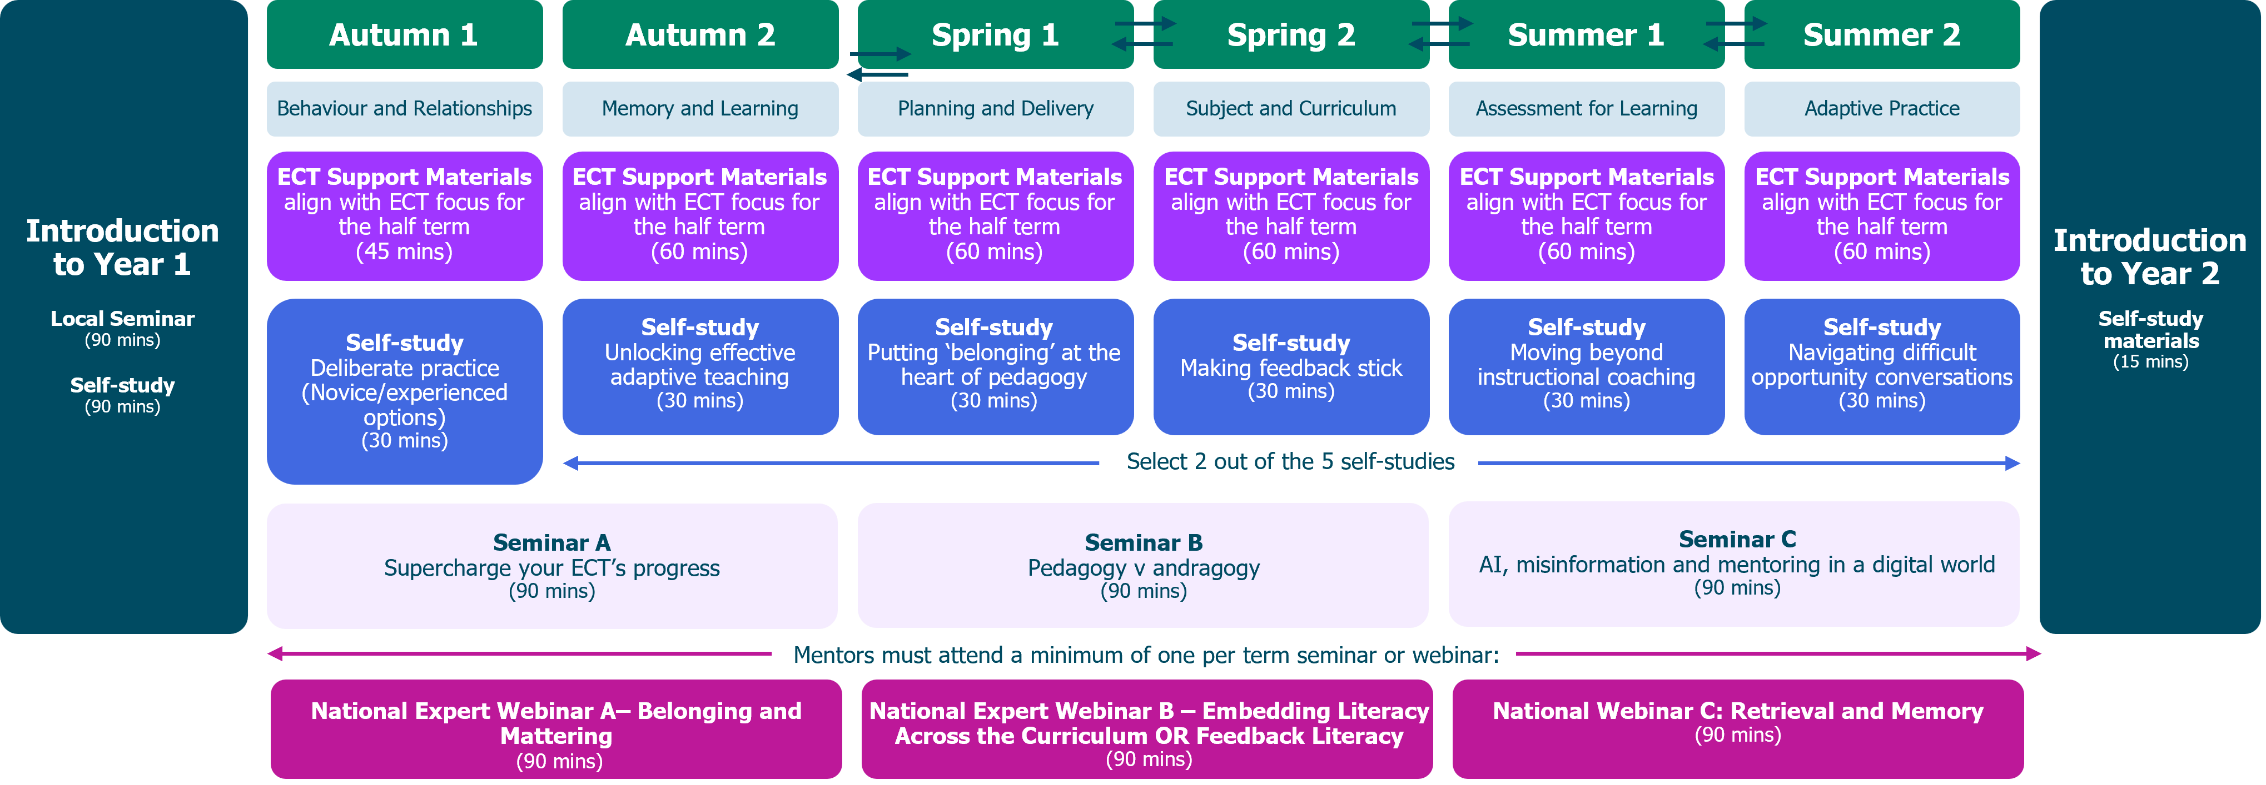
Introduction to the programme
The programme begins with a 90-minute online self-study on Prism. This can be completed in smaller sections to help mentors manage their time. Mentors also have a 90-minute introductory seminar, where they will learn more about their role and responsibilities as an ECT mentor; explore the observation and feedback model used in NIoT's ECT programme in more detail; practice applying their knowledge of this model and consider how to support their ECT in managing their wellbeing.
Mentor self-study
Mentors on the programme must complete one self-study per term and these take around 30-minutes to complete. There is a choice of six different topics to choose from which allows them freedom to select the focus that most closely meets their current developmental needs or aligns with the school’s priorities. Mentors can complete additional self-studies if they wish.
All mentors will start with the self-study on Deliberate Practice which is a cornerstone of all our programmes and their meetings with ECTs. Two options are available for them to choose from depending on their prior experience of Deliberate Practice: novice and expert.
For a summary of the Mentor Training Programme self-study topics click here.
Mentor seminars
Mentor training includes synchronous seminars. These may be in-person or online and the offer includes seminars and National Expert Webinars. Mentors must attend one of these events per term, with the seminars being the priority.
Seminars
The programme includes three 90-minute seminars, all designed to develop mentors’ understanding, expertise and confidence in key areas of pedagogy in the sector. There is one seminar per term and the topics covered are:
- Seminar A - Supercharge your ECT’s progress
  - Enhancing mentors’ instructional coaching practices by effectively using the Observation and Feedback model to support ECT development.
- Seminar B – Pedagogy v Andragogy
  - Considering which principles are common to both teaching children and adults and how to navigate the challenges that andragogy may present.
- Seminar C – AI, misinformation and mentoring in a digital world
  - Explore how AI and the wider online environment are shaping teacher development alongside the risks and challenges it brings.

National Expert Webinars
Mentors have the opportunity to attend the same series of National Expert Webinars as their ECT. We also offer a webinar specifically designed for mentors in Term 2 on feedback literacy presented by Dr. Rob Nash, Head of Psychological Research at the NIoT.
Return to Content page
Time commitment for the 2026-27 programme
Mentor’s time will be spent differently, depending on their previous mentor training.
It’s important that you know which programme elements they will need to complete as this will affect the funding your school receives. Part of your role as Induction Tutor is to confirm the level of engagement that each mentor must complete and ensure they have the time to do this as part of their entitlement.
To help you to establish this, please refer to the flowchart in Appendix 7 . If you are still unsure on mentor types or engagement requirements, you should speak to your NIoT regional campus or associate college.
Training mentor – full programme
For mentors who have not previously received any training as either an ITT or ECT mentor.
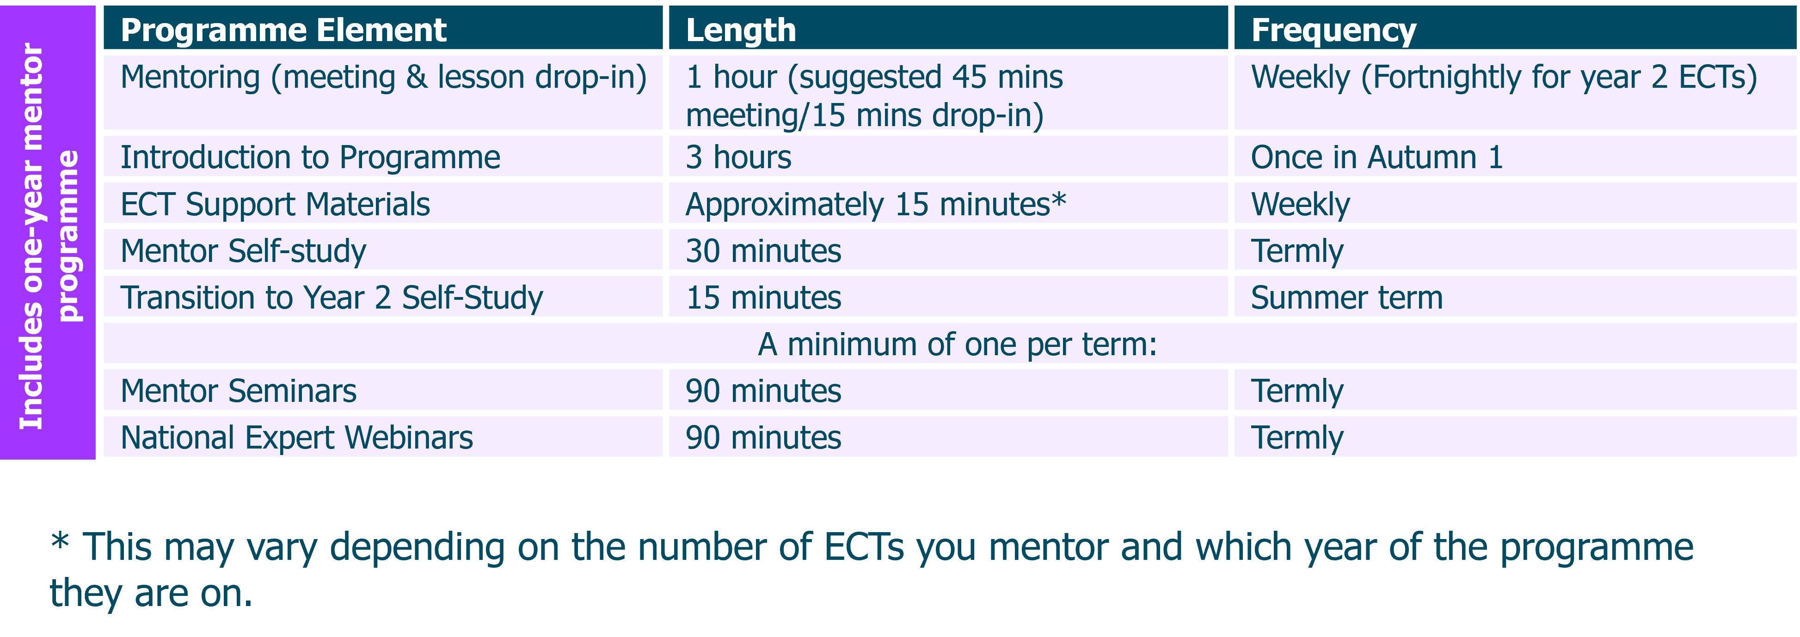
Training mentor – reduced programme
For mentors who have previously received training as either an ITT or ECT mentor with either the NIoT or another provider, but have not completed it, this is how their time will be spent:
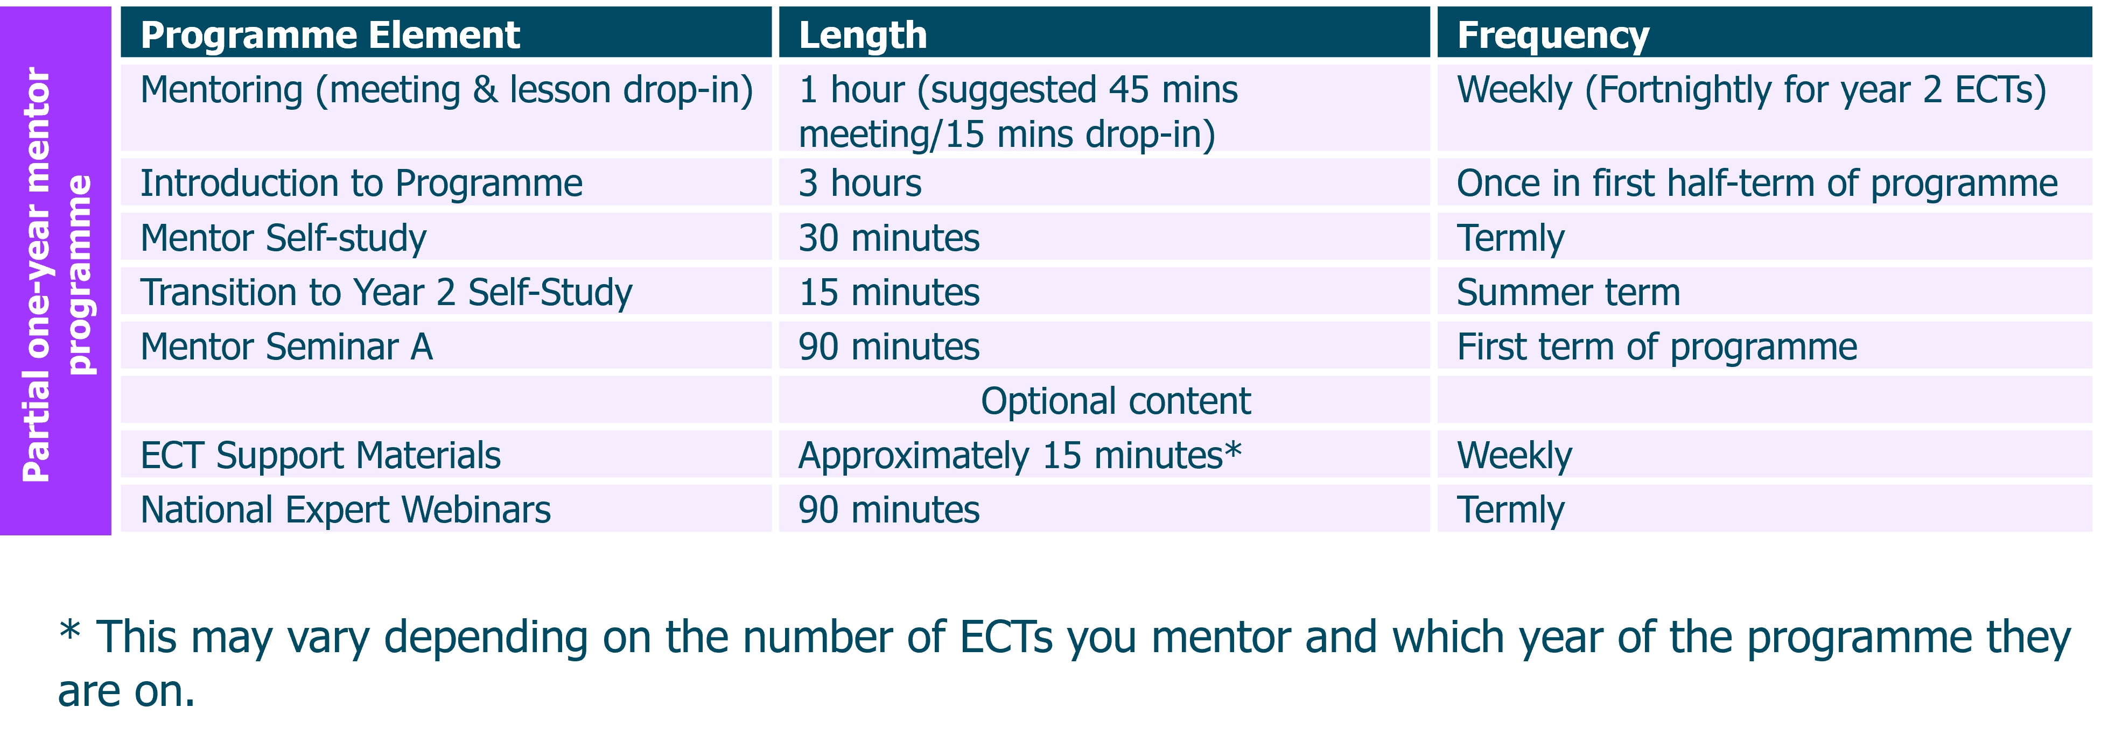

Non-training mentor
Mentors who have previously received training as either an ITT or ECT mentor with either the NIoT or another provider do not need to complete any study. However, we do still recommend that they read the ECT Support Materials which are designed specifically to help them plan and prepare for their meetings.

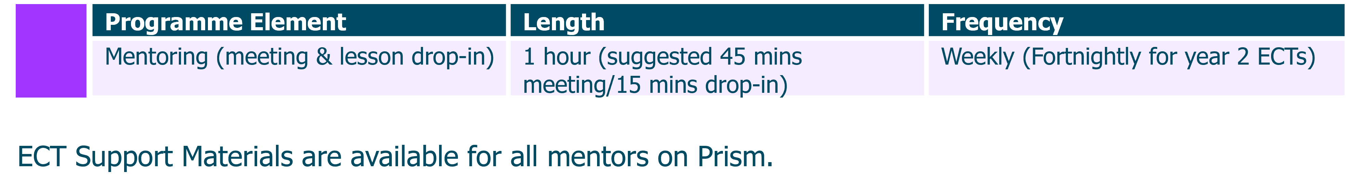
Early Career Teachers
A key responsibility as Induction Tutor is to ensure that early career teachers complete their studies and have the time to do this as part of their entitlement. You can read more about their entitlement here.
To help you plan the timetable for your early career teacher(s), here is an overview of how their time will be spent in each year of the programme:
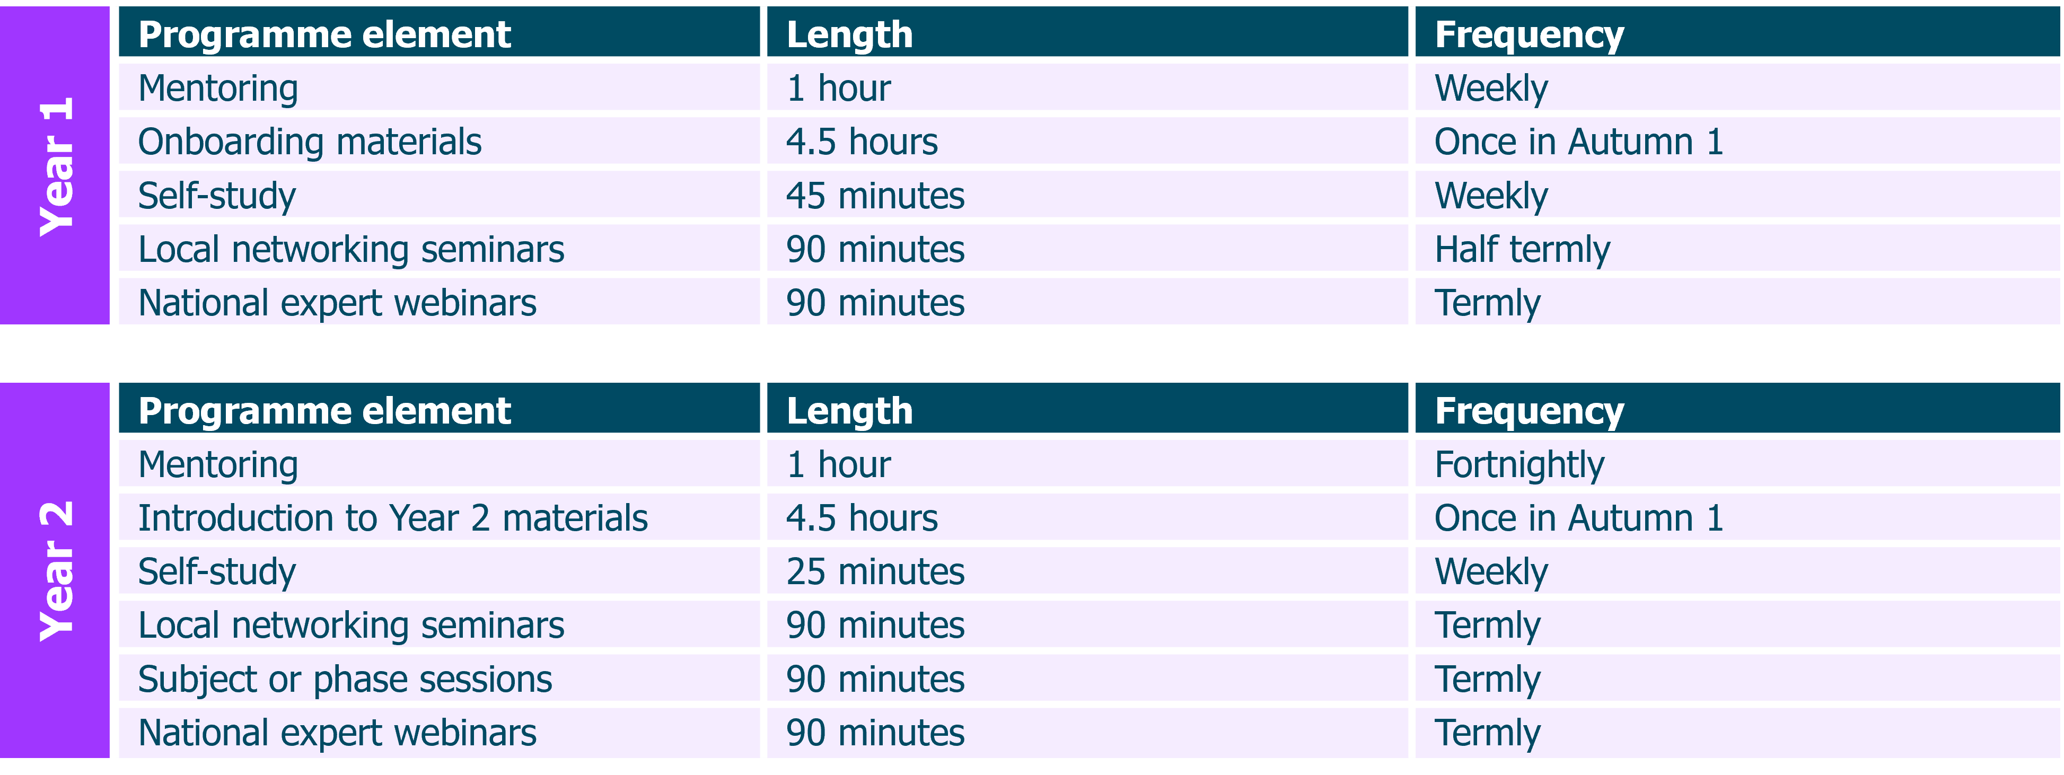
This time commitment is for full-time ECTs. For part-time ECTs, or ECTs on an extended programme, please contact your local NIoT regional campus or associate college, who will be able to provide more information.
Return to Content page

Prism
Our learning management system (LMS) is called Prism and will be used by ECTs, mentors and Induction Tutors.
As an induction tutor, it will ensure you have clear insights into how the programme is going for your participants, including self-study, live session attendance and mentor meetings. You will have oversight of targets set during mentor-ECT meetings and be able to see what your ECTs and mentors are working on as well as monitor the quality of feedback shared.
Prism is a one-stop shop where you will be able to:
- Monitor progress and engagement of your ECTs and mentors with their self-study and seminars (minimum 75% required).
- View ECT-mentor meeting notes and targets.
- Pair ECTs and mentors.
- Send messages to ECTs and mentors.
- Amend your school’s module sequence (before the specified deadline).
- View ECT support materials and mentor programme self-study materials.

The Prism Knowledge Base contains helpful guidance on all you need to know.

Return to Content page

Wellbeing tool
This tool, brought to you by the NIoT, is designed to gather diagnostic responses on the well-being of ECTs and mentors throughout their programme. It aims to enhance the overall programme experience for all participants by gathering anonymous insights that can be used to refine and enhance the programme materials and to identify any patterns or changes in well-being that may need to be addressed.
You’ll find it on Prism, and it will be available for ECTs and mentors to access 7 days a week, as often as they like. It only takes a few minutes to complete a short set of diagnostic questions, and submissions are completely anonymous.
Please note that the wellbeing tool is currently being enhanced following feedback and the implementation of a wellbeing research study during the previous academic year. It is anticipated that developments will be complete during the 2026 autumn term, and following its launch, further information and guidance will be available on the Prism Knowledge Base.

Return to Content page

Funding
From September 2025, there have been some key changes to mentor funding for the ECT programme, including the following:
- Mentors are only funded to train for one year.
- Mentors will not be funded if already fully trained on ITT (with NIoT) or ECF (with any provider). Known as ‘trained mentors’ in different cases.
- School backfill funding (for mentor time) relies on mentors engaging with a minimum of 75% of the programme during their year of training.

It is vitally important that induction tutors understand how this affects their school and the training for mentors and ECTs.
You can read more here: https://www.gov.uk/guidance/funding-and-eligibility-for-ecf-based-training, and you can also find out whether your mentors are funded via your DfE portal.
Regardless of funding, all mentors will have access to materials to help them support their ECTs and plan their meetings, including self-study materials, the NIOT meeting cycle template in Prism and the lesson recording tool.

Return to Content page

Entitlement
Early Career Teachers
ECTs have specific entitlements to support their induction into the profession. One of these is a reduced timetable. In the first year, they must not teach more than 90% of the timetable of experienced teachers on the main pay range. In their second year on the programme this should be no more than 95% (or the equivalent for part-time ECTs).
This reduction is in addition to the standard planning, preparation and assessment (PPA) time all teachers receive. The allocated time off timetable is specifically for them to engage in induction activities such as mentor meetings, self-study or observing colleagues.
Further information can be found here: Induction for early career teachers (England) - GOV.UK

Mentors
All mentors will get time off timetable for mentor training (if they are a funded mentor following a provider-led programme) and/or for supporting ECTs.
If your school uses a training provider, mentors will typically deliver mentoring sessions:
- One hour per week in their ECT’s first year (minimum required for their ECT meeting and lesson drop-in)
- One hour every 2 weeks in their ECT’s second year (minimum required for their ECT meeting and lesson drop-in)
ECT mentoring sessions should be scheduled during teaching hours, unless in exceptional circumstances, where these sessions may take place outside of teaching hours.
Further information can be found here: Mentors: responsibilities for early career teacher entitlement - GOV.UK

Return to Content page

Key terminology
Early Career Teacher Programme (ECTP): The Early Career Teacher (ECT) Programme is the part of the statutory two-year period of training and support for all newly qualified teachers in England.
Early Career Teacher Entitlement (ECTE): the statutory two-year period of training and support to help ECTs develop their professional knowledge, skills, and confidence as classroom practitioners. It builds on initial teacher training and is based on the Initial Teacher Training and Early Career Framework (ITTECF).
Initial Teacher Training and Early Career Framework (ITTECF): The Initial Teacher Training and Early Career Framework (ITTECF) supports new teachers through their training and early years in teaching. It underpins one year of Initial Teacher Training (ITT) and two years of Early Career Teacher (ECT) training (or part-time equivalent). It sets out the evidence-informed knowledge, skills, and behaviours that lead to effective teaching.
Lead Provider: National Institute of Teaching (NIOT). Responsible for design and delivery of ECF/ECTP programmes in partnership with local associate colleges and campuses, who contextualise learning for participants to apply effectively in schools.
Delivery Partner/Associate College/Regional Campus: Local organisations collaborating with NIOT to deliver live sessions tailored to ECTs and mentors, utilising their local knowledge for effective support.
Appropriate Body (AB): Organisation to whom termly reviews of ECTs are submitted for progress assessments. An independent body, ABs address concerns about ECT progress, agreeing on extended or reduced inductions and ensuring adequate support for ECTs and mentors.
Training and non-training mentors: Training mentors are those who are taking part in the programme because they have not yet completed either a total of 6 full terms of an ECF Mentor programme or 3 full terms of an ECTP Mentor programme. Non-training mentors have completed either of the above and thus are no longer required to attend live sessions or complete self-study for their own programme; they will no longer be funded to complete the ECTP training. They must still support the ECT in the same way as training mentors though and will have access to resources to support with this.

Return to Content page

To do checklist
You may find this checklist useful to prepare for the start of the year.
Task | Tick when done
Register ECTs and mentors with the DfE
Register ECTs and mentors with the NIoT
Register ECTs with an Appropriate Body
Assign ECTs to an appropriate mentor
Check the engagement requirements of your mentors
Choose the sequence of modules for your school and confirm on Prism
Oversee timetable planning for mentors and ECTs ensuring regular cover is in place for meetings and observations
Ensure you, ECTs and mentors have login details for Prism
Add your own tasks

Return to Content page
Appendix 1
ECT Programme Year 1 - modules and associated self-studies
Module | Elective self-studies in this module
Behaviour and Relationships | 1 | Communicating belief in pupils' academic potential
Behaviour and Relationships | 2 | Establishing effective routines and expectations
Behaviour and Relationships | 3 | Creating a positive, predictable, and safe learning environment
Behaviour and Relationships | 4 | Building effective relationships
Behaviour and Relationships | 5 | Motivating pupils
Memory and Learning | 1 | How the memory works
Memory and Learning | 2 | The role of pupils’ prior knowledge
Memory and Learning | 3 | Managing cognitive load
Memory and Learning | 4 | Understanding and addressing pupil misconceptions
Memory and Learning | 5 | Retrieval, revisiting and reviewing information
Planning and Delivery | 1 | Explanations, modelling and examples
Planning and Delivery | 2 | Scaffolding and increasing challenge
Planning and Delivery | 3 | Planning effective practice, including homework
Planning and Delivery | 4 | Questioning as an essential tool for teachers
Planning and Delivery | 5 | Fostering classroom talk and peer collaboration
Subject and Curriculum | 1 | Delivering a carefully sequenced curriculum
Subject and Curriculum | 2 | Anticipating misconceptions
Subject and Curriculum | 3 | Building increasingly complex mental models
Subject and Curriculum | 4 | Developing early literacy
Subject and Curriculum | 5 | Enhancing all pupils' literacy
Assessment for Learning | 1 | Designing effective assessment
Assessment for Learning | 2 | Checking prior knowledge and understanding
Assessment for Learning | 3 | Providing high-quality feedback
Assessment for Learning | 4 | Making marking and feedback manageable
Assessment for Learning | 5 | Developing your practice in relation to assessment and feedback
Adaptive Practice | 1 | Understanding different pupil needs
Adaptive Practice | 2 | Providing opportunities for all pupils to succeed
Adaptive Practice | 3 | Meeting individual needs without creating unnecessary workload
Adaptive Practice | 4 | Effective grouping and deployment of teaching assistants (TAs)
Adaptive Practice | 5 | Developing your knowledge in special educational needs and disabilities (SEND)

Return to page 15
Return to Content page

Appendix 2
ECT Programme Year 2 – Overview of focus areas
Each focus area links to a piece of research from the ITTECF. ECTs will select one and read a summary of the paper before they critically reflect on the evidence.
Module | Focus area 1 | Focus area 2 | Focus area 3 | Focus area 4
Module A Behaviour and Relationships | ‘The Pygmalion Effect’ and teacher expectancies | Using ante-cedent strategies to manage behaviour proactively | Strategies and approaches to motivate pupils
Module B Memory and Learning | Deepening understanding of working memory | Instructional designs and Cognitive Load Theory | ‘The Testing Effect’ – how to use feedback as part of retrieval practice
Module C Planning and Delivery | Exploring the role of scaffolding | Using worked examples as part of instructional design | How to develop pupils as self-regulated learners
Module D  Subject and Curriculum | Understanding ‘inflexible knowledge’ | Using corrective feedback to address misconceptions | Developing pupils’ critical thinking
Module E Assessment for Learning | Deepening understanding of using formative assessment to move learning forwards | Understanding how and when to use different focus areas of feedback | Planning to use formative assessment effectively
Module F Adaptive Practice | Strategies and approaches for pupils with communication SEN | Strategies and approaches for pupils with cognition and learning SEN | Strategies and approaches for pupils with BESD | Strategies and approaches for pupils with sensory or physical SEND

Return to page 22
Return to Content page

Appendix 3
The Six-Step Observation and Feedback Model
The National Institute of Teaching uses the six-step observation and feedback model based on the work of Bambrick-Santoyo (2016).
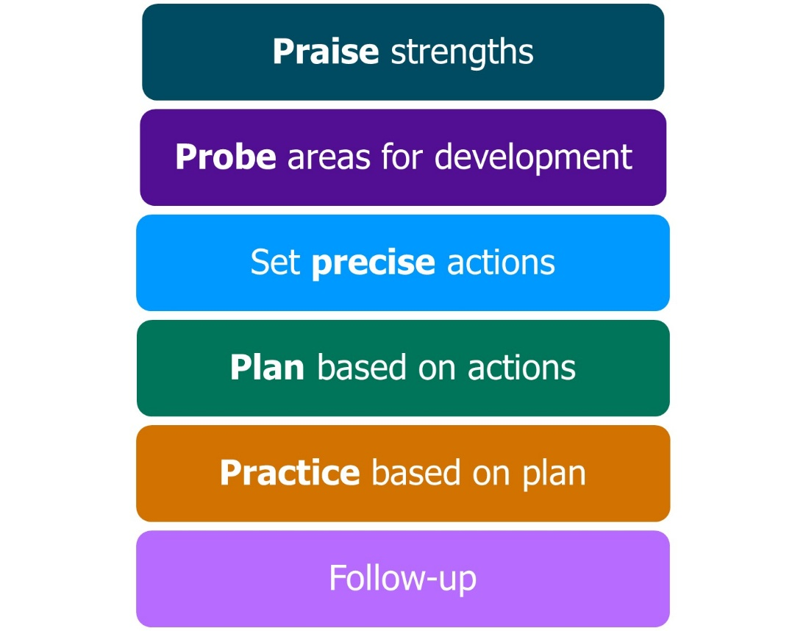
Adapted from Bambrick-Santoyo, 2016
Following regular lesson drop-ins, the framework should be used to provide feedback to early career teacher. Here’s a quick overview of each step:
- Praise and recognise strengths: Acknowledge where the ECT has effectively planned or implemented actions from prior observations.
- Probe and identify areas for development: Using evidence from the observation, mentors engage in a dialogue with ECTs to identify possible development areas in their practice.
- Set precise actions: Focusing on the highest-leverage granular element of practice linked to the area identified for development.
- Plan together how to apply the action: Mentors work with the ECT to plan when and how the action step will be used in an upcoming lesson.
- Practice how it will be embedded: Using our deliberate practice approach, mentors model or share an example of effective practice. ECTs will then practice, receiving feedback from their mentor, until they are confident and ready to apply the action in their own classroom or setting.

- Arrange a follow-up observation session: Organise a further opportunity to observe the ECT implementing the agreed action with follow-up feedback.
Watch this video introduction to the model for more details about each part and guidance on how it will be used in mentor meetings. This video and a PDF version of the slides is available in the Knowledge Base on Prism.
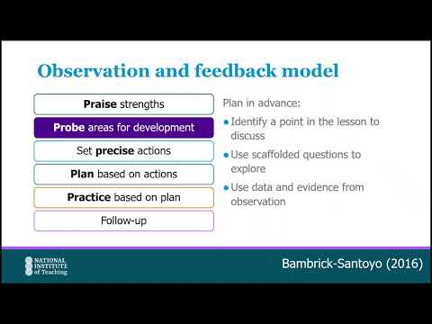
Click here to watch: Introduction to the Six-Step Observation and Feedback model

Return to Content page

Appendix 4
Deliberate Practice
Deliberate Practice is a key component across all programmes at the National Institute of Teaching. It focuses on developing expertise by tailoring practice with guidance from peers, an experienced teacher, a coach or a mentor.
The NIoT approach draws on Bambrick-Santoyo’s ‘See it, name it, do it’ model (2018) and Deans for Impact’s ‘Practice with Purpose’ (2016).
Mentors should use this in meetings with their ECT. It lies within the Observation and Feedback model - during the fifth step, ’Practice based on plan’.
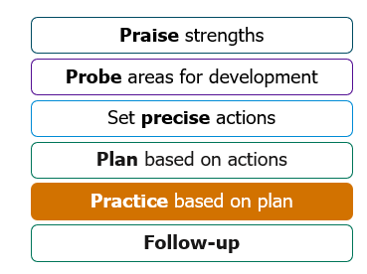
Adapted from Bambrick-Santoyo, 2016
Watch this short introduction to the Deliberate Practice model:
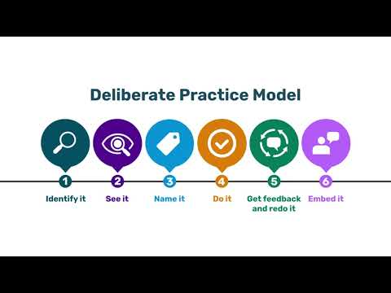

Click to watch: NIoT Deliberate Practice model
Return to Content page
Appendix 5
Flexible module sequence - Frequently asked questions
Why can schools change the order of ECT modules?
In response to feedback from the education sector, the ECT programme allows schools to adapt the order of some modules. This flexibility enables schools and trusts to align ECT development with their own professional development priorities, which can increase the overall impact of training.
Do schools have to change the module sequence?
No. There is no obligation to change the sequence. Schools may choose to follow the programme exactly as designed. If you do not wish to adapt the sequence, no action is required.
Can a school choose any order for the remaining modules?
Yes, modules B–F can be completed in any order, provided:
- Behaviour and Relationships is completed first.
- The full set of six modules is completed within the year.
- The sequence is agreed and confirmed on Prism by the end of half term 1.
No further changes can be made after this point.
Can our school combine parts of different modules together?
No, each module must be completed in its entirety before moving on to the next.
Why might a school choose to adapt the sequence?
Schools may adapt the sequence to:
- Align ECT development with whole-school or trust priorities.
- Address specific areas of need, such as planning, assessment, or confidence in teaching.
- Support existing professional development programmes already planned for staff.
Can different ECTs in the same school follow different sequences?
No. Where there is more than one ECT in a school, all ECTs must complete the modules in the same order. This supports consistency, peer support, and more effective mentoring.

What if we are part of a multi-academy trust?
If you work in a MAT, you should check whether module sequencing decisions are being made at:
- a trust-wide level, or
- an individual school level.
This discussion should take place before submitting a revised sequence.
Will changing the sequence affect ECT progress reviews?
No. Changing the order of modules will not affect termly progress reports. The programme is designed so that:
- All ITTECF framework statements are covered across Year 1, and
- Learning is consolidated in Year 2, regardless of sequence.
Will seminars be in a flexible sequence too?
No. All seminars remain in the fixed seminar sequence outlined in the programme materials, even if the module study sequence is adapted. Seminars are carefully designed to ensure that the content is relevant to all ECTs, regardless of their sequence of study.
Will the mentor’s ECT Support Materials align with ECT materials if we change the sequence?
Yes. ECT support materials for mentors will automatically align with the ECT’s selected module sequence.
What happens if an ECT joins the school partway through the year?
Any ECT joining later in the year should:
- complete Behaviour and Relationships first, and
- then join the programme at the same point as their colleagues.
What should schools consider before changing the sequence?
Before adapting the sequence, consider:
- Whether the decision sits at school or trust level.
- Your school or trust’s professional development priorities.
- Input from experienced mentors and relevant senior leaders.
- Whether you have a clear rationale for why an alternative sequence would benefit your ECTs.
How do we submit a revised module sequence?
If you decide to adapt the module sequence:
- Log in to Prism.
- Submit your revised sequence for modules B–F.
- Ensure this is done before the end of Autumn half term 1.
If no changes are needed, no submission is required.

Remember, you can find further information and support on Prism’s Knowledge Base by clicking here.

Return to Content page

Appendix 6
Mentor programme self-study overview
Autumn Term
 | Self-study | Title | Summary
Choose 1 | 1a | Delving into deliberate practice | Exploring the key components of effective deliberate practice for those who have not used it before.
Choose 1 | 1b | Beyond the basics: embedding deliberate practice | Revisiting and developing your understanding of the key components of effective deliberate practice.
Spring and Summer terms
Choose 2 from the following | 2 | Unlocking effective adapting teaching | Considering how to support their ECTs to adapt their classroom practice in order to make their teaching inclusive. Responding to the growing numbers of pupils with SEND in mainstream settings, this self-study will draw on the latest research.
Choose 2 from the following | 3 | Putting 'belonging' at the heart of pedagogy | Explore the value of pupils' sense of 'belonging' and its impact on positive outcomes both in school and longer term. They will work with peers and experts to explore how to support ECTs in considering where 'belonging' fits within their teaching and how to develop this.
Choose 2 from the following | 4 | Making feedback stick | Consider why feedback isn't always acted on by the recipient. Using up-to-the-minute research and insights gained from NIoT research on feedback literacy, participants will explores strategies and approaches to ensure their feedback sticks.
Choose 2 from the following | 5 | Moving beyond instructional coaching | Lifting the lid on coaching approaches, providing insights into the mechanisms for effective coaching including instructional coaching and also exploring other strategies that can be leveraged as part of the professional development of others.
Choose 2 from the following | 6 | Navigating difficult opportunity conversations | Tools for mentors to feel better-equipped to conduct potentially challenging conversations and re-framing them as opportunities for reflection, growth and development.

Return to page 28
Return to Content page

Appendix 7
Flowchart to show mentor types and training required
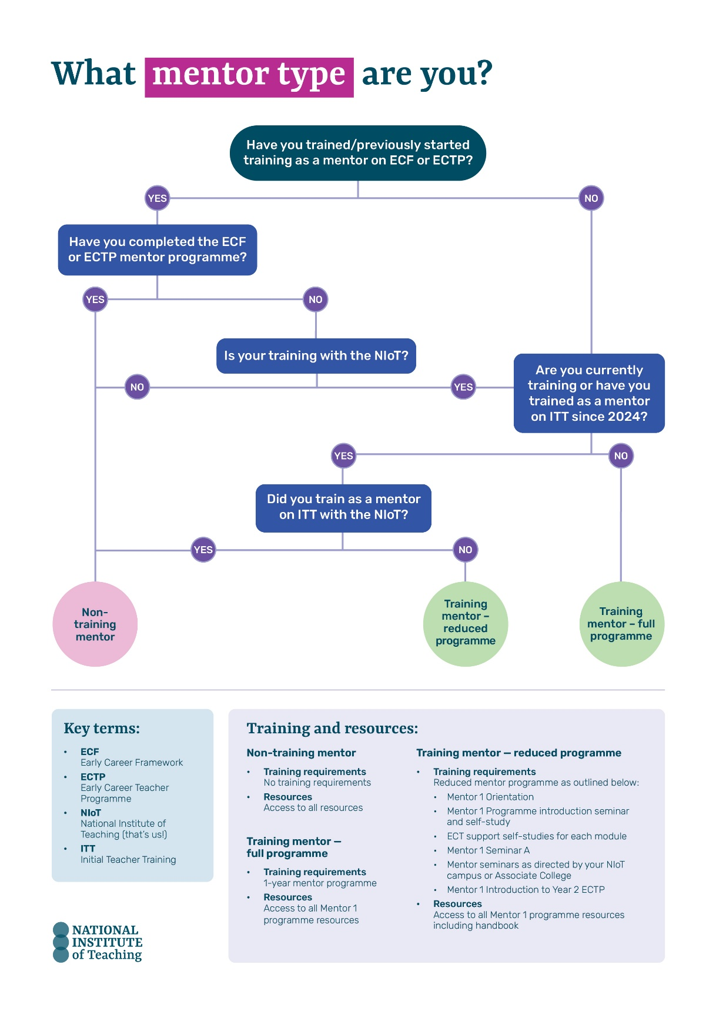
Return to page 29
Return to Content page

