

|  |
| --- |
|  |
| **ECT Programme Handbook for mentors** |
| [Document subtitle] |
| **How to get in touch with us:**  North West: [ECF_NW@niot.org.uk](mailto:ECF_NW@niot.org.uk)  North East: [ECF_NE@niot.org.uk](mailto:ECF_NE@niot.org.uk)  South East & London: [ECF_ESL@niot.org.uk](mailto:ECF_ESL@niot.org.uk)  South West: [ECF_SW@niot.org.uk](mailto:ECF_SW@niot.org.uk)  **Online:**  [Early Career Teachers – The National Institute of Teaching](https://niot.org.uk/programmes/ECF) |



# **Introduction**

Welcome to this mentor handbook for the Early Career Teacher (ECT) Programme from the National Institute of Teaching. It includes information to support mentors working with ECTs on both the new programme for year 1 and the existing early career framework (ECF) programme for those in their second year. Please navigate to the relevant sections in the Content table below.

|  |  |
| --- | --- |
| **Content** |  |
| ECT Programme - Year 1 | Page 3 |
| Year 1 Mentor Programme | Page 10 |
| ECF Programme– Year 2 | Page 12 |
| Mentors in Year 2 | Page 16 |
| Time commitment 2025/26 – Year 1 and Year 2 | Page 17 |
| On-line learning management system – Prism | Page 18 |
| Wellbeing tool | Page 18 |
| Mentor role and responsibilities | Page 19 |
| Key terminology | Page 20 |
| Suggested actions | Page 21 |
| Appendix 1: Year 1 Modules and associated self-studies | Page 22 |
| Appendix 2: NIoT 6-step observation and feedback model | Page 24 |
| Appendix 3: Weekly meeting template for Year 1 ECTs | Page 25 |
| Appendix 4: Meeting template for Year 2 ECTs | Page 31 |
| Appendix 5: Mentor Programme - self-study overview | Page 34 |

# ECT Programme – Year 1

Programme overview

From September 2026, all early career teachers starting in year 1 will follow the new ECT programme. In the first year, full time ECTs will study 6 modules, 1 per half term, underpinned by the domains in the new initial teacher training and early career framework (ITTECF). You can read more about the ITTECF [here](https://assets.publishing.service.gov.uk/media/661d24ac08c3be25cfbd3e61/Initial_Teacher_Training_and_Early_Career_Framework.pdf).

ECTs who are working and studying part time will require a bespoke programme to match their working patterns and engagement preferences. Induction Tutors will be responsible for organising that.

In year 1, you should observe your ECT every week for around 15 minutes, focusing on their action step. You’ll meet with them weekly for an hour (or equivalent) to provide feedback using the NIoT’s six-step observation and feedback model of instructional coaching. You should record your feedback and the next action for your ECT on Prism. See Appendix 2 for more information on the observation and feedback model.

The new ECT programme from the NIoT offers a flexible sequence of study combined with personalised pathways for participants. Take a moment to watch the video below which outlines how our programme works.

[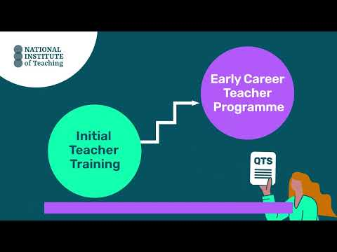](https://www.youtube.com/embed/TteLqYk2Mro?feature=oembed)

Click to watch video: [ECT Programme structure for Y1](https://www.youtube.com/watch?v=TteLqYk2Mro)

Summary of key features of the ECT programme for year 1:

* 6 modules that align with the ITTECF.
* ECTs complete one module per half-term.
* The module sequence is flexible apart from the first half-term. Schools can select a different order. Induction Tutors will make this decision and confirm it on Prism before Autumn half-term.
* The content intentionally revisits the evidence that ECTs first explored as an initial teacher trainee providing opportunities for them to build on existing knowledge and skills.
* Each module, is made up of 1 core self-study, a diagnostic reflection and 5 elective self-studies.
* Having completed their core self-study each term, ECTs will complete a 30-minute diagnostic.
* The diagnostic will help to guide ECTs and their mentors to select **3 of the 5** elective self-studies (2 in half-term 1) to study over the remainder of the half-term.
* Mentor support materials are available to support mentors when working with their ECTs, including planning their weekly meetings.

Modules in Year 1

In year 1 of the ECT programme, the modules that ECTs will study are:

* Behaviour and relationships
* Memory and learning
* Planning and delivery
* Subject and curriculum
* Assessment for learning
* Adaptive practice

The first module that all ECTs will complete in year 1 is Behaviour and relationships. This will support ECTs to establish a positive, structured learning environment that fosters pupil engagement, wellbeing, and academic success at the very start of the academic year. You can see a list of the focus areas within each module here.

Due to the flexible approach to the module sequence, some ECTs may complete their study in a different order to colleagues in different schools or outside their trust. You should reassure your ECT that this will not impact on their termly progress reports as the programme design ensures that all ITTECF framework statements will be covered across year 1 of the programme and consolidated in year 2.

“My school has selected a different module sequence” - what you need to know as a mentor

* All ECTs complete the module on ‘Behaviour and relationships’ in Autumn half term 1.
* ECTs will still complete all 6 modules – one module per half term.
* All ECTs will attend live seminars in the sequence outlined in the introductory materials and in this handbook.
* Your mentor support materials on Prism will align with the ECT’s modules.
* Where there is more than one ECT in a school, all participants must complete the modules in the same order. This ensure a consistent approach.
* All ITTECF statements will be addressed across year 1 of the programme and consolidated in year 2.
* In schools where there is more than one ECT, all participants must complete the modules in the same sequence.
* Should any ECTs join the school later in the year, they will still complete the module on behaviour and relationships first and then join the programme as the same point as their colleagues.

Year 1 Programme content - Early Career Teachers

Take a moment to look at the structure of the ECT programme in year 1:

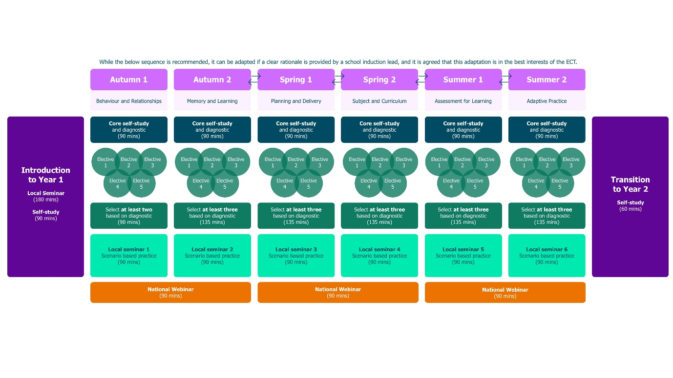

Introductory materials

At the start of the programme, all ECTs will attend a 3-hour in-person local seminar where they will:

* learn more about the structure of the NIoT’s ECT programme
* understand what it means to develop teacher expertise
* explore the observation and feedback model used by the NIoT’s ECT programme
* consider how to manage their well-being

The seminar will also provide the opportunity for ECTs to network with peers. ECTs will also complete a 90-minute on-line self-study as part of their onboarding process.

**Core self-study**

Early career teachers will complete one core self-study per module followed by a diagnostic reflection.Both of these will be accessed on the learning management system, Prism.The core self-study acts a refresher to the evidence and theory that ECTs will have gained in that specific domain during their ITT.

Diagnostic personal reflection

ECTs will complete a diagnostic for each module after they’ve read the related core-study. The diagnostic is found on Prism and it will take them approximately 30 minutes. It’s comprised of 20 multiple-choice questions related to the domain. The results will be accessible to you on Prism to be used during the reflective discussion you have with your ECT prior to their selection of elective self-studies for each module.

There is no pass or fail - the diagnostic report is designed as a guide or a ‘proxy’ to help you and your ECT identify specific areas for further development or enhancement within their current practice. The suggested recommendations are intended to support the start of a conversation between you both as to what electives could have the greatest impact on their personal development.

**Elective self-studies**

The outcome of the diagnostic, along with the ECT’s Career Entry Development Profile (CEDP) or other targets from their ITT, will guide their discussion with you, as their mentor, as you identify together a focus for development within a module.

ECTs then select **3 elective self-studies** permodule – each focused on a more granular aspect of the broader topic. However, for half-term 1 they will only need to complete 2 elective self-studies. This is to give them more time to get settled into the new school year**.**

Local seminars

ECTs attend half-termly local seminars which are run by carefully selected, highly experienced teachers and school leaders. The seminars will be either in person or online and the activities undertaken will give them the chance to engage with wider expertise and network with peers.

Our holistic approach to seminar-design means the content of each session will support the development of all ECTs regardless of their sequence of self-study modules or choice of electives.

In seminars, ECTs have the opportunity to connect different aspects of their teaching—such as planning, assessment, and behaviour management—into a more cohesive and effective practice. By integrating multiple elements of teaching as they work through a range of thought-provoking scenarios, ECTs will develop their adaptive expertise supporting them to make better-informed decisions in real time and making their teaching more responsive to individual needs.

For example, while seminar 1 focuses on ‘Ensuring safe and predictable learning environments’, ECTs will also be supported to draw on and deepen their understanding of the role that planning and formative assessment has in achieving this goal.

**Local seminars for ECTs in Year 1 - 2025/26**

|  |  |  |  |  |  |
| --- | --- | --- | --- | --- | --- |
| Autumn half term 1 | Autumn half term 2 | Spring half term 1 | Spring half term 2 | Summer half term 1 | Summer half term 2 |
| Ensuring safe and predictable learning environments | Planning effective lessons | Working in partnership with stakeholder | Checking prior knowledge and addressing misconceptions | Assessment literacy and analysis to inform teaching and learning | Integrating technology into classroom practice to support adaptive teaching |

National Expert Webinars

ECTs will also attend one National Expert Webinar per term facilitated by leading experts in their fields. These provide an opportunity for them to hear from a range of experts on different areas of pedagogy. The experts leading our National Webinar Series for the 2025/26 Year 1 ECT programme will be confirmed in September 2025. Previous experts include Tom Bennett and Alex Quigley.

As a mentor, you are also invited to attend these webinars to support your own development and enable you discuss the content with your ECT.

**Return to Content page**

# Year 1 Mentor Programme

The mentor programme is designed to develop you as mentors of teachers, not just early career teachers. We have spoken to mentors to find out what they feel would be most useful for them. This programme is an entitlement and (funded) mentors should be enabled and encouraged to engage throughout in order to complete it. If you have any queries relating to this, speak to your Induction Tutor.

You’ll gain access to **mentor support materials** on Prism. These are summaries of the ECT studies so that you can have an overview of what your ECT is learning. Your self-study content adjusts in line with any sequence order changes made to your paired ECT's module order. The materials are designed to support you to identify and name the ‘active ingredients’ of effective practice, select appropriate actions for ECTs and plan your weekly meetings. The materials include a framework for you to use to plan the meetings (see Appendix 3).

In addition to the mentor support materials, you’ll also have **a programme of bespoke materials** designed especially for mentors. This comprises of self-study sessions (hosted on Prism) and a choice of attending live seminars or expert webinars. They’ll help you in your mentoring role and in your professional development more widely as a teacher or school leader.

Each self-study takes 30-minutes, and you’ll complete one per term from a choice of six so you can personalise your own development. However, all mentors must complete the study on deliberate practice in the first term as this is integral to our programme design. For this initial study, you’ll elect to complete either the ‘novice’ or ‘experienced’ option depending on your previous experience using deliberate practice. This ensures the content is tailored to your needs. Here’s an overview of the self-study topics.

All mentors will complete self-study 1a or 1b:

* Deliberate practice (novice/experienced)

Then you’ll choose a further 2 from:

* Unlocking effective adaptive teaching
* Putting ‘belonging’ at the heart of pedagogy
* Making feedback ‘stick’
* Moving beyond instructional coaching
* Navigating ~~difficult~~ opportunity conversations

The self-study content has been carefully planned based on what mentors have told us they find difficult about mentoring, but also to reflect the expertise you bring to the role. See Appendix 5 for further details about each self-study.

Mentors will attend one local seminar per term designed to both develop your practice as an ECT mentor and build your expertise as a leader of teacher development. The local seminars on the Mentor Programme are:

**Autumn 1:** **Supercharge your ECT's progress!**

How to identify the highest leverage practice to support your ECT. Enhance your instructional coaching practices by effectively using the NIoT’s own observation and feedback model.

**Autumn 2: Pedagogy v Andragogy?**

How different really is working with adults? A chance to consider which principles are common to both teaching children and adults and how to navigate the challenges that andragogy may present.

**Autumn 3: Getting under the hood of AI and its implications for teacher development**

What role should AI have in changing the role of the teacher and what are the implications for mentoring? Deepen your understanding of the use of AI in the sector including the risks and challenges. Drawing on up-to-the minute research, you’ll consider how to support ECTs with their workload by using AI. You’ll also explore how it can be leveraged to enhance the role of the mentor.

As mentioned earlier, you’ll also have the option to join the same three National Expert Webinars that ECTs will be attending.

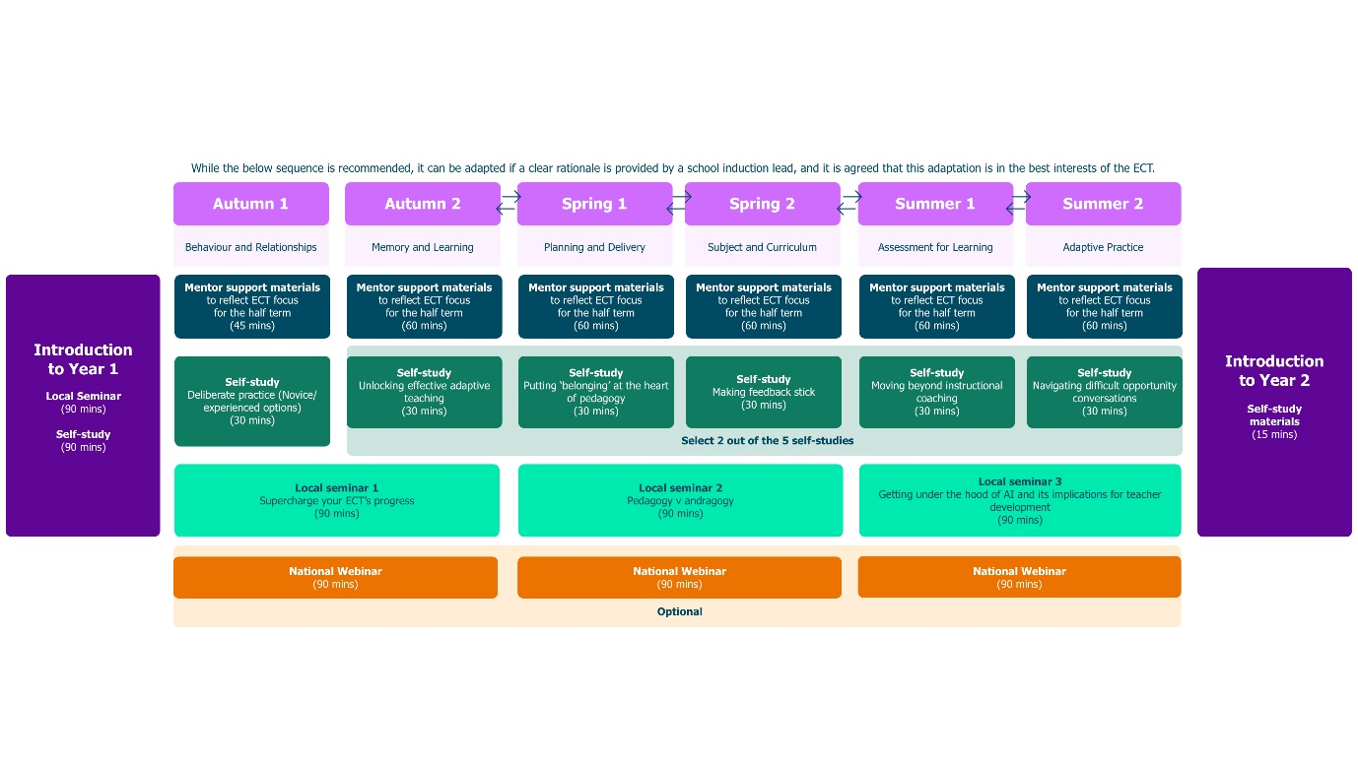

**Return to Content page**

**ECF Programme – Year 2**

The Year 2 programme is outlined below; please note that the half-termly structure is different to the ECTP Year 1 programme.

# A flowchart-style timeline showing the recommended sequence for Year 2 of an Early Career Teacher (ECT) program. The timeline is divided into six terms: Autumn 1 (Behaviour and Relationships), Autumn 2 (Memory and Learning), Spring 1 (Planning and Delivery), Spring 2 (Subject and Curriculum), Summer 1 (Assessment for Learning), and Summer 2 (Adaptive Practice). Each term includes self-study materials with diagnostics, three focus areas, a seminar or scenario-based practice session, and national webinars. The sequence starts with an 'Introduction to Year 2' including a local seminar and self-study.

For each module, ECTs will study three key ‘readings’. These are summaries of research from the ITTECF evidence base. They’ll consider the implications of the evidence on their own classroom practice and explore exemplification that demonstrates how this could look.

Materials have been designed to ensure that ECTs revisit key concepts and practices from both their initial teacher training and the first year of the ECF programme, using both diagnostic approaches and reflection to ensure that the content you are engaging with is most useful to your developing practice as a teacher.

Observations and actions

Unlike year 1, the programme structure in year 2 does not provide suggested weekly actions for early career teachers. Instead and with support from you, the mentor, the ECT will use their diagnostic reflection to **plan and implement** a strategy or approach in their classroom and assess its effectiveness, making tweaks as appropriate **across the half term**.

Mentor observations should focus on this area and feedback be used to inform those tweaks so that ECTs develop and **reflect on and review the impact** and success of the implementation throughout the half term and especially in their final meeting of the half term.

We suggest that the initial observation for each half-term focuses on pedagogical aspects of the related domain for that module, for example in half-term 2, the first observation will focus on strategies linked to how pupils learn. The feedback can be used, in conjunction with the diagnostic reflection, to support the selected area of focus for the remainder of the half-term.

Meetings with the mentor (fortnightly) should be structured like this across a standard half term to support this implementation cycle:

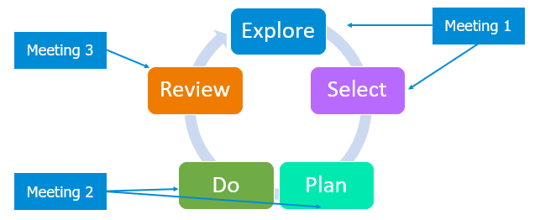

In year 2 of the programme, ECTs and mentors meet once per fortnight for an hour (or equivalent). You should observe ECTs each fortnight for no less than 15 minutes and, as with year 1, you’ll use the six-step feedback model (see Appendix 2), instructional coaching and record your feedback and the ECT’s fortnightly target on Prism. You can use the template in Appendix 4 to help you plan your meeting.

Year 2 Onboarding

At the start of the year, ECTs will attend a three-hour in-person local seminar where they will:

* review the ECT programme structure for year two in depth
* consider the role and responsibilities of a second year early career teacher
* understand what it means to make use of research evidence as they continue to develop teacher expertise
* explore the personal professional development model used by the NIoT’s ECF programme and
* consider how they will manage their own well-being as they continue to develop their career in teaching
* have the opportunity to network with peers

They will also complete an associated self-study on Prism.

Self-study materials

Self-study materials for ECTs are designed to take 90 minutes over six weeks and are accessed via Prism. These do not need to be completed in one go to support ECTs in managing their time, however, they should complete the study within the first two weeks of the half-term to ensure they have sufficient time to implement the actions.

Diagnostic assessment – your ECT’s personal professional reflection

Having completed their self-study, ECTs will complete a diagnostic assessment to identify their current development needs. This document can be downloaded from Prism.

ECTs will encounter a series of statements across each of the domains of the ECF, allowing them to assess their current practice and gauge their level of mastery. The ‘Professional Growth Continuum’ against which they will reflect on their practice is based on the expectations of teachers at different stages along the path to expertise, with level 5 a description of an expert teacher. While we do not anticipate ECTs to have reached the pinnacle of expertise at this stage, there may be specific elements of their practice that they feel they’ve mastered more than others.

Professional Growth Continuum

Each domain from the ITTECF has been set up as a single diagnostic assessment so ECTs can complete them as they move through the modules over the year. There is no expectation that all the diagnostic assessments will be completed at once.

Once completed, ECTs should share their diagnostic assessment with you. With your support, ECTs should then explore and choose **one** of the readings to focus on more closely for the remainder of the half term. They should use their diagnostic assessment to help guide their choice but ultimately they should choose the one which is most relevant, helpful or challenging for them at this point in their journey from novice to expertise.

A table with four statements and five columns numbered 1 to 5 for rating. The statements are:

1. "Consistently employ intentional actions to build positive relationships that enhance pupil wellbeing, motivation and behavioural development."
2. "Recognise the role of the teacher as an influential role model and consistently model positive attributes and values."
3. "Set challenging, yet attainable goals for each student within the framework of a rigorous curriculum."
4. "Communicate a strong belief in the academic potential of all pupils through intentional, consistent, and empowering language that fosters a sense of challenge and aspiration among students."

The table is designed for users to rate their agreement or performance on each statement using the scale from 1 to 5.


Example from diagnostic for ‘High Expectations’

Live seminars

Throughout the second year, ECTs will have half termly seminars, lasting 90 minutes, with expert, local facilitators who will reinforce learning, focusing on application in context using deliberate practice to allow ECTs to develop their mental models and gain feedback on their practice.

In year two, there is a greater emphasis on subject and phase specialism. Three of the six sessions will be subject/phase specific, led by experienced subject specialists to deepen ECTs’ expertise.

National Expert Webinars

As with year 1, ECTs will attend one webinar per term, hosted by leading experts in their fields. These last 90 minutes.

**Return to Content page**

# Mentors in Year 2

Mentors remain a pivotal part of the year 2 programme whether they are funded on the ECF for a second year (and therefore also training on the programme) or a fully trained mentor who is continuing to support an ECT through their induction.

However, for mentors who are training on the ECF programme already (meaning they commenced training prior to September 2025 and have not completed a full two years of ECF training yet), there is a bespoke suite of training. This is aimed at ensuring you are confident when exploring the evidence and its application but also in supporting less-experienced colleagues (ECTs specifically) to apply what they are learning to their school context.

The mentor programme in year 2 combines self-study summaries of ECT content (accessed on Prism) with live termly seminars and optional National Expert Webinars. These will provide an opportunity for you to network with other mentors and practice your mentoring skills with both peer and expert facilitator support. Attending these will develop your own skill and expertise as well as learning more about what your ECT is doing on their programme.

Whilst seminars for mentors focus on the ECT readings, they specifically do so from the perspective of a mentor who is supporting an ECT to apply and reflect in context; using the implementation cycles outlined earlier.

**Return to Content page**

**Time commitment for the 2025-26 programme (Year 1 and 2)**

**
A table titled "ECT Overview of 2025/26" showing the programme elements, their duration, and frequency for Early Career Teachers (ECTs) in Year 1 and Year 2.

**Alt text:**
A table titled "ECT Overview of 2025/26" outlines the programme elements, their duration, and frequency for Early Career Teachers (ECTs) in Year 1 and Year 2.

In Year 1 (ECTP), mentoring lasts 1 hour and occurs weekly. Onboarding is 3 hours long and takes place once in Autumn 1. Self-study takes 45 minutes and is completed weekly. Local networking seminars are 90 minutes long and happen half termly. National expert webinars also last 90 minutes and occur termly.

In Year 2 (ECF), mentoring is 1 hour and takes place fortnightly. Onboarding remains at 3 hours and happens once in Autumn 1. Self-study is reduced to 15 minutes weekly. Local subject seminars are 90 minutes and occur half termly. National subject webinars last 1 hour and are held termly.

**

****Alt text:**
A table titled "Mentor Overview of 2025/26" presents the programme elements, their length, and frequency for mentors supporting Early Career Teachers (ECTs) in Year 1 and Year 2.

In Year 1 (ECTP), mentoring lasts 1 hour and occurs weekly. Onboarding is 3 hours long and happens once in Autumn 1. Self-study is 30 minutes and takes place half termly. Mentors are required to choose three from the following options: local seminars, which last 90 minutes and are termly (optional); national expert webinars, also 90 minutes and termly (optional); and an introduction to Year 2 self-study, which lasts 15 minutes and is completed in the summer term.

In Year 2 (ECF only), mentoring is 1 hour and takes place fortnightly. Onboarding lasts 90 minutes and is held once in Autumn 1. Self-study is 10 minutes, completed fortnightly. Regional subject seminars are 90 minutes and occur termly. National subject webinars are optional, last 1 hour, and take place termly.
**

**Return to Content page**

# On-line learning management system – Prism

Our learning management system (LMS) is called Prism and will be used by ECTs, mentors and Induction Tutors.

As a mentor, it will help you to support your ECT by giving you clear insights into how the programme is going for them, including their self-study, live session attendance and meetings. It’s where you will record your feedback and set and monitor their actions.

Prism is also a one-stop shop for all your self-study content meaning that you’ll only need one login to access everything you need. You’ll be directed to a ‘how-to’ guide the first time you log on to Prism so you’ll know exactly how to use each feature.

# 

# Well-being tool

We are proud of our well-being tool which is designed to gather diagnostic responses on the well-being of ECTs throughout their two-year ECTE. This tool aims to enhance the overall programme experience for all participants within the National Institute of Teaching.

ECTs will access this via their account on Prism and it will be available for them to access 24/7 as often as they like. It only takes a few minutes for them to complete a diagnostic and the results will be shared with you enabling you to provide additional support where necessary.

Wellbeing app

A diagram showing 3 pages from the NIoT diagnostic tool. 

One being the log in page, one being an example question page and the final being an example of the results page.

**Return to Content page**

**Mentor role and responsibilities**

Your role as a mentor is pivotal to developing ECTs as they progress through the programme.

**Observation and feedback**

As a mentor, you will observe and meet with your ECT weekly in the first year, and every two weeks in the second year of the programme.

During these interactions you’ll support your ECT to access and reflect on programme materials, provide regular feedback focusing on supporting them to develop their practice and help them to identify further opportunities for professional development. In order to do this effectively, you should familiarise yourself with the self-study materials before the feedback meeting using the summary materials​.

**Bridging the theory to practice gap**

A key part of your role is to help your ECT connect theoretical concepts with practical application within your specific educational environment. This process will be facilitated through the exchange of feedback and discussions that occur during your regular weekly developmental meetings. The NIoT observation and feedback model will play a crucial role in the ongoing growth of ECTs.

Additionally, you may want to arrange opportunities for the ECT to observe experienced colleagues in action. This can help them bridge the gap between theory and practice by seeing how teaching is applied in their specific context.

**Pastoral care**

The role of the mentor extends to providing pastoral care for your trainee and as part of this care, the well-being of your ECT should be closely monitored. Some of the ways that you can do this include:

* add a well-being check-in as part of your weekly meeting using the data from the well-being tool
* if necessary, signpost ECTs to any additional well-being resources offered by your school
* ensure that your ECT is receiving their full entitlement to non-contact time
* share and model strategies to use their time efficiently and effectively
* adding AOB to the weekly meeting, for example, discussing upcoming key events in the school calendar that ECTs may need to prepare for

Where there are any concerns regarding your ECT, you should escalate these to your Induction Tutor​.

**Return to Content page**

# Key terminology

**Early Career Framework (ECF)**: Replaced Newly Qualified Teacher (NQT) induction in 2021 to enhance career retention. A two-year statutory programme providing core evidence-based training for Early Career Teachers (ECTs) and their Mentors. ECF includes self-study and live sessions, crucial for accessing funding.

**Early Career Teacher Programme (ECTP) or Entitlement (ECTE):** Replaces ECF from September 2025 onwards. You can read more about the it [here](https://www.gov.uk/government/publications/early-career-teacher-entitlement/early-career-teacher-entitlement#background).

**Lead Provider:** National Institute of Teaching (NIOT). Responsible for design and delivery of ECF/ECTP programmes in partnership with local associate colleges and campuses, who contextualise learning for participants to apply effectively in schools.

**Delivery Partner/Associate College/Regional Campus**: Local organisations collaborating with NIOT to deliver live sessions tailored to ECTs and mentors, utilising their local knowledge for effective support.

**Appropriate Body (AB):** Organisation to whom termly reviews of ECTs are submitted for progress assessments. An independent body, ABs address concerns about ECT progress, agreeing on extended or reduced inductions and ensuring adequate support for ECTs and mentors.

**Funded or fully trained Mentors:** Funded mentors are those who are taking part in the programme because they have not yet completed a total of 6 full terms of ECF Mentor induction programme yet. Fully Trained (completed) mentors have completed 6 terms (on any lead provider’s programme) and thus are no longer required to attend live sessions or complete self-study for their own programme; they will no longer be funded to complete the ECTP training. They must still support the ECT in the same way as funded mentors though and are likely to benefit from completing induction training.

**Return to Content page**

# Suggested actions

To help you prepare for your role, you may wish to consider the following actions:

1. Speak to your Induction Tutor to confirm the module sequence (for Year 1 only)
2. Have you accessed Prism and can you see your ECT’s details?
3. Have you planned when you will engage with your own self-study?
4. Have you scheduled time within your timetable to meet with your ECT either weekly (Year 1) or fortnightly (Year 2)?
5. Have you encouraged your ECT to allocate time in their timetable to engage with the content of the self-study each week?
6. If they are new to your school, you may wish to spend some time in your first meeting helping your ECT find the answers to some of the following questions:

* What are the different platforms that the school uses to take the register or record behaviour incidents and rewards? How do they use them?
* What should they do if they encounter an IT issue during a lesson?
* How many duties will they have? What is expected of them during duty? What should they do if there's an issue while on duty?
* Where can they find the resources they need to plan and adapt their lessons?
* What are the working hours? When do staff need to arrive at the building?
* What time can staff leave at the end of the day?
* How can they make a call out to SLT or their Head of Department if they need assistance in their classroom?

You may need to schedule some time with your Induction Tutor or other colleagues to find the appropriate responses to some of these questions.

**Return to Content page**

# Appendix 1

ECT Year 1 Programme - Modules and associated self-studies

|  |  |  |
| --- | --- | --- |
| **Module** | **Elective self-studies in this module** | |
| Behaviour and relationships | 1 | Communicating belief in pupils' academic potential |
| 2 | Establishing effective routines and expectations |
| 3 | Creating a positive, predictable, and safe learning environment |
| 4 | Building effective relationships |
| 5 | Motivating pupils |
| Memory and learning | 1 | How the memory works |
| 2 | The role of pupils’ prior knowledge |
| 3 | Managing cognitive load |
| 4 | Understanding and addressing pupil misconceptions |
| 5 | Retrieval, revisiting and reviewing information |
| Planning and delivery | 1 | Explanations, modelling and examples |
| 2 | Scaffolding and increasing challenge |
| 3 | Planning effective practice, including homework |
| 4 | Questioning as an essential tool for teachers |
| 5 | Fostering classroom talk and peer collaboration |
| Subject and curriculum | 1 | Delivering a carefully sequenced curriculum |
| 2 | Anticipating misconceptions |
| 3 | Building increasingly complex mental models |
| 4 | Developing early literacy |
| 5 | Enhancing all pupils' literacy |
| Assessment for learning | 1 | Designing effective assessment |
| 2 | Checking prior knowledge and understanding |
| 3 | Providing high-quality feedback |
| 4 | Making marking and feedback manageable |
| 5 | Developing your practice in relation to assessment and feedback |
| Adaptive practice | 1 | Understanding different pupil needs |
| 2 | Providing opportunities for all pupils to succeed |
| 3 | Meeting individual needs without creating unnecessary workload |
| 4 | Effective grouping and deployment of teaching assistants (TAs) |
| 5 | Developing your knowledge in special educational needs and disabilities (SEND) |

**Return to Modules overview**

**Return to Content page**

# Appendix 2

The National Institute of Teaching uses the six-step observation and feedback model based on the work of Bambrick-Santoyo (2016).

This six-step observation and feedback model supports mentors to:

1. **Praise and recognise strengths:** Acknowledge where the ECT has effectively planned or implemented actions from prior observations.
2. **Probe and identify areas for development:** Using evidence from the observation, mentors engage in a dialogue with ECTs to identify possible development areas in their practice.
3. **Set precise actions:** Focusing on the highest-leverage granular element of practice linked to the area identified for development.
4. **Plan together how to apply the action:** Mentors work with the ECT to plan when and how the action step will be used in an upcoming lesson.
5. **Practice how it will be embedded:** Using our deliberate practice approach, mentors will model or share an example of effective practice. ECTs will then practice, receiving feedback from their mentor, until they are confident and ready to apply the action in their own classroom or setting.
6. **Arrange a follow-up observation session:** Organise a further opportunity to observe the ECT implementing the agreed action with follow-up feedback.

**Return to Content page**

# Appendix 3

Year 1 Programme - Mentor and ECT meeting template

|  |
| --- |
| **Please ensure you read the mentor session materials for the relevant elective self-study on the LMS before your meeting.** |
| **Check-in**  Start by asking your ECT how their week has been, both in and out of school, check in on their wellbeing, workload, and energy levels. You could invite them to share any successes, challenges, or areas where they’d like support. |
|  |
| **Praise strengths** Following the observation of your ECT this week, praise a specific area of their practice based on your observations from the lesson. This may be a previous action step that they have successfully implemented. |
| Notes |
| **Probe areas for development** Based on your notes from the observation, identify an area for development linked to the current focus area. You may wish to ask your ECT to share their notes from their reflections during the self-study as part of this process to help elicit their understanding and drive the dialogic process. |
| Notes (include relevant dates and details from specific observations) |
| **Set precise actions** Having probed areas for development, elicit a precise action your ECT can implement to develop their practice relating to the focus area. Ensure it is:   * **Observable** – ensure it is something that can be seen during the lesson observation. * **Practice-able** – is this something that your ECT can successfully achieve? Aspirational targets should be avoided. * **Bite-sized** – the action should be granular so that ECTs can achieve it by the next observation rather than long-term, multi-faceted targets. * **Include the ‘how’ not just ‘what’** – success criteria will help determine how the action will be achieved. This could be written jointly with the ECT. |
| Agreed precise action |
| Plan based on actions: Work with your ECT to review and refine their chosen action. This could include a script or product to be used live with pupils.  Identify success criteria together focusing on the ‘active ingredients’ of the approach. Through questioning and dialogue, support your ECT to identify ways to successfully implement their action. |
| Observations of colleagues? Who? When?  When will the action be implemented within the lesson?  Together, prepare a script/create a product that would be delivered live to pupils. Outline the success criteria below. You may wish to review the ‘active ingredients’ highlighted in the elective self-study. |
| Practice based on plan: Practice could involve creating a product, such as a resource or it may include planning a scripted performance that would ultimately be delivered live to pupils.   1. **Review** what effective delivery would look like. 2. Provide your ECT with a **model or exemplar** of how to implement the chosen strategy or approach before supporting them with practice. 3. Having shared the model or exemplar with your ECTs, they should then **undertake practice** using the success criteria you have written together. 4. Provide **feedback** based on the success criteria and support your ECT as required. ​ This may involve repeating the practice until all the success criteria are successfully achieved. |
| **Feedback:** |
| Follow up: Plan a follow-up observation of your ECT to see them put their plan into action.  Time and date agreed with ECT: |
| Observing expert practice    If possible, arrange an opportunity for your ECT to observe how a colleague in your school or within your trust actively puts the approach into practice.  **Notes (who, when, where)** |
| AOB (any other business)  Is there anything else you need to discuss with your ECT today? This could include upcoming dates in the school diary or any other areas of support they might need. |
|  |

**Return to Content page**

# Appendix 4

Meeting template for Year 2 ECTs

Explore (Meeting 1)

|  |  |
| --- | --- |
| Reflecting on the content of the readings, your current practice, your pupils, and your context, which areas of your practice would you like to develop further? |  |
| Why have you identified this area of your practice as a focus for improvement?  *You may wish to guide the early career teacher towards feedback from you, the pupils or other colleagues.* |  |
| Are there successful teaching strategies used by other educators that you could explore and potentially integrate into your practice, based on the above? |  |

Select (Meeting 1)

|  |  |
| --- | --- |
| Among the areas discussed during the explore stage, which specific teaching strategy or approach aligns best with the areas you've identified for improvement? |  |
| Thinking specifically about your class/classes, how can you adapt the chosen strategy or approach to meet the unique needs of your pupils and classroom context? |  |
| Are there any barriers or challenges that could hinder the development of the identified approach or strategy? How could you address these challenges? |  |

Plan (Meeting 2)

|  |  |
| --- | --- |
| What specific steps do you need to take to implement the chosen teaching strategy in your classroom? What resources or materials will you need? |  |
| Have you set realistic and measurable goals for the changes you intend to make in your teaching practice? What would it look like if it was effective? How will you know if it has been effective? |  |
| Who can you work with to gain additional insights and support in planning the chosen approach? Or do you feel ready to work on this independently? |  |

Do (Meeting 2)

|  |  |
| --- | --- |
| How will you monitor the impact of your actions? You could suggest they consider the impact on pupils learning and/or their own practice. |  |
| Are there any things you might need to be prepared to adapt or adjust? |  |
| How can you document and reflect on your experiences as you enact the changes in your teaching practice?  *You may wish to record lessons or keep a reflective journal, for example.* |  |

Review (Meeting 3)

|  |  |
| --- | --- |
| What aspects of the implementation were successful, and why? |  |
| What challenges or obstacles did you encounter, and how did you address them? |  |
| What adjustments or refinements can you make based on the insights gained during the review process, and how will these inform future practice? |  |

**Return to Content page**

# Appendix 5 **Mentor programme self-study overview**

|  |  |  |  |
| --- | --- | --- | --- |
| Autumn Term | | | |
|  | **Self-study** | **Title** | **Summary** |
| Choose 1 | 1a | Delving into deliberate practice | Exploring the key components of effective deliberate practice for those who have not used it before. |
| 1b | Beyond the basics: embedding deliberate practice | Revisiting and developing your understanding of the key components of effective deliberate practice. |
| Spring and Summer terms | | | |
| Choose 2 from the following | 2 | Unlocking effective adapting teaching | Considering how to support their ECTs to adapt their classroom practice in order to make their teaching inclusive. Responding to the growing numbers of pupils with SEND in mainstream settings, this self-study will draw on the latest research. |
| 3 | Putting 'belonging' at the heart of pedagogy | Explore the value of pupils' sense of 'belonging' and its impact on positive outcomes both in school and longer term. They will work with peers and experts to explore how to support ECTs in considering where 'belonging' fits within their teaching and how to develop this. |
| 4 | Making feedback stick | Consider why feedback isn't always acted on by the recipient. Using up-to-the-minute research and insights gained from NIoT research on feedback literacy, participants will explores strategies and approaches to ensure their feedback sticks. |
| 5 | Moving beyond instructional coaching | Lifting the lid on coaching approaches, providing insights into the mechanisms for effective coaching including instructional coaching and also exploring other strategies that can be leveraged as part of the professional development of others. |
| 6 | Navigating ~~difficult~~ opportunity conversations | Tools for mentors to feel better-equipped to conduct potentially challenging conversations and re-framing them as opportunities for reflection, growth and development. |

**Return to Content page**